

**Thcnology stack: cybersecurity with IBM Qrader**

**Project Title: DIVE INTO INFORMATION GATHERING FOR THREAT INTELLIGENCEC**

**Team ID: LTVIP2024TMID15581**

**TEAM MEMEBERS:**

**1.** **MAJJI VENKATA SIVA GANESH**

**2.DEVANASETTI RAGHAVENDRA**

**3.** **TEKUMUDI SATYA SAI HARSHITHA**

**4.** **PEDIREDLAPOOJITHA**

**5.** **VIPPARTHI SELVA RAJU**

|  |  |
| --- | --- |
| **SNO** | **TITLE** |
| 1 | **ABSTRACT** |
| 2 | **INTRODUCTION** |
| 3 | **DIVE INTO INFORMATION GATHERING FOR**  **THREAT INTELLIGENCE** |
| 4 | **Introduction to threat intelligence gathering** |
| 5 | **STAGE-1 & REPORT** |
| 5 | **OPEN SOURCE INTELLIGENCE(OSINT) FRAMEWORK** |
| 6 | **Advanced information gathering techniques** |
| 7 | **Analysis And processing of gathered information** |
| 8 | **THREAT INTELLIGENCE FUSION AND Enrichment** |
| 9 | **STAGE-2** |
| 10 | **Operationalizing Threat Intelligence** |
| 11 | **REFERENCES** |

|  |  |  |  |
| --- | --- | --- | --- |
| **SNO** | **NAME** | **COLLEGE** | **CONTACT** |
| **1.** | **MAJJI VENKATA SIVA GANESH** | PRGC-AP | majjisivaganesh71354@gmail.com |
| **2.** | **DEVANASETTI RAGHAVENDHRA** | PRGC-AP | devansettiraghavendhra123@gmail.com |
| **3.** | **TEKUMUDI SATYA SAI HARSHITHA** | PRGC-AP | **satyaharshitha1828@gmail.com** |
| **4.** | **PEDIREDLA POOJITHA** | PRGC-AP | **poojithapediredla02@gmail.com** |
| **5.** | **VIPPARTHI SELVA RAJU** | PRGC-AP | **selvarajbunny5@gmail.com** |
|  |  |  |  |

**LIST OF TEAMATES:**

**INTRODUCTION**

**"Delving into Information Gathering for Threat Intelligence" involves the systematic process of collecting, analyzing, and interpreting data to identify potential cyber threats and vulnerabilities within a digital environment. Threat intelligence is crucial for organizations to stay ahead of cyberattacks, as it provides insights into the tactics, techniques, and procedures (TTPs) employed by malicious actors.**

**In the introduction to this topic, it's important to highlight the significance of threat intelligence in today's digital landscape. With cyber threats becoming increasingly sophisticated and prevalent, organizations need to adopt proactive measures to protect their assets and sensitive information. Effective threat intelligence enables organizations to anticipate and mitigate potential risks before they escalate into full-blown security breaches.**

**The introduction should also emphasize the holistic nature of information gathering for threat intelligence. This process involves collecting data from various sources such as network logs, security tools, open-source intelligence (OSINT), dark web monitoring, and threat feeds. By leveraging a diverse range of data sources, organizations can gain a comprehensive understanding of thethreat landscape and enhance their ability to detect and respond to emerging threats.**

**Furthermore, the introduction should underscore the importance of proper analysis and interpretation of gathered information. Simply collecting data is not enough; it's essential to extract actionable insights from the collected data to make informed decisions and prioritize security efforts effectively.**

**Overall, the introduction to "Dive Into Information Gathering for Threat Intelligence" sets the stage for exploring the methodologies, tools, and best practices involved in gathering, analyzing, and leveraging threat intelligence to enhance cybersecurity posture**

**Abstract:**

Threat intelligence is a critical component of modern cybersecurity operations, providing organizations with valuable insights and actionable information to defend against cyber threats effectively. This paper provides an overview of threat intelligence, focusing on information gathering, the role of open-source intelligence (OSINT) frameworks, and key concepts essential for understanding and leveraging threat intelligence effectively.

Information gathering in threat intelligence involves collecting data from various sources, including open sources, commercial feeds, internal logs, and threat sharing communities. This data is processed, analyzed, and disseminated to relevant stakeholders to inform decision-making and response efforts.

The OSINT framework plays a crucial role in threat intelligence, providing structured methodologies for gathering and analyzing intelligence from publicly available sources such as websites, social media, and forums. Understanding the OSINT framework enables organizations to harness the wealth of information available online to enhance their cybersecurity posture and mitigate risks effectively.

Threat intelligence serves multiple roles in cybersecurity operations, including early threat detection, risk assessment, incident response, and strategic decision-making. By providing insights into emerging threats, vulnerabilities, and attack trends, threat intelligence enables organizations to anticipate, detect, and respond to cyber threats proactively.

Key concepts of threat intelligence, including indicators of compromise (IOCs), threat actors, tactics, techniques, and procedures (TTPs), and cyber threat intelligence platforms (CTIPs), are essential for understanding and operationalizing threat intelligence effectively. These concepts provide a framework for gathering, analyzing, and leveraging intelligence to enhance cybersecurity posture and mitigate risks in today's dynamic and evolving threat landscape.

In summary, threat intelligence plays a crucial role in modern cybersecurity operations, providing organizations with the insights and information needed to defend against cyber threats effectively. By leveraging information gathering techniques, understanding the OSINT framework, and applying key concepts of threat intelligence, organizations can enhance their resilience and protect against evolving cyber threats proactively.

1. Introduction to threat intelligence gathering

***Over view of threat intelligence***

Threat intelligence is a critical component of cybersecurity, providing organizations with essential information to identify, analyze, and mitigate potential threats to their systems and data. This abstract offers a concise overview of threat intelligence, including its definition, types, sources, benefits, and challenges.

Threat intelligence encompasses the collection, analysis, and dissemination of data about cybersecurity threats, including information about threat actors, their tactics, and indicators of compromise. It comes in various forms, including strategic, tactical, and operational intelligence, each serving different purposes in security decision-making.

Sources of threat intelligence range from open-source information and commercial feeds to government agencies and industry-specific organizations. These sources provide valuable insights into emerging threats, vulnerabilities, and best practices for defense.

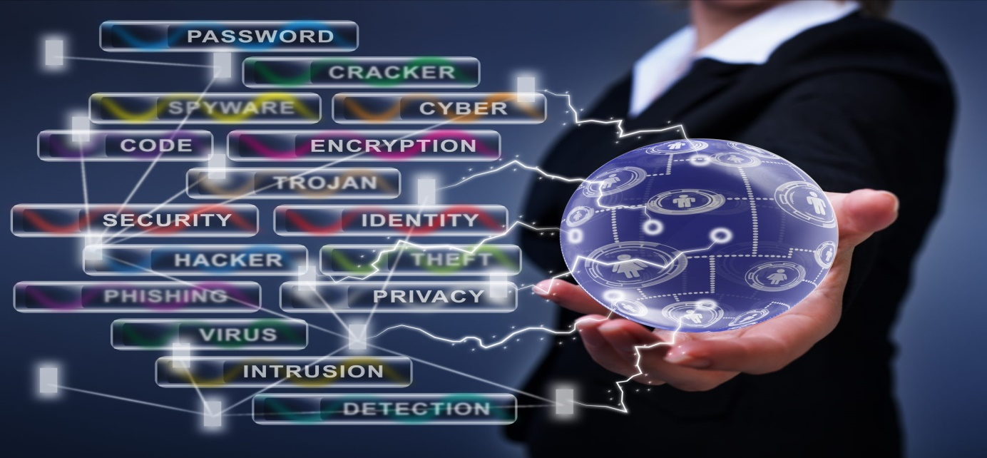

The benefits of threat intelligence include proactive defense, enhanced incident response capabilities, informed decision-making, and improved overall security posture. However, organizations also face challenges such as data overload, ensuring the quality of data, resource constraints, and fostering collaboration and information sharing.

In summary, threat intelligence empowers organizations to anticipate, respond to, and mitigate cybersecurity threats effectively, ultimately enhancing their resilience and protection against cyber risks.

**Threat intelligence is a crucial component of cybersecurity strategy, providing organizations with valuable insights into potential threats, vulnerabilities, and risks to their systems, networks, and data. Here's an overview of threat intelligence:**

1. **Definition:**
   * Threat intelligence refers to the collection, analysis, and dissemination of information about cybersecurity threats and risks. It includes data about threat actors, their tactics, techniques, and procedures (TTPs), and indicators of compromise (IOCs).
2. **Types of Threat Intelligence:**
   * **Strategic Intelligence:** Provides high-level insights into emerging threats, trends, and geopolitical factors that may impact an organization's security posture in the long term.
   * **Tactical Intelligence:** Offers detailed information about specific threats, including indicators of compromise (IOCs), malware analysis, and vulnerabilities.
   * **Operational Intelligence:** Focuses on immediate threats and ongoing security incidents, providing actionable information for incident response and mitigation.
3. **Sources of Threat Intelligence:**
   * **Open Source Intelligence (OSINT):** Information gathered from publicly available sources such as social media, forums, and security blogs.
   * **Commercial Threat Intelligence Feeds:** Subscription-based services that provide curated threat data and analysis tailored to specific industries or organizations.
   * **Government and Law Enforcement Agencies:** Agencies such as CERTs (Computer Emergency Response Teams), DHS (Department of Homeland Security), and law enforcement agencies may share threat intelligence with the private sector.
   * **Information Sharing and Analysis Centers (ISACs):** Industry-specific organizations that facilitate the sharing of threat intelligence among member organizations within a particular sector.
4. **Benefits of Threat Intelligence:**
   * **Proactive Defense:** Helps organizations anticipate and mitigate potential threats before they cause harm.
   * **Enhanced Incident Response:** Provides actionable information to respond quickly and effectively to security incidents.
   * **Informed Decision Making:** Enables informed decisions about resource allocation, security investments, and risk management strategies.
   * **Improved Security Posture:** Enhances overall security posture by identifying vulnerabilities, emerging threats, and best practices for defense.
5. **Challenges of Threat Intelligence:**
   * **Data Overload:** Managing and analyzing large volumes of threat data can be overwhelming, leading to information overload.
   * **Quality of Data:** Ensuring the accuracy, relevance, and reliability of threat intelligence sources and data is crucial.
   * **Resource Constraints:** Many organizations lack the resources, expertise, and infrastructure needed to effectively collect, analyze, and act on threat intelligence.
   * **Sharing and Collaboration:** Encouraging information sharing and collaboration among organizations can be challenging due to concerns about sharing sensitive data and competitive advantages.

**How to gather the enables to organizations:**

Gathering threat intelligence enables organizations to enhance their cybersecurity posture in several ways:

1. **Proactive Defense:** By collecting and analyzing threat intelligence, organizations can identify potential threats and vulnerabilities before they are exploited. This proactive approach allows them to implement appropriate security measures to mitigate risks and protect their systems and data.
2. **Early Warning System:** Threat intelligence serves as an early warning system, alerting organizations to emerging threats, new attack vectors, and evolving tactics used by threat actors. This early awareness enables organizations to stay one step ahead and prepare defenses before attacks occur.
3. **Informed Decision Making:** Threat intelligence provides valuable insights that inform strategic decision-making within an organization. By understanding the threat landscape and the specific risks faced, organizations can allocate resources effectively, prioritize security initiatives, and invest in the most impactful security controls.
4. **Incident Response:** In the event of a security incident, threat intelligence aids in rapid and effective incident response. Organizations can leverage threat intelligence to identify indicators of compromise (IOCs), analyze attack patterns, and develop tailored response strategies to contain and mitigate the impact of security breaches.
5. **Tailored Security Controls:** Threat intelligence helps organizations tailor their security controls to address specific threats and vulnerabilities relevant to their environment. By understanding the tactics, techniques, and procedures (TTPs) employed by threat actors, organizations can implement appropriate countermeasures to defend against attacks.
6. **Third-party Risk Management:** Threat intelligence also enables organizations to assess and manage risks associated with third-party vendors, suppliers, and partners. By monitoring the threat landscape and sharing intelligence with trusted partners, organizations can better understand and mitigate potential risks arising from their extended supply chain.

**Compliance and Regulatory Requirements:** Gathering threat intelligence assists organizations in meeting compliance and regulatory requirements related to cybersecurity. By staying informed about emerging threats and implementing appropriate security controls, organizations can demonstrate due diligence in safeguarding sensitive data and protecting against cyber threats.

**INFORMATION GATHERING IN THREAT INTELLIGENCE**

1. **Risk Assessment:** Gathering threat intelligence enables organizations to assess their level of risk exposure accurately. By analyzing threat data, organizations can identify vulnerabilities, misconfigurations, and weaknesses in their security posture that could be exploited by threat actors.
2. **Early Detection:** Timely information gathering helps organizations detect threats and security incidents at an early stage. By monitoring indicators of compromise (IOCs) and suspicious activities, organizations can identify potential security breaches before they escalate into major incidents.
3. **Proactive Defense:** Armed with threat intelligence, organizations can adopt a proactive defense posture. By anticipating potential threats and vulnerabilities, organizations can implement preventive measures, such as patching vulnerabilities, updating security controls, and enhancing employee awareness, to mitigate risks before they are exploited.
4. **Incident Response:** Effective incident response relies on accurate and up-to-date threat intelligence. By gathering information about ongoing security incidents, organizations can respond promptly and effectively to contain and remediate breaches, minimize impact, and restore normal operations.
5. **Strategic Decision Making:** Threat intelligence informs strategic decision-making within organizations. By analyzing threat trends, emerging risks, and industry-specific threats, organizations can allocate resources strategically, prioritize security initiatives, and invest in the most effective security controls to mitigate risks effectively.
6. **Third-party Risk Management:** Information gathering helps organizations assess and manage risks associated with third-party vendors, suppliers, and partners. By monitoring the threat landscape and sharing intelligence with trusted partners, organizations can identify and mitigate potential risks arising from their extended supply chain.
7. **Compliance and Regulatory Requirements:** Gathering threat intelligence assists organizations in meeting compliance and regulatory requirements related to cybersecurity. By staying informed about emerging threats and implementing appropriate security controls, organizations can demonstrate due diligence in safeguarding sensitive data and protecting against cyber.

**threat intelligence in processing of analyse and detect:**

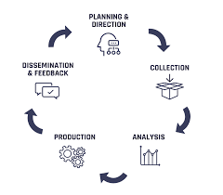

1. **Data Collection:** Threat intelligence involves collecting data from various sources, including open-source intelligence (OSINT), commercial feeds, government agencies, industry reports, and internal security logs. This data includes indicators of compromise (IOCs), threat actor profiles, attack patterns, vulnerabilities, and emerging threats.
2. **Normalization and Enrichment:** Once collected, the data is normalized and enriched to ensure consistency and enhance its value. This involves standardizing formats, categorizing information, and enriching data with additional context, such as threat classifications, severity ratings, and related indicators.
3. **Analysis:** Threat intelligence analysts analyze the collected and enriched data to identify patterns, trends, and correlations. They look for indicators of malicious activity, such as unusual network traffic, suspicious file behavior, or unauthorized access attempts. Analysis techniques may include statistical analysis, machine learning, and behavioral analytics.
4. **Contextualization:** Analysts contextualize the findings within the organization's environment to assess their relevance and potential impact. They consider factors such as the organization's assets, infrastructure, industry sector, and regulatory requirements to prioritize threats and determine their significance.
5. **Detection Rules and Signatures:** Based on the analysis, threat intelligence is used to create detection rules, signatures, and algorithms that enable automated detection of threats. These rules are implemented in security systems such as intrusion detection/prevention systems (IDS/IPS), security information and event management (SIEM) platforms, and endpoint protection solutions.
6. **Threat Hunting:** Threat intelligence guides proactive threat hunting activities, where security teams actively search for signs of compromise or malicious activity within the organization's network and endpoints. Threat hunters leverage threat intelligence to identify anomalies, investigate potential threats, and validate security alerts.
7. **Incident Response:** Threat intelligence is instrumental in incident response efforts. When a security incident occurs, threat intelligence provides valuable context and insights to help security teams understand the nature of the incident, assess its impact, and determine the appropriate response actions.

**THE ROLE OF THREAT INTELLIGENCE OF CYBER SECURITY:**



Threat intelligence plays a vital role in modern cybersecurity, serving as a cornerstone for organizations' defense strategies. By providing valuable insights into the ever-evolving threat landscape, threat intelligence enables organizations to proactively identify, assess, and mitigate cyber risks. It empowers security teams to detect threats early, understand the tactics and techniques employed by threat actors, and prioritize their security efforts effectively. With threat intelligence, organizations can tailor their security controls to address specific threats and vulnerabilities, enhancing their overall resilience against cyber attacks. Moreover, threat intelligence supports incident response efforts by providing context and actionable insights for prompt and effective mitigation. Through collaboration and information sharing, threat intelligence fosters a collective defense approach, enabling organizations to strengthen their defenses collectively. Ultimately, threat intelligence is indispensable for organizations seeking to stay ahead of cyber threats and safeguard their critical assets and data in today's digital landscape.

Top of Form

**UNDERSTANDINNG THE OOSINT FRAMEWORK**

**Understanding the OSINT (Open Source Intelligence) framework is crucial for effectively gathering, analyzing, and leveraging publicly available information for intelligence purposes. The OSINT framework typically involves several key stages**

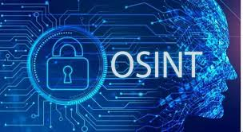

**Collection:** This stage involves systematically gathering relevant information from a wide range of publicly available sources, including websites, social media platforms, public records, news articles, blogs, forums, and government publications. The goal is to collect comprehensive and diverse data related to the intelligence objectives.

**Processing:** Once collected, the raw data undergoes processing to refine and organize it into a usable format. This may involve categorizing the data, filtering out irrelevant information, and extracting key insights or indicators of interest. Automated tools and techniques can assist in this process, helping to manage the volume and complexity of the data.

**Analysis:** In this stage, analysts examine the processed data to identify patterns, trends, relationships, and anomalies. They evaluate the credibility, reliability, and relevance of the information, seeking to derive actionable intelligence that addresses specific intelligence requirements. Analysis may involve various techniques, including data mining, link analysis, sentiment analysis, and geospatial analysis.

**Dissemination:** Once analyzed, the intelligence findings are disseminated to relevant stakeholders, decision-makers, or clients in a clear and concise manner. This may involve preparing reports, briefings, or visualizations that communicate the key findings, insights, and recommendations derived from the OSINT analysis. Effective dissemination ensures that the intelligence is actionable and contributes to informed decision-making.

**Feedback:** The feedback stage involves receiving input and validation from stakeholders regarding the usefulness and effectiveness of the OSINT-derived intelligence. This feedback helps refine and improve the OSINT framework, including data collection methods, analysis techniques, and dissemination strategies, to better meet the intelligence needs of the organization or client.

INTRODUCTON OF THE OSINT FRAMEWORK

The OSINT (Open Source Intelligence) framework is a structured methodology used to gather, analyze, and leverage publicly available information for intelligence purposes. In today's digital age, vast amounts of information are accessible through various online sources, including websites, social media platforms, news articles, public records, blogs, forums, and government publications. The OSINT framework provides a systematic approach to harnessing this wealth of information to generate actionable intelligence.

At its core, the OSINT framework consists of several key stages: collection, processing, analysis, dissemination, and feedback. In the collection stage, relevant information is systematically gathered from a wide range of open sources, ensuring comprehensive coverage of intelligence objectives. Once collected, the raw data undergoes processing to refine and organize it into a usable format. Analysts then analyze the processed data to identify patterns, trends, relationships, and anomalies, deriving actionable intelligence that addresses specific intelligence requirements.

The intelligence findings are disseminated to relevant stakeholders, decision-makers, or clients in a clear and concise manner, often through reports, briefings, or visualizations. Feedback from stakeholders is solicited to validate the usefulness and effectiveness of the OSINT-derived intelligence, helping to refine and improve the framework over time.

Ethical and legal considerations are paramount throughout the OSINT framework, with analysts adhering to principles of privacy, data protection, and compliance with relevant laws and regulations. Operational security (OPSEC) measures are also implemented to protect the identity and activities of analysts and sources involved in OSINT operations.

Overall, the OSINT framework provides organizations, intelligence agencies, and researchers with a structured and systematic approach to leveraging publicly available information for intelligence purposes, enabling them to gain valuable insights, mitigate risks, and make informed decisions in a rapidly evolving threat landscape.

CONCEPTS AND USES OF THE OSINT FRAMWORK

The OSINT (Open Source Intelligence) framework offers various uses in gathering, analyzing, and leveraging publicly available information for intelligence purposes. Here are some key uses of the OSINT framework:

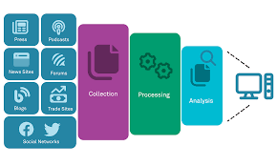

1. **Threat Detection:** OSINT is utilized to detect and identify potential threats to an organization's systems, networks, and data. By monitoring open sources such as social media, forums, and news articles, organizations can identify indicators of compromise (IOCs) and emerging threat trends.
2. **Investigations:** OSINT is valuable for conducting investigations into security incidents, data breaches, or suspicious activities. Investigators leverage publicly available information to gather evidence, identify perpetrators, and reconstruct events leading up to security incidents.
3. **Competitive Intelligence:** Organizations use OSINT to gather intelligence on competitors, industry trends, market dynamics, and emerging technologies. By monitoring publicly available information, organizations can gain insights into competitor strategies, product launches, and customer sentiment.
4. **Brand Protection:** OSINT is employed to monitor online mentions and discussions related to a brand or organization. By tracking social media, forums, and review websites, organizations can identify and mitigate reputational risks, counterfeit products, and brand impersonation.
5. **Cyber Threat Intelligence:** OSINT provides valuable insights into the cyber threat landscape, including emerging threats, vulnerabilities, and attack trends. By analyzing publicly available information, organizations can anticipate and prepare for potential cyber threats, enhancing their cybersecurity posture.
6. **Fraud Detection:** OSINT is used to detect and prevent fraud by monitoring online marketplaces, social media platforms, and financial forums. Organizations can identify suspicious activities, fraudulent schemes, and financial scams, enabling them to take proactive measures to mitigate fraud risks.
7. **Due Diligence:** OSINT is employed for conducting due diligence on individuals, businesses, or entities before engaging in partnerships, mergers, or acquisitions. By gathering publicly available information, organizations can assess reputations, backgrounds, and potential risks associated with business relationships.
8. **Policy and Decision Making:** OSINT provides decision-makers with valuable insights and information for policy development, strategic planning, and risk management. By leveraging publicly available information, organizations can make informed decisions based on current trends, developments, and threats in their operating environment.

**THE ROLE OF CYBER SECURITY**

Cyber threat intelligence can be immensely important to your business, especially if you’re seeking strategic solutions to boost your cyber security team. As cyber attackers become increasingly more sophisticated, threat intelligence can help reduce the risk of cyber attacks, improve your security posture, and help your team respond to incidents more effectively.

CTI can provide your business with valuable insight into the latest threats, the attackers behind them, and their specific methods. With this information, you can make more informed decisions regarding the allocation of your cyber security resources whilst also giving your wider teams the reassurance your organisation is fully protected and free to operate at optimal levels.

We've highlighted five benefits of cyber threat intelligence to punctuate its importance and the value it can bring to your business. These benefits consist of how it allows for collaborative knowledge, minimises the risks of cyber threats, enhances your team's efficiencies, provides a deeper analysis of various threats and can be a cost-effective solution for your organisation.

**Cyber threat intelligence can be a cost-effective solution**

Our final point in our benefits of cyber threat intelligence and to emphasise the importance of CTI is how it can be a cost-effective solution for your business. According to IBM Security, in the UK alone, the average cost of a data breach to a business is £3.2m. Therefore, to help minimise the risk of your company falling victim to the financial damages of a cyber threat, investing in CTI and your cyber security team makes justifiable sense.

Supported by your cyber security experts, CTI can ensure your defences are the best in the industry. It can help you predict when threats could occur and prevent them from causing severe harm. It’s not just data breaches and attacks that could be costly to your business. If your company has no proper CTI measures in place, this could be a concern for your internal team and customers. They could avoid partnering with your brand because of this, thus seeing you lose out financially.

The money you could lose by failing to recruit the top cyber security professionals who can implement threat intelligence into your business is not worth losing. It could, ultimately, set your business back to the point of no return. Thankfully, there is a solution. That solution is to invest in your cyber security team and CTI as a long-term, cost-effective solution.

**DISCUSS HOW THREAT INTELLIGENCE INFORMS DECISION MAKING ENHANCES THREAT DETECTION**

### Informs Decision Making:

1. **Risk Assessment:** Threat intelligence provides valuable insights into emerging threats, vulnerabilities, and attack trends. By evaluating this intelligence, organizations can assess their level of risk exposure accurately and prioritize security efforts accordingly.
2. **Resource Allocation:** Threat intelligence helps organizations allocate resources effectively by identifying high-priority threats and vulnerabilities. This information guides decision-makers in allocating budget, personnel, and technology investments to address the most critical security gaps.
3. **Security Strategy:** Threat intelligence informs strategic decision-making by providing insights into the current threat landscape and specific risks facing the organization. This information helps organizations develop and refine their security strategies, ensuring they are aligned with current threat trends and intelligence.
4. **Incident Response Planning:** Threat intelligence informs incident response planning by providing actionable insights and intelligence to incident responders. Decision-makers can use this information to develop and update incident response plans, ensuring they are prepared to effectively respond to security incidents when they occur.
5. **Policy Development:** Threat intelligence contributes to the development of cybersecurity policies and procedures. Decision-makers can use intelligence insights to develop policies that address specific threats, vulnerabilities, and attack vectors, thereby enhancing the organization's overall security posture

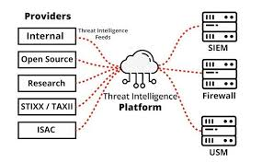

# Enhances Threat Detection:

1. **Early Threat Detection:** Threat intelligence enables organizations to detect potential threats at an early stage. By monitoring indicators of compromise (IOCs) and emerging attack patterns, organizations can identify and respond to security incidents before they escalate into major breaches, minimizing their impact and reducing potential damage.
2. **Improved Context:** Threat intelligence provides context and insights into the tactics, techniques, and procedures (TTPs) used by threat actors. This contextual information enhances threat detection by helping security teams identify patterns, anomalies, and indicators of suspicious activity that may indicate a security threat.
3. **Correlation and Analysis:** Threat intelligence supports the correlation and analysis of security events and alerts. By correlating security events with threat intelligence data, organizations can identify patterns and relationships between seemingly unrelated events, enabling them to detect and respond to threats more effectively.
4. **Behavioral Analysis:** Threat intelligence enables organizations to conduct behavioral analysis of security events and user activities. By comparing observed behavior with known threat intelligence data, organizations can identify deviations from normal behavior patterns, helping to detect insider threats, malware infections, and other security incidents.
5. **Proactive Defense:** Threat intelligence enables organizations to adopt a proactive approach to cybersecurity. By leveraging insights from threat intelligence, organizations can anticipate potential threats and vulnerabilities, allowing them to implement preventive measures and strengthen their defenses before attacks occur, rather than reacting to incidents after they happen.

## The evolving threat

As the digital agenda develops, so too does the scale and sophistication of cybercrime.Cyber-attacks have been taking place since the initial development of computer technology. Prior to 2010, such attacks were referred to as computer crime. As the world becomes increasingly interconnected, we used more precise terms, to reflect the diverse nature of the attacks.

Cyber-attacks emanate from a variety of increasingly sophisticated sources:

* Opportunistic attackers: These were hobbyists and opportunistic attackers, who created viruses and worms for their own amusement and to gain notoriety. They still exist today, attacking poorly-protected systems.
* Sophisticated attackers: As computing became more mainstream, so did the emergence of “hackers.” Some did it for money, but most did it for political, social or environmental causes. Today, these attackers are relatively sophisticated and attack because they disagree with your organisations goals and mission.
* Organised crime: Traditional criminals began to understand the possibilities of cybercrime at the turn of the century, starting with phishing scams and spyware infections. It has evolved rapidly, to form a highly-organised, sophisticated and layered criminal ecosystem where tools, techniques and the fruits of cybercrime are widely traded. Everything from denial of service; ransom schemes; sophisticated data theft; and intellectual property theft can be included in this category. In recent years, attackers have focused on “hacking the human” – manipulating or deceiving people in order to compromise organisational security – rather than breaching complex layered defences.
* Corporate espionage: Industrial spies migrated to the digital space just as business operations went online. They tend to be malicious insiders or external competitors and the techniques became more sophisticated as technology became more interconnected.
* Nation-sponsored attackers: The 2010 StuxNet attack was the first high-profile attack that was attributed to a nation state. This attack targeted the control systems of Iranian nuclear facilities. Attacks of this nature tend to be highly-targeted and are driven by political or military objectives. They are sometimes used for the purpose of intellectual property theft, for national competitive advantage.

**KEY CONCEPTS OF THREAT INTELLIGENCE INCLUDE:**

1. **Indicators of Compromise (IOCs):** These are artifacts or evidence indicating that a security incident has occurred or is ongoing. IOCs can include IP addresses, domain names, file hashes, URLs, and patterns of suspicious activity.
2. **Threat Actors:** Individuals, groups, or organizations responsible for carrying out malicious activities. Threat actors can include cybercriminals, nation-state actors, hacktivists, insiders, and advanced persistent threats (APTs).
3. **Tactics, Techniques, and Procedures (TTPs):** These are the methods and strategies used by threat actors to conduct attacks. TTPs encompass various tactics such as phishing, malware deployment, exploitation of vulnerabilities, and lateral movement within networks.
4. **Open Source Intelligence (OSINT):** Intelligence gathered from publicly available sources such as websites, social media, forums, news articles, and public records. OSINT provides valuable insights into the threat landscape and complements other forms of intelligence.
5. **Structured Threat Information eXpression (STIX):** A standardized language for representing and sharing cyber threat information. STIX provides a common framework for describing indicators, threat actors, TTPs, and other threat intelligence attributes.
6. **Cyber Threat Intelligence Platforms (CTIPs):** Tools and platforms used to collect, aggregate, analyze, and disseminate threat intelligence data. These platforms facilitate the management and sharing of threat intelligence within organizations and across industry sectors.
7. **Dark Web Intelligence:** Monitoring and analyzing activities on the dark web, where threat actors often conduct illicit activities such as selling stolen data, malware, and exploit kits. Dark web intelligence provides insights into underground cybercriminal networks.
8. **Actionable Intelligence:** Threat intelligence that can be used to inform and guide security actions and decisions.

**THE LIFE CYCLE OF THREAT**

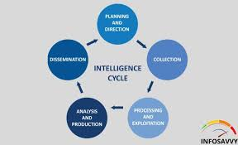

1. **Planning and Requirements Gathering:** The life cycle begins with defining the organization's intelligence requirements and objectives. This involves understanding the organization's assets, threat landscape, and specific security challenges to determine what type of threat intelligence is needed.
2. **Collection:** In this stage, relevant threat data is collected from various sources, including open source intelligence (OSINT), commercial feeds, internal logs, incident reports, and threat sharing communities. The goal is to gather comprehensive and diverse data to address the organization's intelligence requirements.
3. **Processing:** Once collected, the raw threat data undergoes processing to refine and organize it into a usable format. This may involve categorizing the data, enriching it with additional context, and normalizing it to ensure consistency and relevance.
4. **Analysis:** The processed threat data is then analyzed to identify patterns, trends, and insights that can inform decision-making and response efforts. Analysts evaluate the credibility, reliability, and relevance of the information, seeking to derive actionable intelligence that addresses specific intelligence requirements.
5. **Dissemination:** Once analyzed, the intelligence findings are disseminated to relevant stakeholders, decision-makers, or clients in a clear and concise manner. This may involve preparing reports, briefings, or visualizations that communicate the key findings, insights, and recommendations derived from the analysis.
6. **Feedback and Iteration:** The feedback stage involves receiving input and validation from stakeholders regarding the usefulness and effectiveness of the threat intelligence. This feedback helps refine and improve the threat intelligence process, including data collection methods, analysis techniques, and dissemination strategies, to better meet the intelligence needs of the organization.
7. **Action and Response:** Finally, organizations take action based on the intelligence insights and recommendations. This may involve implementing security controls, updating policies and procedures, deploying countermeasures, or initiating incident response actions to mitigate identified risks and threats effectively.

Throughout the threat intelligence life cycle, organizations adhere to ethical and legal principles, ensuring compliance with relevant laws and regulations governing data collection and use. Additionally, maintaining operational security (OPSEC) is crucial to protect the identity and activities of analysts and sources involved in threat intelligence operations.

The threat intelligence lifecycle is not a linear process, but rather an iterative cycle that requires constant refinement and adaptation to the ever-changing cyber threat landscape. Cybersecurity teams can apply the threat intelligence lifecycle to analyze a range of threats including geopolitical risk, vulnerabilities, cybercrime groups, advanced persistent threats, and fraud threats among others. By embracing this structured approach, cybersecurity professionals can synergize their threat detection, analysis, and research initiatives, ensuring that the intelligence is relevant, actionable, and aligned with the organization’s unique risk profile

**Understanding the Threat Intelligence LifecycLE**

### Phase 1 of the CTI Lifecycle: Scoping Threat Intelligence Requirements

Besides routine day to day threat intelligence work, such as monitoring dark web markets and forums for company mentions, most threat intelligence projects start with requirements identification. During this phase the CTI team or those responsible for intelligence collection will interface directly with other business units or executives to determine what type of intelligence needs to be collected and what the goal of the project is. Requirements identification is critical for ensuring that CTI processes correctly align with business and risk management objectives, and provide intelligence that can be actioned by relevant stakeholders.

For the purpose of this example of a threat intelligence lifecycle, we are going to assume that the CTI team has been tasked with collecting information about initial access brokers on dark web markets. Specifically we will assume that the CTI team has been asked to:

* Identify initial access brokers (cybercriminals who hack into corporate IT environments and then sell their access to other criminals on specialized dark web forums) targeting healthcare companies
* Create a list of personas that the initial access brokers use, along with relevant data about the size of organizations that they attack
* Gather relevant information around any identifiable tactics, techniques, and procedures (TTP’s) that the threat actors use to gain access or escalate privileges
* Provide recommendations to the organization about how they can reduce the risk associated with being compromised by an initial access broker

### Phase 2 of the CTI Lifecycle: Threat Intelligence Collection

During this phase sources of threat intelligence are identified and collection of raw data begins. If the organization is using a dedicated threat intelligence platform, data may be collected directly from the platform, if not data may be collected from relevant sources.

In this case the team would likely examine specialized dark web forums that are used by initial access brokers to auction off access to corporate IT environments. If they were using a threat intelligence platform, this data might come in a structured format, if not it’s likely they would manually scrape data off of specific web pages on TOR.

### Phase 3 of the CTI Lifecycle: Threat Intelligence Processing

Once relevant data has been collected during the threat intelligence collection phase, the team would set about processing it. This involves filtering out irrelevant data that was collected incidentally, structuring data to make the analysis phase easier, and grouping similar data together that can be used during the analysis phase. This step could involve:

* Creating spreadsheets and linking disparate data elements together to create context for events and assets
* Uploading vendor supplied IOCs to a SIEM or SOAR tool to compare against real traffic
* In our example, the CTI team would likely create a matrix to show relationships between initial access brokers, identifiable TTP data discovered during collection, along with the specific forums and marketplaces they operate on

### Phase 4 of the CTI Lifecycle: Threat Intelligence Analysis

The analysis phase is pivotal for providing the business with actionable, relevant data that can be used to reduce risk or inform corporate information security decisions. During the analysis phase threat intelligence analysts will work to create meaningful context and actionable intelligence out of the data that has been formatted and structured during the processing phase. CTI analyst teams should work to ensure that:

* Analysis effectively and clearly communicates to the right audience. Analysis focused on commonly exploited vulnerabilities that is destined for the vulnerability management team can be highly technical, but reports destined for the board and other executives should be focused around actionable recommendations and risk
* Analysis should be only as verbose as necessary to clearly explain the results and provide recommendations
* In our example, the CTI team would likely provide context around IABs discovered on the dark web, identify those that pose the greatest threat to the organization, and provide additional information about identifiable TTPs and countermeasures

### Phase 5 of the CTI Lifecycle : Threat Intelligence Dissemination

During dissemination, relevant threat intelligence is sent out to various business units that could derive value from it and that were identified during the “identify requirements” phase. Despite seemingly being one of the most simple phases, many organizations fail to effectively ensure that actionable threat data arrives to the right stakeholders at an organization. Here are a few best practices you can use to improve threat intelligence dissemination:

* Consider creating different versions of “finished” threat intelligence at varying levels of technicality to provide value to stakeholders in technical teams, risk management teams, and at the executive level
* As your team progresses through the threat intelligence lifecycle, take the time to identify additional business units that may benefit from finished intelligence

### Phase 6 of the CTI Lifecycle: Feedback

Once intelligence has been sent to relevant business units and individuals, it is time to collect feedback from the organization to determine whether the intelligence analysis was timely, relevant, and actionable. Below are some good leading questions you can ask to receive feedback that can be used to improve future intelligence gathering & analysis.

LELLLLLLFWWF

THE ROLE OF CYBER SECURITY

Cyber threat intelligence can be immensely important to your business, especially if you’re seeking strategic solutions to boost your cyber security team. As cyber attackers become increasingly more sophisticated, threat intelligence can help reduce the risk of cyber attacks, improve your security posture, and help your team respond to incidents more effectively.

CTI can provide your business with valuable insight into the latest threats, the attackers behind them, and their specific methods. With this information, you can make more informed decisions regarding the allocation of your cyber security resources whilst also giving your wider teams the reassurance your organisation is fully protected and free to operate at optimal levels.

We've highlighted five benefits of cyber threat intelligence to punctuate its importance and the value it can bring to your business. These benefits consist of how it allows for collaborative knowledge, minimises the risks of cyber threats, enhances your team's efficiencies, provides a deeper analysis of various threats and can be a cost-effective solution for your organisation.

**Cyber threat intelligence can be a cost-effective solution**

Our final point in our benefits of cyber threat intelligence and to emphasise the importance of CTI is how it can be a cost-effective solution for your business. According to IBM Security, in the UK alone, the average cost of a data breach to a business is £3.2m. Therefore, to help minimise the risk of your company falling victim to the financial damages of a cyber threat, investing in CTI and your cyber security team makes justifiable sense.

Supported by your cyber security experts, CTI can ensure your defences are the best in the industry. It can help you predict when threats could occur and prevent them from causing severe harm. It’s not just data breaches and attacks that could be costly to your business. If your company has no proper CTI measures in place, this could be a concern for your internal team and customers. They could avoid partnering with your brand because of this, thus seeing you lose out financially.

The money you could lose by failing to recruit the top cyber security professionals who can implement threat intelligence into your business is not worth losing. It could, ultimately, set your business back to the point of no return. Thankfully, there is a solution. That solution is to invest in your cyber security team and CTI as a long-term, cost-effective solution.

**DISCUSS HOW THREAT INTELLIGENCE INFORMS DECISION MAKING ENHANCES THREAT DETECTION**

### Informs Decision Making:

1. **Risk Assessment:** Threat intelligence provides valuable insights into emerging threats, vulnerabilities, and attack trends. By evaluating this intelligence, organizations can assess their level of risk exposure accurately and prioritize security efforts accordingly.
2. **Resource Allocation:** Threat intelligence helps organizations allocate resources effectively by identifying high-priority threats and vulnerabilities. This information guides decision-makers in allocating budget, personnel, and technology investments to address the most critical security gaps.
3. **Security Strategy:** Threat intelligence informs strategic decision-making by providing insights into the current threat landscape and specific risks facing the organization. This information helps organizations develop and refine their security strategies, ensuring they are aligned with current threat trends and intelligence.
4. **Incident Response Planning:** Threat intelligence informs incident response planning by providing actionable insights and intelligence to incident responders. Decision-makers can use this information to develop and update incident response plans, ensuring they are prepared to effectively respond to security incidents when they occur.
5. **Policy Development:** Threat intelligence contributes to the development of cybersecurity policies and procedures. Decision-makers can use intelligence insights to develop policies that address specific threats, vulnerabilities, and attack vectors, thereby enhancing the organization's overall security posture



# Enhances Threat Detection:

1. **Early Threat Detection:** Threat intelligence enables organizations to detect potential threats at an early stage. By monitoring indicators of compromise (IOCs) and emerging attack patterns, organizations can identify and respond to security incidents before they escalate into major breaches, minimizing their impact and reducing potential damage.
2. **Improved Context:** Threat intelligence provides context and insights into the tactics, techniques, and procedures (TTPs) used by threat actors. This contextual information enhances threat detection by helping security teams identify patterns, anomalies, and indicators of suspicious activity that may indicate a security threat.
3. **Correlation and Analysis:** Threat intelligence supports the correlation and analysis of security events and alerts. By correlating security events with threat intelligence data, organizations can identify patterns and relationships between seemingly unrelated events, enabling them to detect and respond to threats more effectively.
4. **Behavioral Analysis:** Threat intelligence enables organizations to conduct behavioral analysis of security events and user activities. By comparing observed behavior with known threat intelligence data, organizations can identify deviations from normal behavior patterns, helping to detect insider threats, malware infections, and other security incidents.
5. **Proactive Defense:** Threat intelligence enables organizations to adopt a proactive approach to cybersecurity. By leveraging insights from threat intelligence, organizations can anticipate potential threats and vulnerabilities, allowing them to implement preventive measures and strengthen their defenses before attacks occur, rather than reacting to incidents after they happen.

## The evolving threat

As the digital agenda develops, so too does the scale and sophistication of cybercrime.Cyber-attacks have been taking place since the initial development of computer technology. Prior to 2010, such attacks were referred to as computer crime. As the world becomes increasingly interconnected, we used more precise terms, to reflect the diverse nature of the attacks.

Cyber-attacks emanate from a variety of increasingly sophisticated sources:

* Opportunistic attackers: These were hobbyists and opportunistic attackers, who created viruses and worms for their own amusement and to gain notoriety. They still exist today, attacking poorly-protected systems.
* Sophisticated attackers: As computing became more mainstream, so did the emergence of “hackers.” Some did it for money, but most did it for political, social or environmental causes. Today, these attackers are relatively sophisticated and attack because they disagree with your organisations goals and mission.
* Organised crime: Traditional criminals began to understand the possibilities of cybercrime at the turn of the century, starting with phishing scams and spyware infections. It has evolved rapidly, to form a highly-organised, sophisticated and layered criminal ecosystem where tools, techniques and the fruits of cybercrime are widely traded. Everything from denial of service; ransom schemes; sophisticated data theft; and intellectual property theft can be included in this category. In recent years, attackers have focused on “hacking the human” – manipulating or deceiving people in order to compromise organisational security – rather than breaching complex layered defences.
* Corporate espionage: Industrial spies migrated to the digital space just as business operations went online. They tend to be malicious insiders or external competitors and the techniques became more sophisticated as technology became more interconnected.
* Nation-sponsored attackers: The 2010 StuxNet attack was the first high-profile attack that was attributed to a nation state. This attack targeted the control systems of Iranian nuclear facilities. Attacks of this nature tend to be highly-targeted and are driven by political or military objectives. They are sometimes used for the purpose of intellectual property theft, for national competitive advantage.

**STAGE-1**

**REPORT**

#### 2. OPEN SOURCE INTELLIGENCE(OSINT) FRAMEWORK

1. EXPLORING OSINT TOOLS AND TECHNIQUES:

OSINT:

OSINT, or Open Source Intelligence, is the practice of gathering information from publicly available sources to gain insights and make informed decisions. These sources can include social media, news articles, public records, online forums, and more. OSINT is used in various fields such as security, law enforcement, competitive intelligence, and journalism. It involves analyzing and synthesizing data from multiple sources to produce actionable intelligence. OSINT techniques can range from simple searches on search engines to more advanced methods like data mining and social network analysis. It's a powerful tool for understanding and navigating the vast amount of information available online.

Using this website link: https://osintframework.com

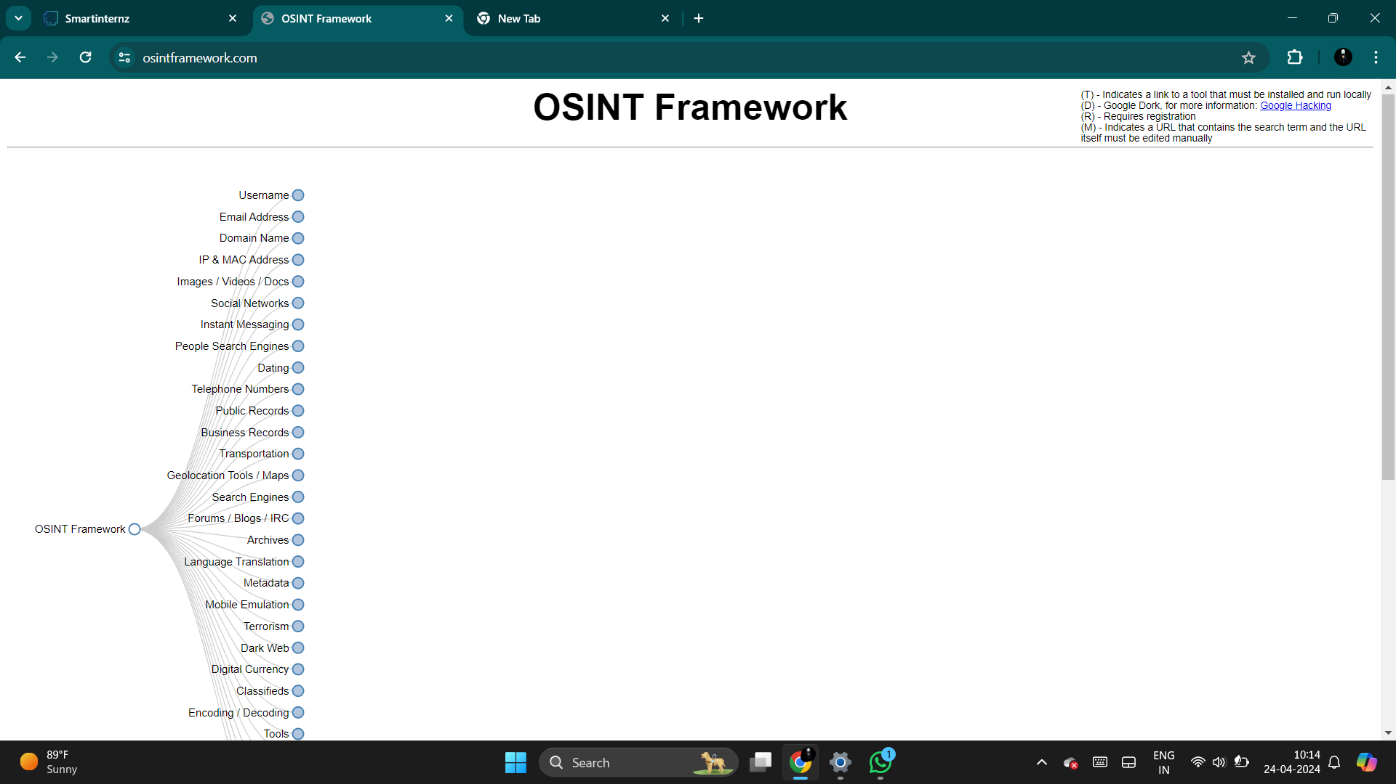

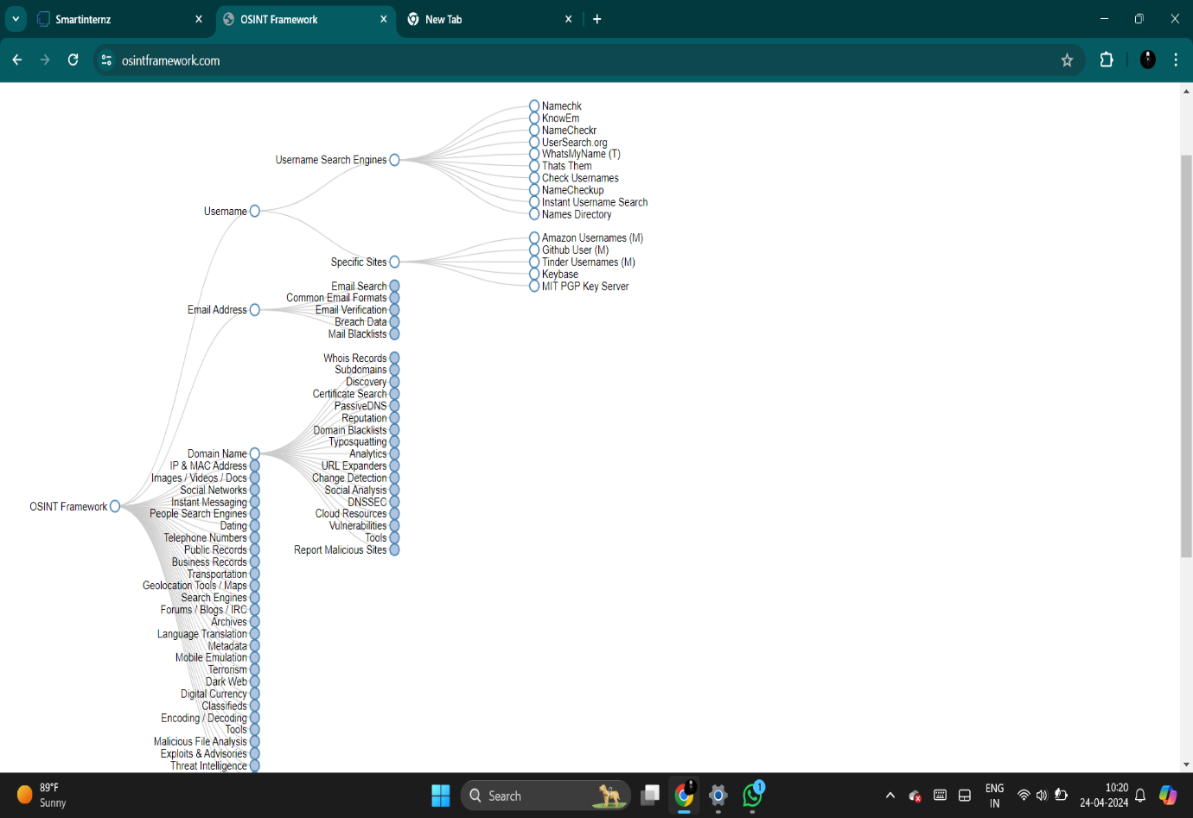

By using OSINT TECHNIQUES from above are:

OSINT, or Open Source Intelligence, refers to the practice of collecting and analyzing publicly available information to gather insights and intelligence. Some common OSINT techniques include:

1.Social Media Analysis: Examining posts, profiles, and interactions on platforms like Twitter, Facebook, and LinkedIn for valuable information.

2.Web Scraping: Automating the extraction of data from websites, forums, and blogs to uncover trends or patterns.

3.Metadata Analysis: Extracting hidden information from files such as photos or documents, like geolocation data or author details.

4.Search Engine Queries: Using advanced search operators and tools to sift through vast amounts of web content for relevant information

**LEVERAGING SOCIAL MEIDA PLATFORMS FOR INTELLIGENCE**

**GATHERING**

Leveraging social media platforms for intelligence gathering involves using various tools and techniques to extract valuable information from social media networks for security, business, or research purposes

Step-1

IN OSINT website select the social networks and click on facebook after click on serach then you can click on any website you get the information

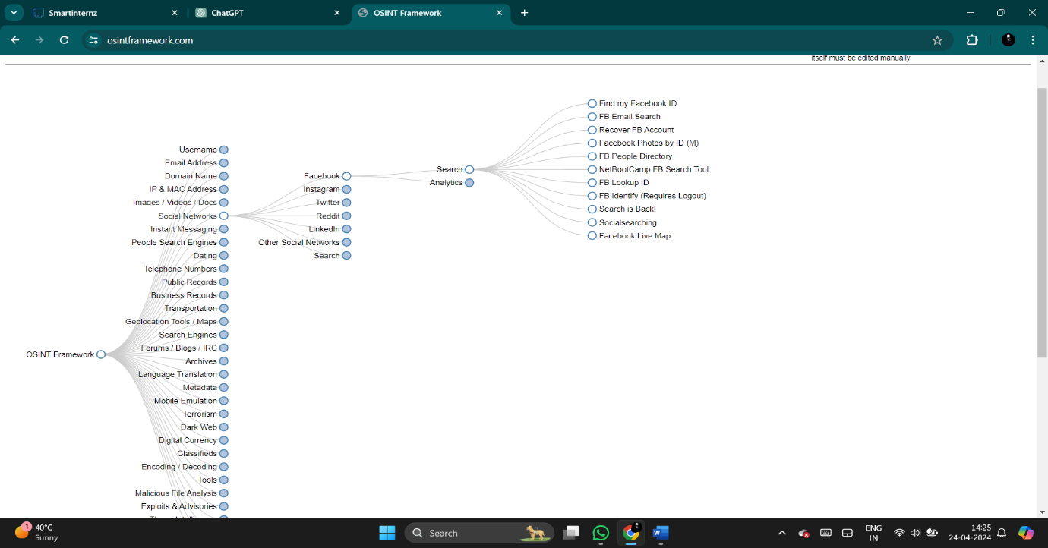

Then I click on the Fb mail search then I got the information

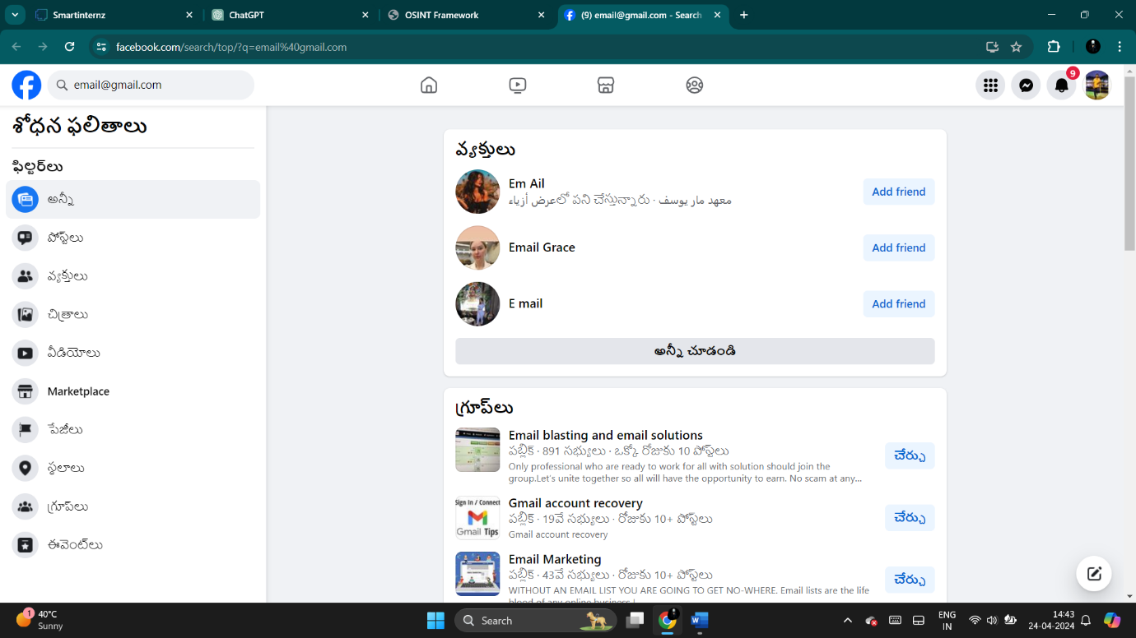

After I click on the instagaram and open that website then see information

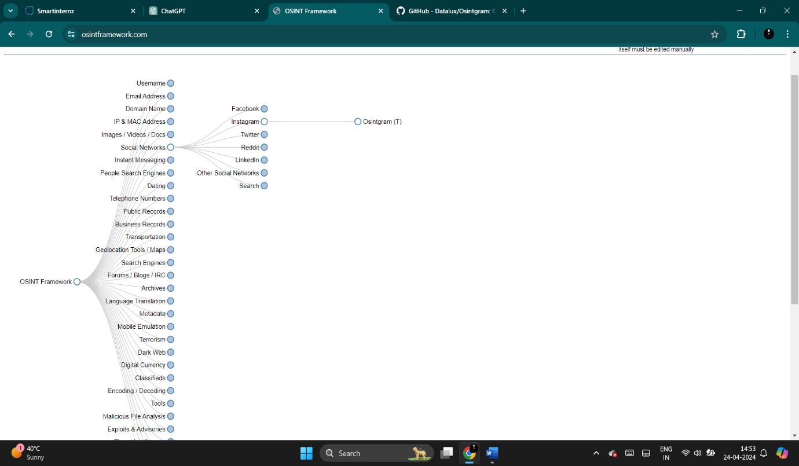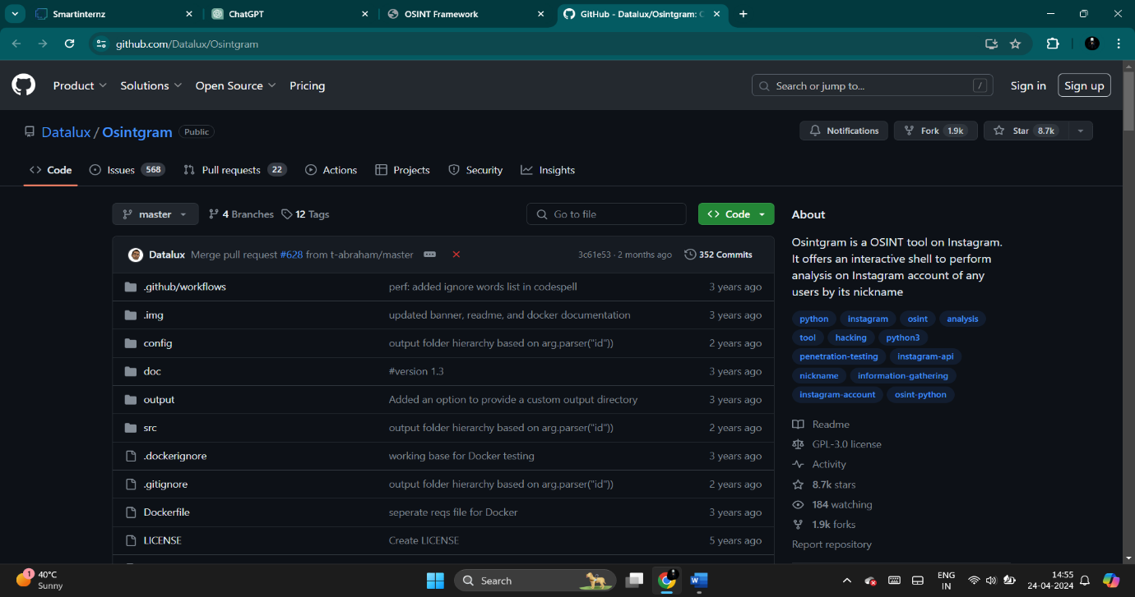

After click on the twitter some option are ther you can select any on of that for gathering data

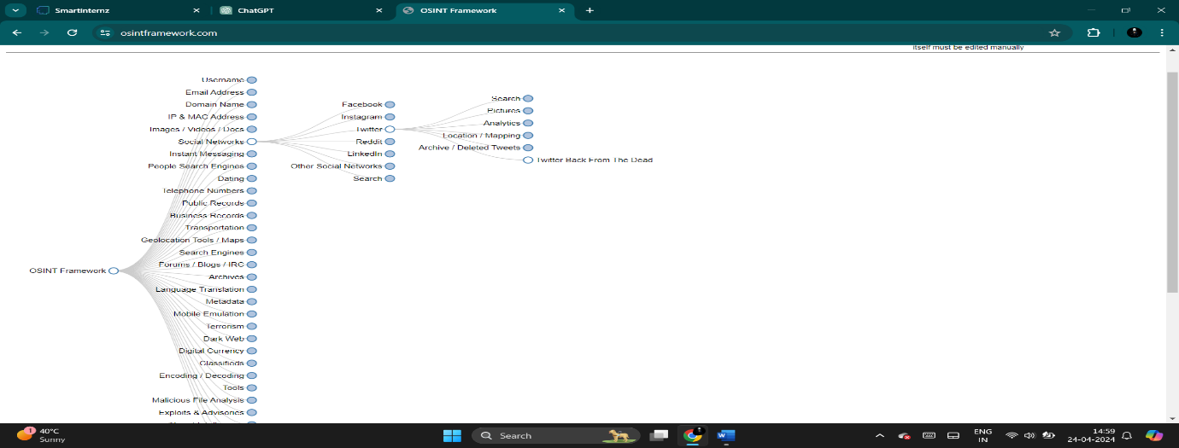

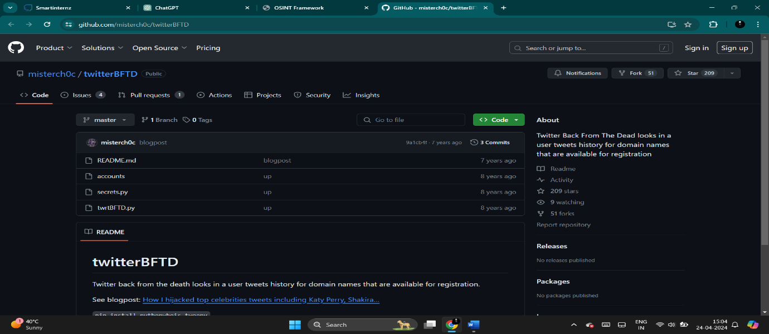

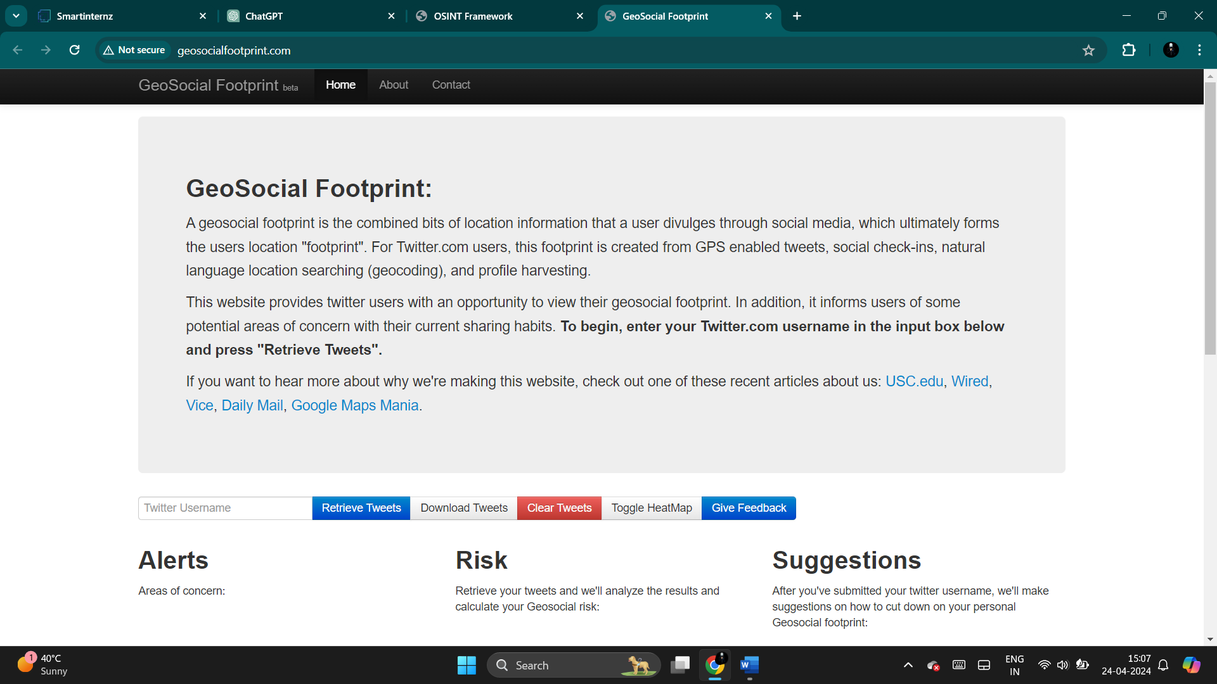

Above website you can get the information .

Then click on the reddit and get some website for gathering the information

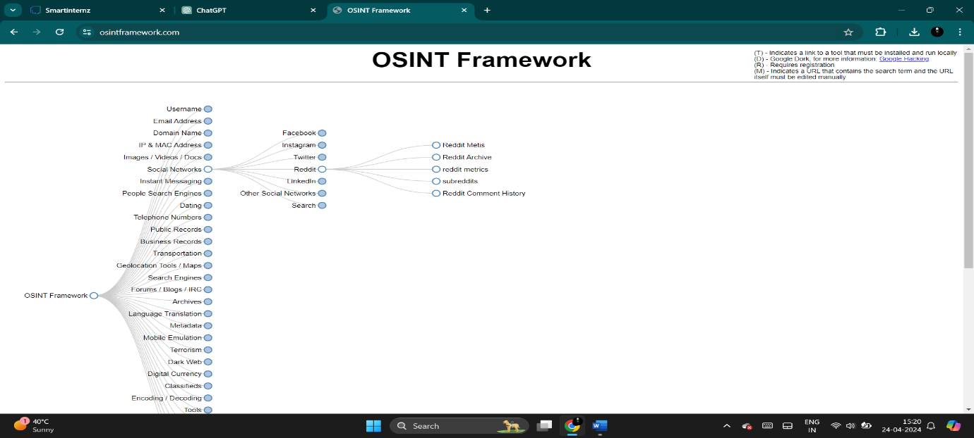

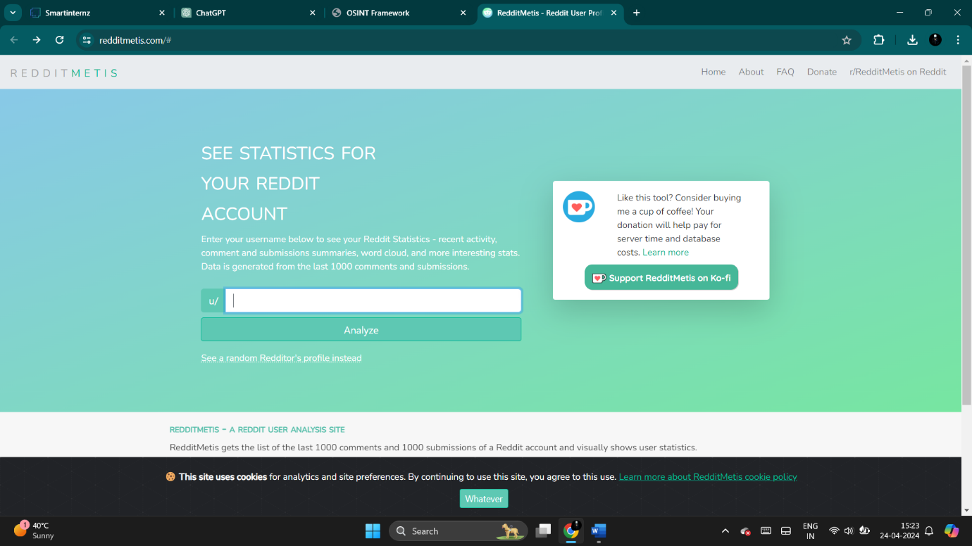

These is all about of information gathering in social media.

**MINING PUBLICLY AVAILABLE INFORMATION SOURCES**

**Mining publicly available information sources involves extracting valuable insights, patterns, or knowledge from various sources of information that are accessible to the public. These sources can include:**

**1.Websites: Information available on websites, including news articles, blogs, forums, and social media platforms. Tools like web scrapers can help extract relevant data from these sources.**

**2.Government Databases: Government agencies often make data available to the public, such as census data, economic indicators, and regulatory filings. These datasets can provide valuable insights into demographics, economic trends, and more.**

**3.Open Data Repositories: Many organizations, both public and private, make datasets openly available for analysis. These datasets can cover a wide range of topics, including healthcare, education, transportation, and environmental data.**

**By using OSINT website click on the Forums/blogs/IRC are see in below**

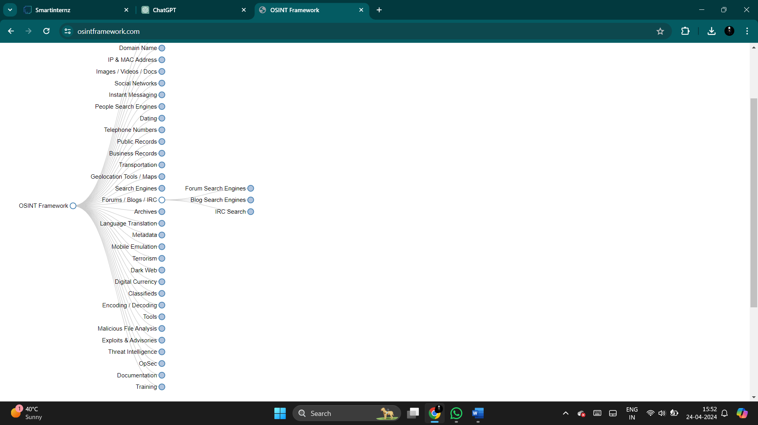

After select any one on that three

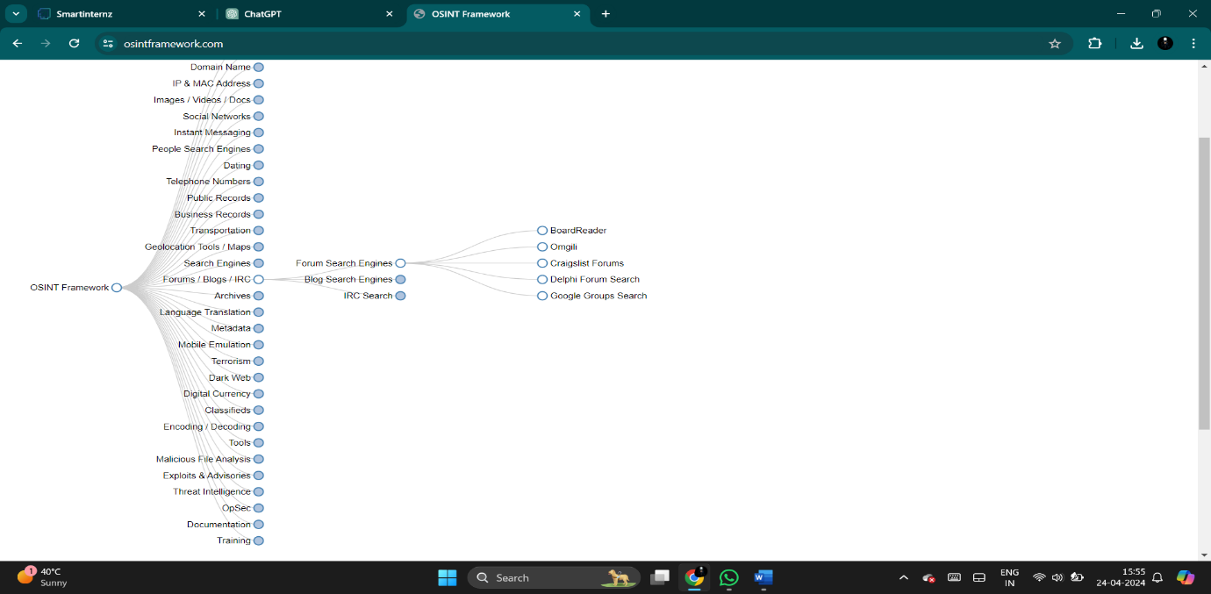

After select any website for gathering information in forums

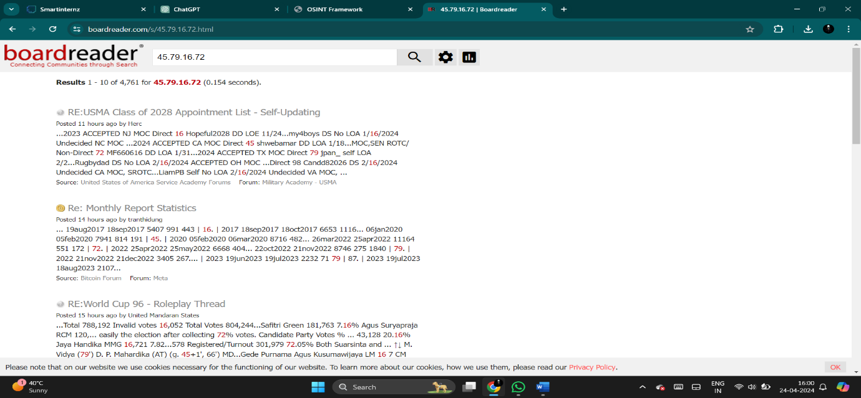

RE:USMA Class of 2028 Appointment List - Self-Updating

Posted 11 hours ago by Herc

...2023 ACCEPTED NJ MOC Direct 16 Hopeful2028 DD LOE 11/24...my4boys DS No LOA 1/16/2024 Undecided NC MOC ...2024 ACCEPTED CA MOC Direct 45 shwebamar DD LOA 1/18...MOC,SEN ROTC/ Non-Direct 72 MF660616 DD LOA 1/31...2024 ACCEPTED TX MOC Direct 79 jpan_ self LOA 2/2...Rugbydad DS No LOA 2/16/2024 ACCEPTED OH MOC ...Direct 98 Candd82026 DS 2/16/2024 Undecided CA MOC, SROTC...LiamPB Self No LOA 2/16/2024 Undecided VA MOC

Some information gather by using prg college ip address

And also next one is blogs

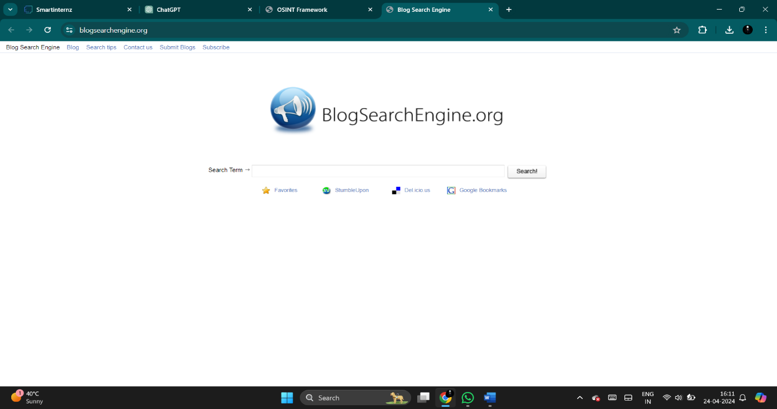

You can get information you search on that website

Another one is IRC click on that for gathering information

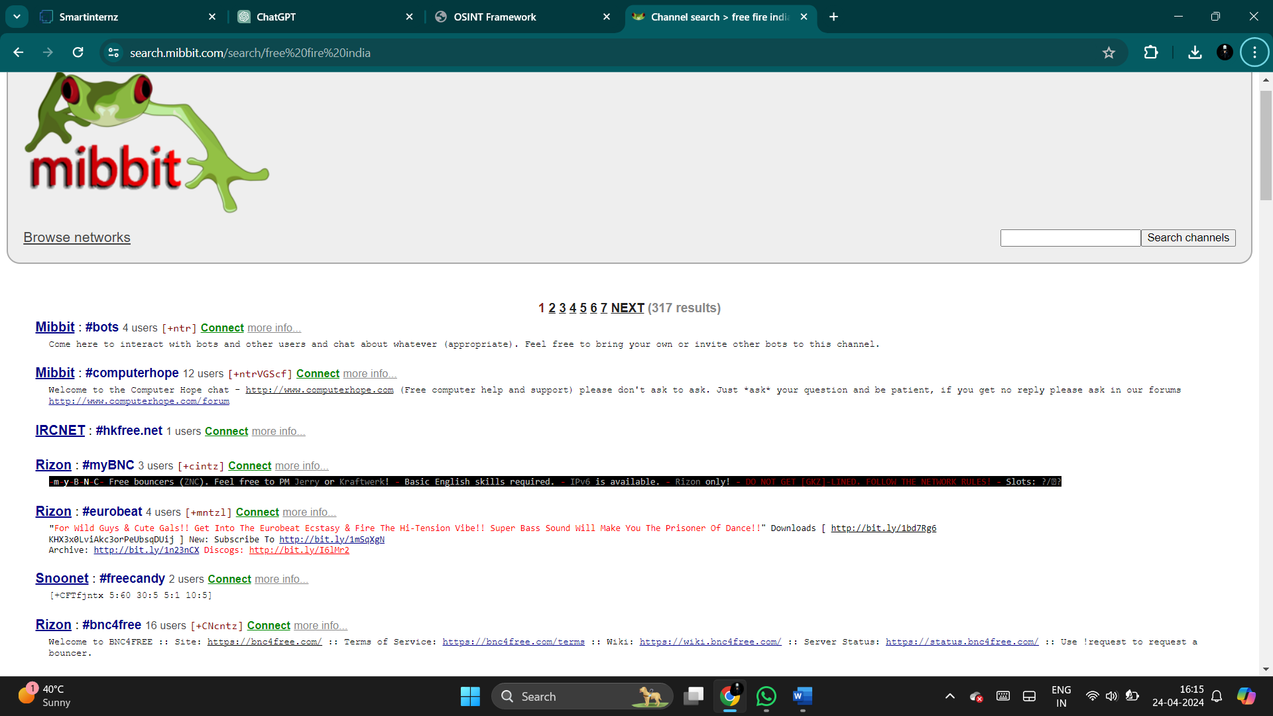

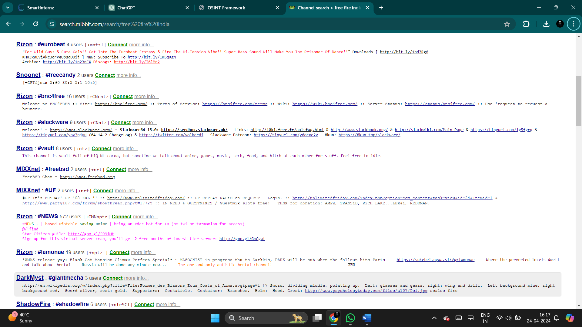

These is all about **Mining publicly available information sources**

**CONDUCTING DOMAIN AND DNS ANALYSIS**

**Conducting domain and DNS analysis involves examining various aspects related to internet domains and their associated Domain Name System (DNS) records. This analysis is crucial for various purposes such as cybersecurity investigations, network troubleshooting, and digital forensics. Here's an overview of what it entails:**

**Domain Registration Information: Start by looking up the registration details of the domain. This includes information such as the domain owner's name, contact information, registration date, and expiration date. WHOIS databases are commonly used for this purpose.**

**DNS Records: Analyze the DNS records associated with the domain. These records provide information about how the domain is configured and what services it may be using. Common DNS records include:**

**A Records: Maps a domain name to an IPv4 address.**

**AAAA Records: Maps a domain name to an IPv6 address.**

**MX Records: Specify the mail servers responsible for receiving email on behalf of the domain.**

**CNAME Records: Alias of one domain to another.**

**TXT Records: Text information associated with the domain.**

**Reverse DNS Lookup: Perform a reverse DNS lookup to find out which domains are associated with a particular IP address. This can help identify other domains hosted on the same server or IP range, which might be relevant for security or investigative purposes.**

**Historical DNS Data: Look for historical DNS data to see how the domain's DNS configuration has evolved over time. This can reveal changes in infrastructure, ownership, or malicious activities.**

**DNSSEC Analysis: DNS Security Extensions (DNSSEC) add an additional layer of security to the DNS by digitally signing DNS data. Analyzing DNSSEC information can help assess the integrity and authenticity of DNS records.**

**Geolocation Analysis: Determine the physical location of the servers hosting the domain by analyzing their IP addresses. This can provide insights into potential regulatory compliance issues, as well as help identify suspicious activities originating from specific geographic regions.**

**Malware and Threat Intelligence: Use threat intelligence feeds and malware analysis tools to check if the domain has been associated with malicious activities in the past. This could include being flagged for phishing, distributing malware, or participating in botnet activities.**

**Now we select the domain name in OSINT framework website. After click the DNS and DNSSEC then gathered the information is in below**

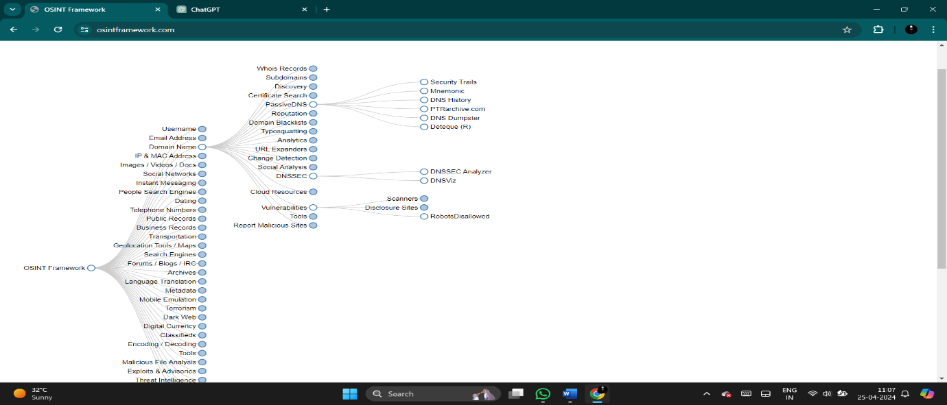

**After click on any website of in DNS**

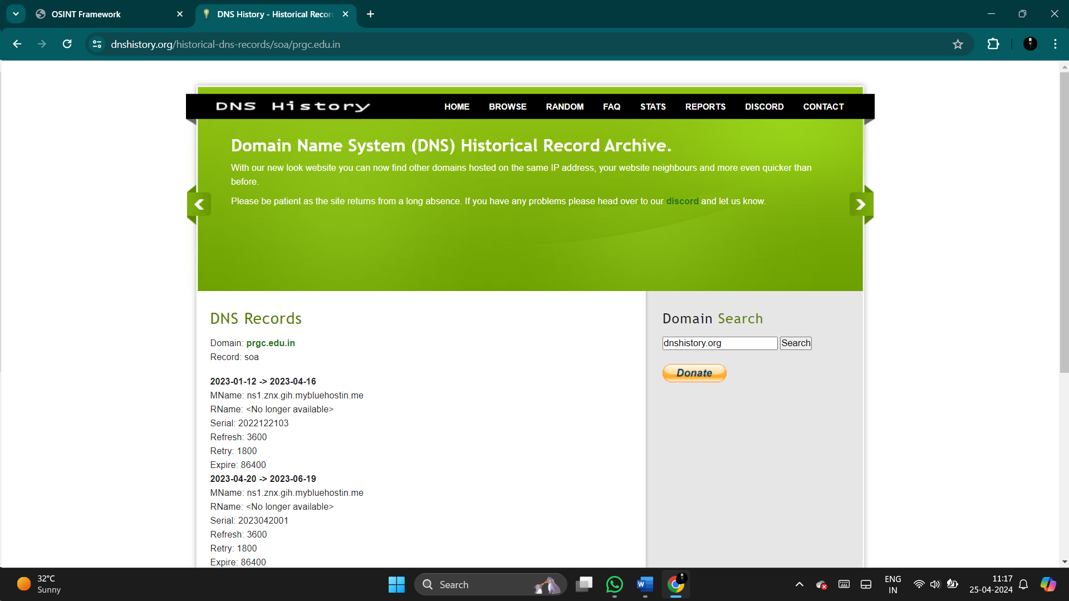

DNS Records

Domain: [**prgc.edu.in**](https://dnshistory.org/dns-records/prgc.edu.in)  
Record: soa

**2023-01-12 -> 2023-04-16**  
MName: ns1.znx.gih.mybluehostin.me  
RName: <No longer available>  
Serial: 2022122103  
Refresh: 3600  
Retry: 1800  
Expire: 86400  
**2023-04-20 -> 2023-06-19**  
MName: ns1.znx.gih.mybluehostin.me  
RName: <No longer available>  
Serial: 2023042001  
Refresh: 3600  
Retry: 1800  
Expire: 86400  
**2023-06-24 -> 2023-08-19**  
MName: ns1.znx.gih.mybluehostin.me  
RName: <No longer available>  
Serial: 2023062001  
Refresh: 3600  
Retry: 1800  
Expire: 86400  
**2023-09-01 -> 2023-09-22**  
MName: ns1.znx.gih.mybluehostin.me  
RName: <No longer available>  
Serial: 2023082001  
Refresh: 3600  
Retry: 1800  
Expire: 86400

Now click on the DNSSEC

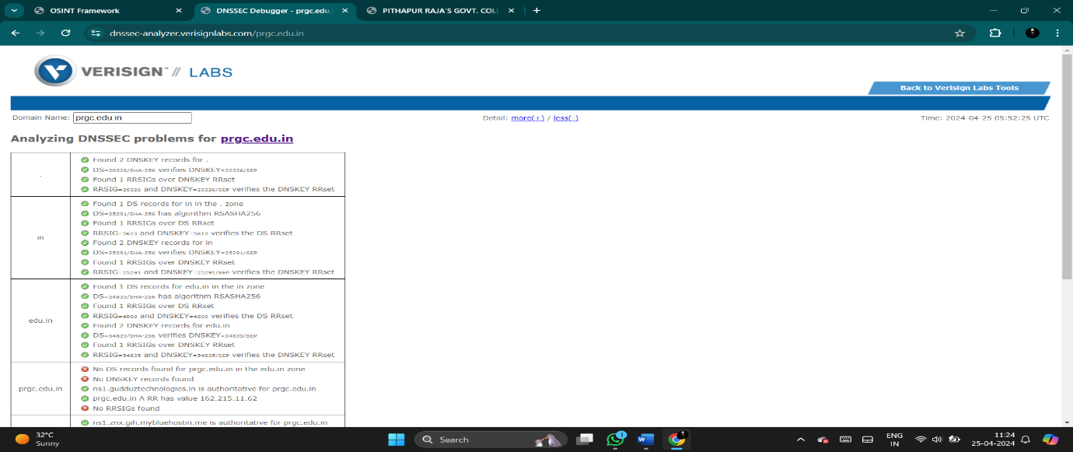

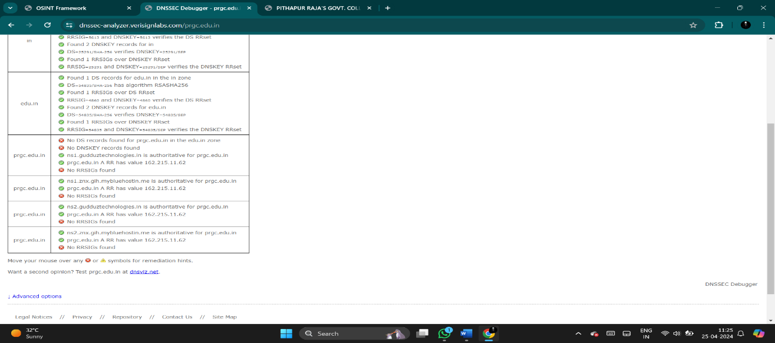

Now open the geolocation on OSINT website then click on geolocation

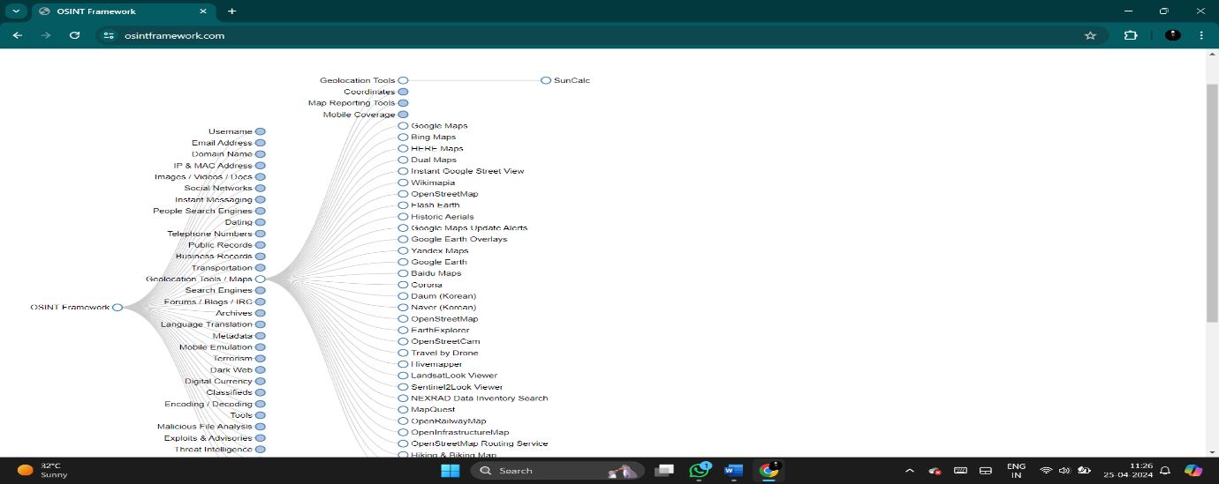

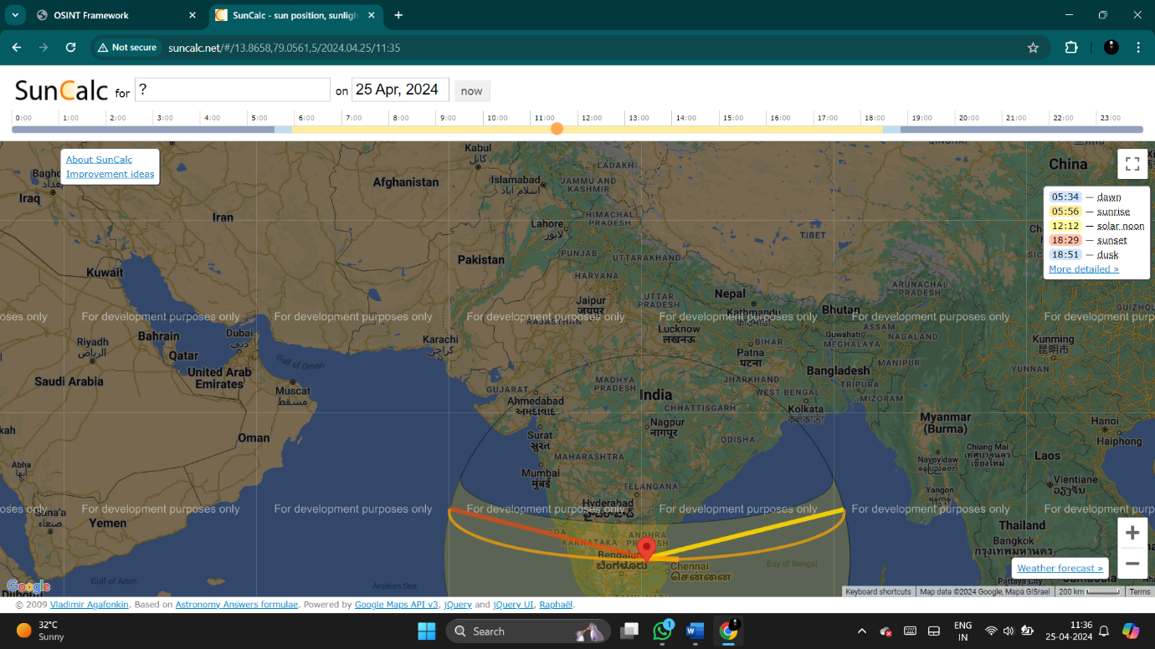

**Now open the threat intelligence then click on any website and gather the information**

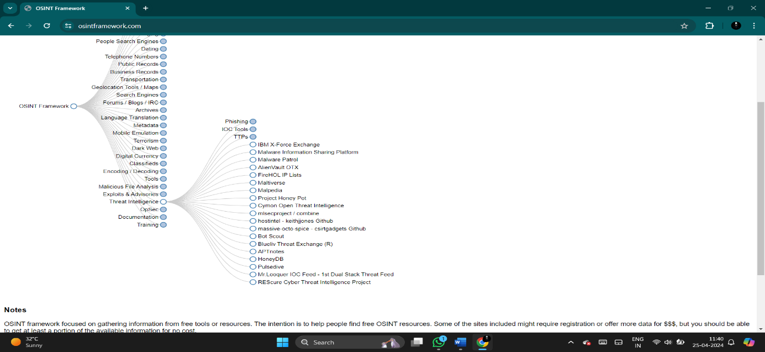

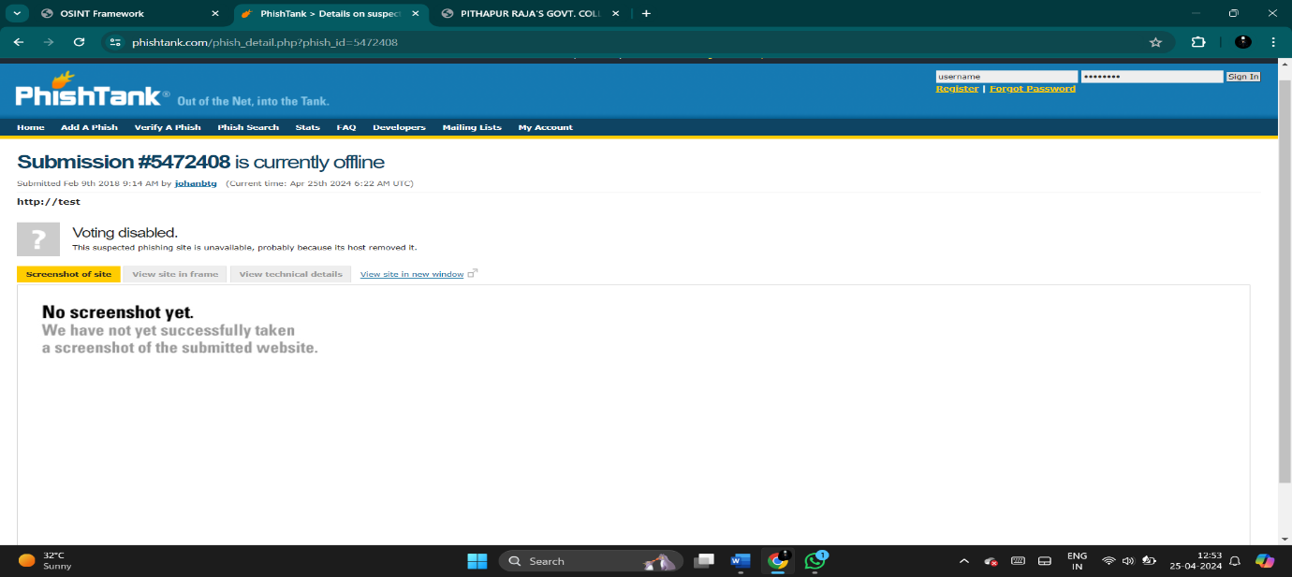

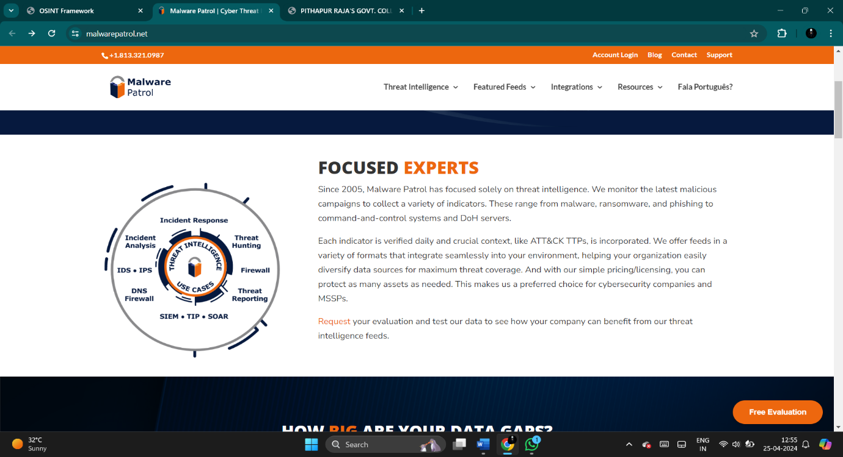

**These is all about of Conducting domain and DNS analysis**

**EXTRACTING INTELLIGENCE FROM DARK WEB SOURCES**

**The dark web is a part of the internet that is not indexed by traditional search engines and requires special software, configurations, or authorization to access. It's often associated with illicit activities due to its anonymity features, making it a haven for cybercriminals, hackers, and other malicious actors. From a cybersecurity perspective, understanding the dark web is crucial as it houses various threats, vulnerabilities, and valuable intelligence that can impact organizational security.**

**In the context of Open Source Intelligence (OSINT) frameworks, the dark web presents both challenges and opportunities. Here's how it fits into the OSINT framework:**

**Challenges:**

**Anonymity: Dark web users often operate under pseudonyms and take measures to conceal their identities, making it difficult to trace malicious activities back to their source.**

**Illicit Activities: The dark web hosts marketplaces for illegal goods and services, including drugs, weapons, stolen data, and hacking tools. This presents a significant challenge for law enforcement and cybersecurity professionals.**

**Encryption: Communications on the dark web are often encrypted, making it challenging to intercept and analyze data for intelligence purposes.**

**Lack of Regulation: The dark web operates beyond the reach of traditional regulations, allowing malicious actors to conduct activities with relative impunity.**

**Opportunities:**

**Threat Intelligence: Monitoring the dark web can provide valuable insights into emerging threats, vulnerabilities, and attack techniques. This intelligence can help organizations proactively defend against cyber threats.**

**Data Breach Detection: Stolen data often surfaces on the dark web for sale or distribution. Monitoring dark web forums and marketplaces can help organizations identify if their data has been compromised and take appropriate action.**

**Investigative Purposes: Law enforcement agencies leverage the dark web for investigations related to cybercrime, terrorism, and other illicit activities. OSINT frameworks can aid in gathering intelligence from these sources.**

**Incorporating the dark web into an OSINT framework requires specialized tools, techniques, and expertise. It involves deep web crawling, monitoring forums and marketplaces, analyzing cryptocurrency transactions, and collaborating with law enforcement agencies and other organizations involved in cybersecurity intelligence.**

**Now open the OSINT framework website and click on the dark web then open it on that website to get information**

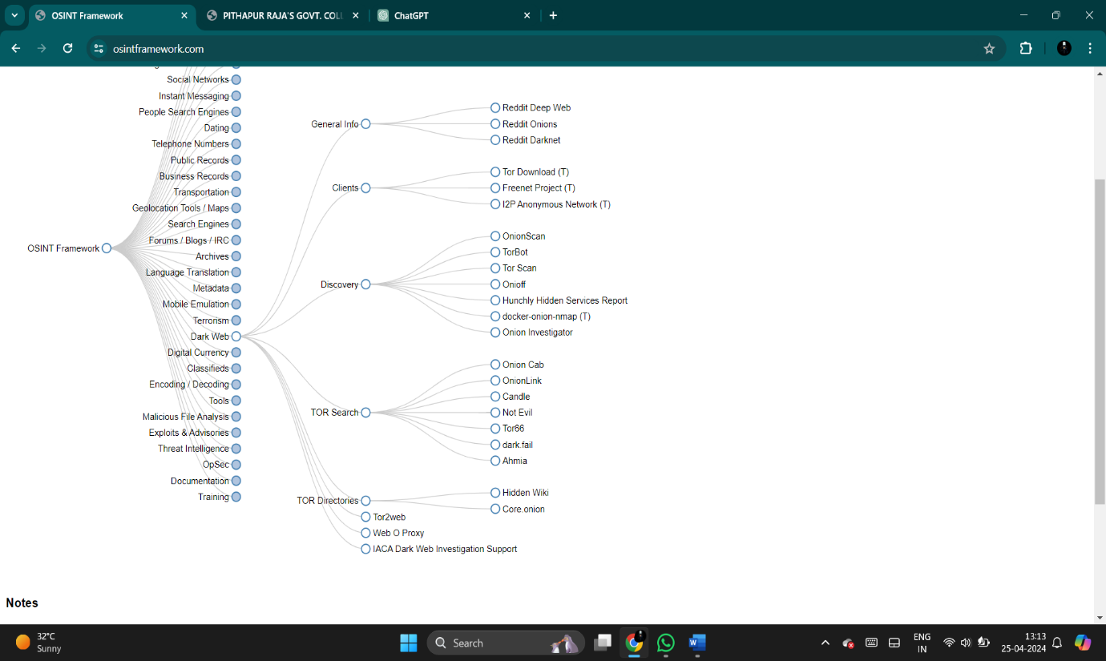

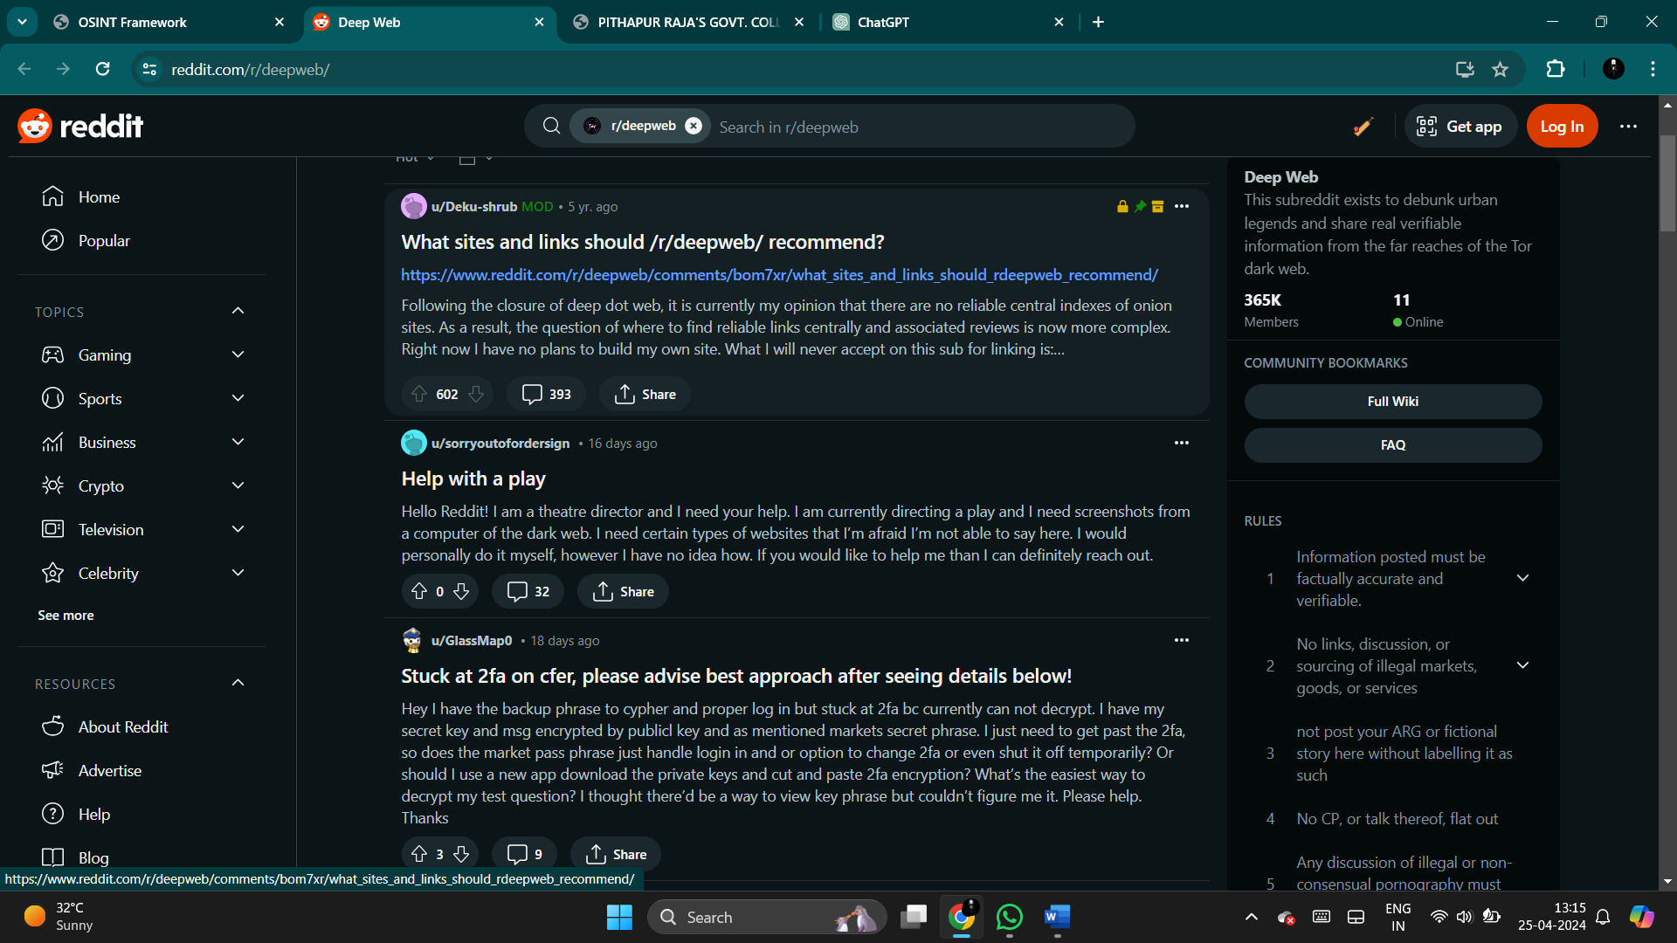

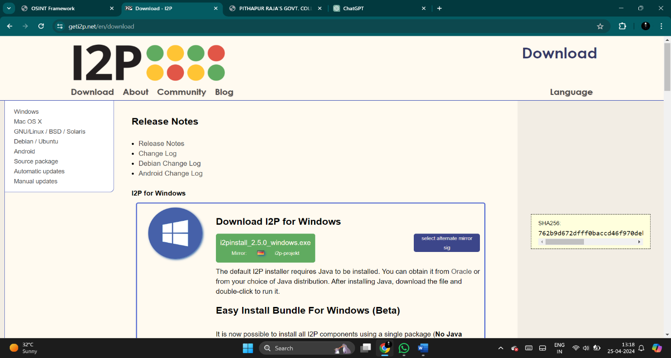

**Now can get information about dark web**

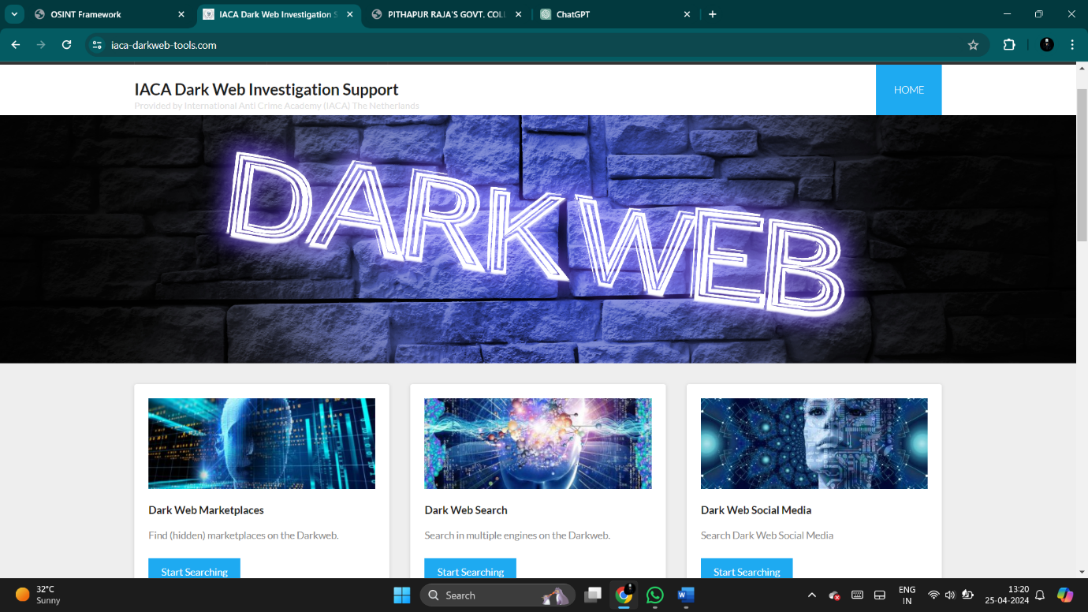

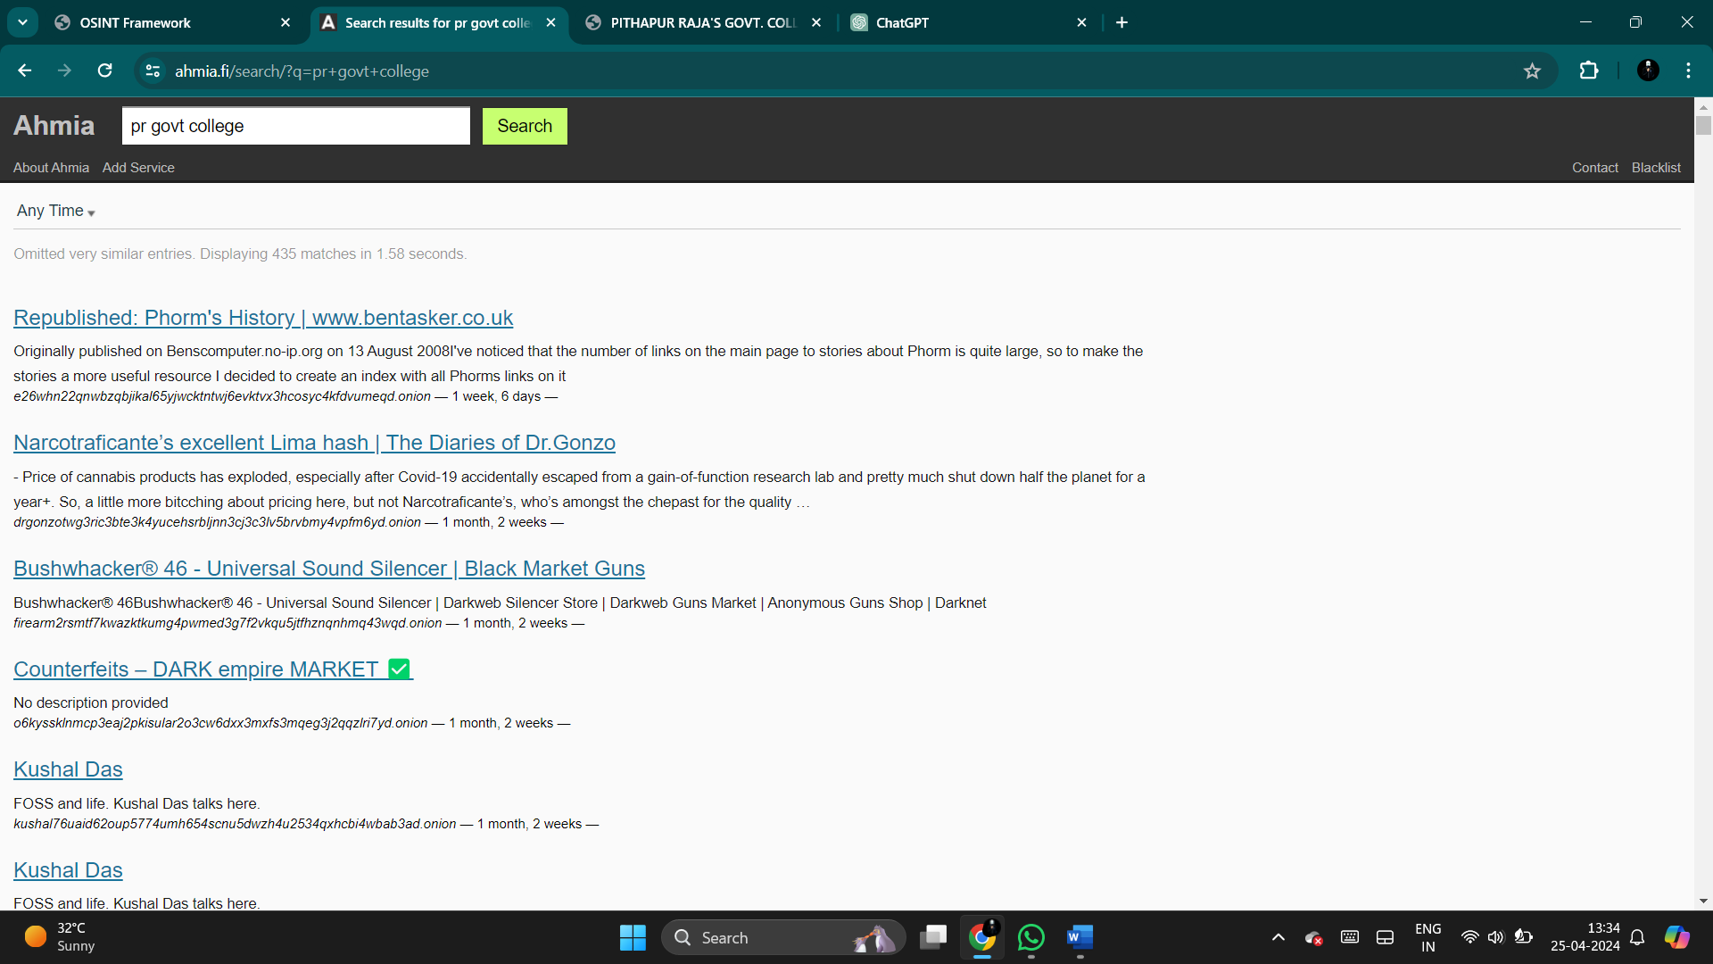

**These is all about of EXTRACTING INTELLIGENCE FROM DARK WEB SOURCES.**

**3.Advanced information gathering technique**

## Active scanning and enumeration

Active scanning and enumeration are crucial steps in the process of network reconnaissance and penetration testing.

Active scanning involves sending packets to target systems to gather information about them, such as open ports, services running on those ports, and potentially vulnerable software versions. This is often done using tools like Nmap or Nessus.

Enumeration, on the other hand, involves extracting more detailed information about the services and systems discovered during scanning. This could include usernames, groups, shares, and other resources that may be useful for further exploitation.

Both processes are essential for understanding the target environment and identifying potential vulnerabilities that could be exploited during a security assessment. However, it's important to

conduct these activities ethically and with appropriate permissions to avoid causing harm or violating laws and regulations.

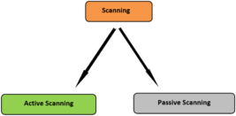

### Types of scanning :

There are several types of scanning used in network reconnaissance and security assessments:

Port Scanning:This involves scanning a range of IP addresses for open ports on target systems. Different techniques like TCP SYN, TCP Connect, and UDP scanning can be employed to identify open ports and services.

Service Scanning: Once open ports are identified, service scanning involves probing those ports to determine the specific services and their versions running on the target systems. This helps in understanding the potential vulnerabilities associated with those services.

Vulnerability Scanning: This type of scanning focuses on identifying vulnerabilities within the target systems or network devices. Vulnerability scanning tools like

Nessus, OpenVAS, and Qualys can automatically scan for known vulnerabilities and misconfigurations.

Operating System Fingerprinting: OS fingerprinting techniques are used to identify the operating system running on target machines. This information is valuable for understanding the target environment and selecting appropriate exploits.

Host Discovery: Host discovery techniques involve identifying active hosts on a network. This can be done using methods like ICMP echo requests (ping), ARP scanning, or TCP SYN scans.

Network Mapping: Network mapping involves creating a detailed map of the network topology, including devices, routers, switches, and their interconnections. Tools like Nmap and Netcat can be used for this purpose.

Each type of scanning serves a specific purpose in the reconnaissance process and helps in gaining a comprehensive understanding of the target environment's security posture.

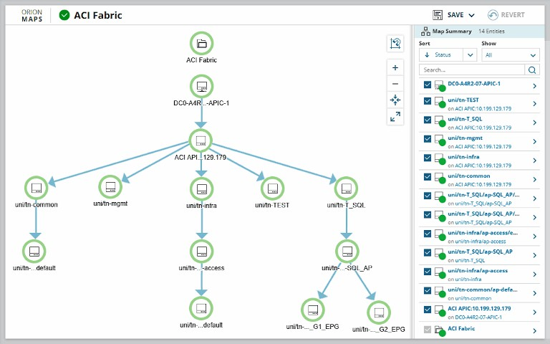

Enumeration is a critical phase in the information gathering process during network reconnaissance and security assessments. It involves extracting more detailed information about the target systems and services discovered through scanning.

During enumeration, security professionals aim to gather specific information such as:

Usernames: Enumerating user accounts on a system can provide valuable insights into potential attack vectors, such as weak passwords or privileged accounts.

Network Shares: Identifying shared resources on a network can reveal sensitive data or misconfigurations that could be exploited.

Group Memberships: Understanding group memberships can help attackers identify high-privilege accounts or potential targets for privilege escalation.

Service Versions and Configurations: Enumerating service versions and configurations helps in identifying known vulnerabilities that could be exploited.

System Information: Gathering information about the target system's operating system, hardware, and software can aid in selecting appropriate exploits and attack vectors.

Enumeration techniques can vary depending on the target environment and the information needed. Common enumeration methods include:

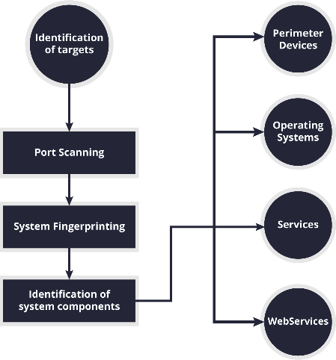information to identify potential vulnerabilities and plan targeted attacks effectively. However, it's important to conduct enumeration ethically and within the bounds of legal and ethical

guidelines

### Purpose of enumeration :

The purpose of enumeration is to list items or elements systematically, often for the purpose of counting, organizing, or categorizing them. It's commonly used in surveys, census-taking, and

data collection to gather information in an orderly manner.

Identify targets :In the context of enumeration, identifying targets involves determining the specific items, entities, or characteristics that need to be counted or classified. For example, in a population census, the targets could be individuals living in a particular area. In a survey about consumer preferences, the targets could be specific demographics or customer segments. The key is to clearly define what is being enumerated and then identify the targets accordingly to ensure accurate data collection.

Gathering information :Gathering information in enumeration involves systematically collecting data about the identified targets. This process typically includes designing surveys or questionnaires, conducting interviews or observations, and recording responses. The goal is to obtain accurate and comprehensive information about each target in order to analyze patterns, trends, or characteristics within the population being enumerated. Quality control measures are often implemented to ensure the reliability and validity of the collected data.

Finding vulnerabilities:Finding vulnerabilities involves identifying weaknesses or flaws in systems, processes, or structures that could be exploited to compromise security, cause harm, or disrupt operations. This could include weaknesses in software code, network configurations, physical security measures, or human behavior. Vulnerability assessments, penetration testing, and security audits are common methods used to uncover vulnerabilities and mitigate risks.

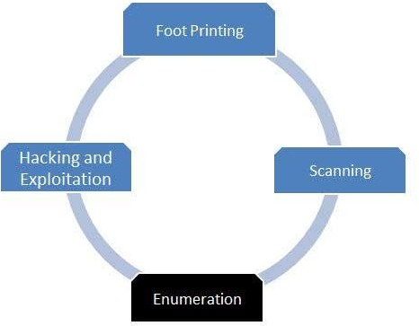

# Passive Reconnaissance and Footprinting in Cybersecurity :

#### Introduction:

Passive reconnaissance and footprinting are foundational activities in the field of cybersecurity, serving as initial steps in the process of understanding and potentially exploiting a target's digital infrastructure. These techniques are used by cyber threat actors to gather intelligence about a target without directly engaging with it, providing crucial insights into an organization's digital presence, infrastructure, and potential vulnerabilities.

Passive reconnaissance techniques include:

Open Source Intelligence (OSINT): Collecting publicly available information from sources like social media, forums, and websites.

|  |
| --- |
| By employing these techniques, cybersecurity professionals and ethical hackers can gather valuable intelligence about target systems and networks without alerting the target to their presence. This information can then be used to identify potential vulnerabilities and plan further stages of security assessments or penetration testing engagements.  Network mapping : |

Network mapping involves the process of visualizing and documenting the layout of a computer network.

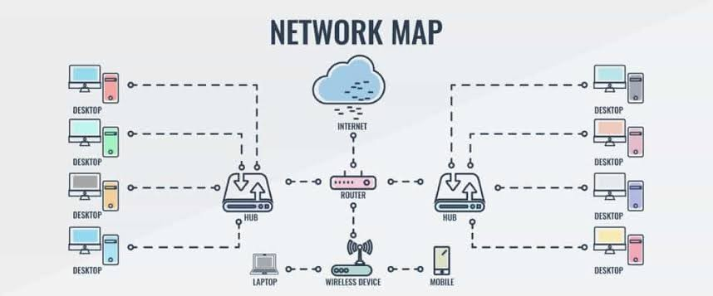

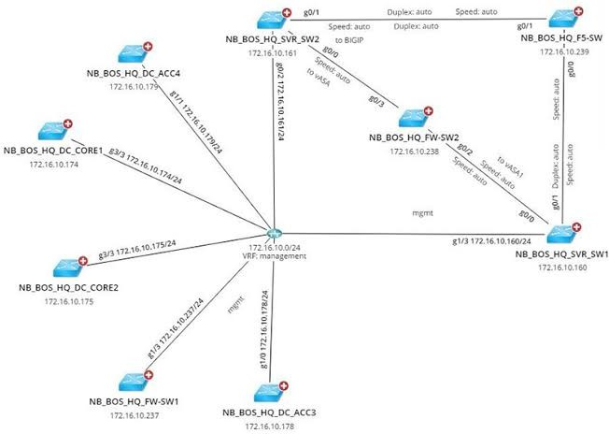

|  |
| --- |
| Overall, network mapping is a fundamental aspect of network management and cybersecurity. By creating accurate and comprehensive network maps, organizations can better understand their network infrastructure, identify potential vulnerabilities, and ensure efficient and secure network operations. |

Nmap Commands :

Nmap (Network Mapper) is a powerful open-source network scanning tool used for discovering hosts and services on a computer network, thus creating a "map" of the network. Here are some commonly used Nmap commands:

### Passive foot printing:

Passive footprinting is a reconnaissance technique used to gather information about a target network or system without directly interacting with it. Unlike active footprinting, which involves

sending probes or queries to the target, passive footprinting relies on publicly available information and passive observation of network traffic to gather data.

Passive footprinting techniques may include:

Open Source Intelligence (OSINT): Gathering information from publicly available sources such as social media, websites, public databases, and online forums.

Network Traffic Analysis: Monitoring and analyzing network traffic to identify devices, services, and potential vulnerabilities without directly interacting with them.

Domain Name System (DNS) Information Gathering: Collecting information about domain names, IP addresses, and network infrastructure through DNS queries and zone transfers.

Social Engineering: Gathering information through interactions with individuals or employees of the target organization, such as through phishing emails or phone calls.

Web Scraping: Extracting information from websites and web applications using automated tools or scripts.

Nmap:

Nmap (Network Mapper) is a powerful open-source network scanning tool used for discovering hosts and services on a computer network, thus creating a "map" of the network. Here are some commonly used Nmap commands:

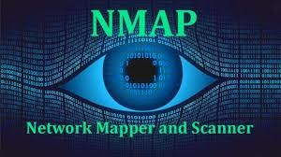

Basic Scan:

css

Copy code nmap [target]

This command performs a basic scan of the target, identifying open ports and services. Scan specific ports:

css

Copy code

nmap -p [port1,port2,...] [target]

This command scans specific ports on the target instead of scanning all ports. Scan multiple hosts:

css

Copy code

nmap [target1 target2 ...]

This command scans multiple hosts simultaneously. Scan a range of IP addresses:

css

Copy code

nmap [startIP-endIP]

This command scans a range of IP addresses. Scan all TCP ports:

css

Copy code

nmap -p- [target]

This command scans all 65535 TCP ports on the target. Scan all UDP ports:

css

Copy code

nmap -sU [target]

This command scans for UDP ports on the target. OS detection:

css

Copy code

nmap -O [target]

This command attempts to determine the operating system of the target. Service version detection:

css

Copy code

nmap -sV [target]

This command detects the version of services running on open ports. Aggressive scan:

css

Copy code

nmap -A [target]

This command enables OS detection, version detection, script scanning, and traceroute. Verbose output:

css

Copy code

This command produces verbose output, providing more detailed information during the scan.

These are just a few examples of Nmap commands. Nmap offers a wide range of options and features for network scanning and reconnaissance. Be sure to use it responsibly and with proper authorization, as unauthorized scanning can be illegal and unethical.

|  |
| --- |
| This command attempts to determine the operating system of the target host based on various network characteristics. |
|  |

|  |
| --- |
| These are just a few examples of common Nmap commands. Nmap offers many more options and advanced features for network scanning and reconnaissance. You can explore additional options and customize your scans based on specific requirements and objectives. Always ensure that you have proper authorization before scanning any network or system that you do not own or manage. |

Footprinting:

|  |
| --- |
| Footprinting, also known as reconnaissance, is the initial phase of the hacking process in which an attacker gathers as much information as possible about a target network or system. This information is crucial for planning further attacks and exploiting vulnerabilities effectively. Footprinting can be divided into two main categories: passive and active.  Passive footprinting involves gathering information about the target without directly interacting with it. This typically includes collecting data from publicly available sources such as: |

## Network mapping

Network mapping involves the process of visualizing and documenting the layout of a computer network. It typically includes the physical and logical connections between devices, such as routers, switches, servers, and endpoints, to help understand the network topology and identify potential vulnerabilities or optimization opportunities. There are various tools and techniques available for network mapping, ranging from manual documentation to automated discovery tools.

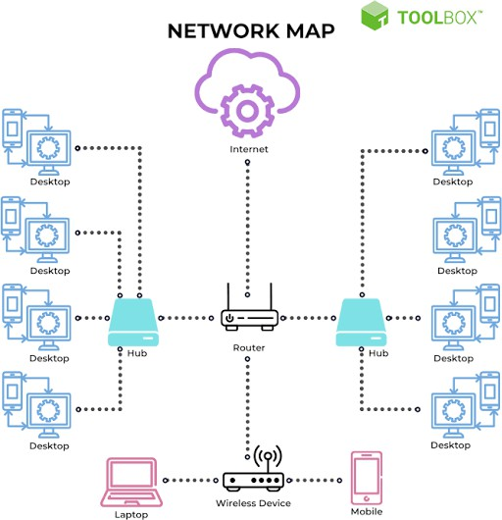Network mapping is the process of creating a visual representd

entation of a computer network's infrastructure. It involves identifying all devices, connections, and configurations within the network to understand its layout and functionality better. This mapping can be done manually or with the help of specialized software tools that automate the discovery and documentation process. The resulting map helps network administrators troubleshoot issues, plan upgrades, and ensure optimal performance and security.

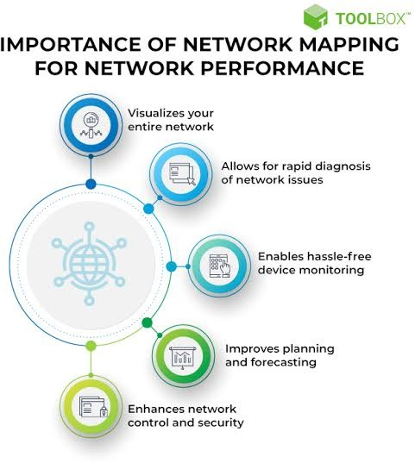

There are several types of network mapping techniques, including:

Physical Mapping: This involves documenting the physical layout of network devices, such as routers, switches, servers, and workstations, along with their physical connections.

Logical Mapping: Logical mapping focuses on documenting the logical connections and relationships between network devices, such as IP addresses, subnets, VLANs, and routing protocols.

Active Mapping: Active mapping techniques involve actively scanning the network to discover devices and map their connections. This can include techniques like ping sweeps, port scanning, and network discovery protocols like SNMP (Simple Network Management Protocol).

Passive Mapping: Passive mapping techniques involve observing network traffic to map out devices and connections. This can include techniques like packet sniffing and analyzing network logs.

Manual Mapping: Manual mapping involves physically inspecting the network and documenting its layout and connections by hand.

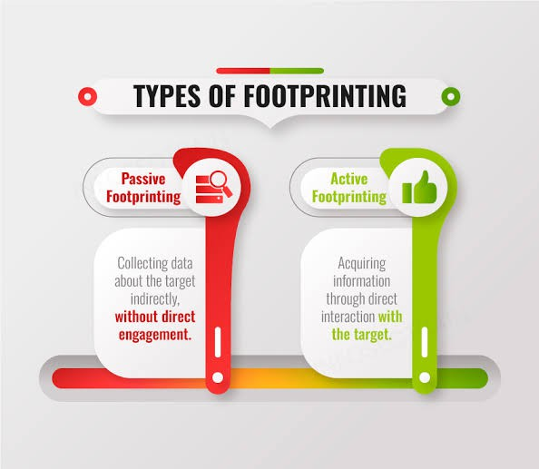

Passive footprinting techniques may include:

Open Source Intelligence (OSINT): Gathering information from publicly available sources such as social media, websites, public databases, and online forums.

Network Traffic Analysis: Monitoring and analyzing network traffic to identify devices, services, and potential vulnerabilities without directly interacting with them.

Domain Name System (DNS) Information Gathering: Collecting information about domain names, IP addresses, and network infrastructure through DNS queries and zone transfers.

Social Engineering: Gathering information through interactions with individuals or employees of the target organization, such as through phishing emails or phone calls.

Web Scraping: Extracting information from websites and web applications using automated tools or scripts.

scanning for vulnerabilities, intercepting and modifying HTTP requests, and analyses the security of web applications. It is known for its user-friendly interface and powerful features, making it a valuable tool for identifying and mitigating security risks in web applications.

## Utilizing Automated Information Gathering Tools :

|  |
| --- |
| Automated information gathering tools are essential for streamlining the footprinting process in cybersecurity and penetration testing. These tools help gather data about target systems, networks, and organizations efficiently and comprehensively. Here are some commonly used automated information gathering tools:    Maltego is a powerful open-source intelligence (OSINT) tool that enables users  to gather and correlate information about targets from various public sources, including social media, websites, DNS records, and more. It visualizes the relationships between |

different entities, such as domain names, IP addresses, email addresses, and people, to provide a holistic view of the target's digital footprint.



theHarvester is a command-line tool used for passive reconnaissance and OSINT gathering. It allows users to gather email addresses, subdomains, hostnames, and other information from search engines, public databases, and popular services like LinkedIn, Shodan, and PGP key servers. The tool is particularly useful for discovering potential attack vectors and targets.

Recon-ng is a full-featured reconnaissance framework that automates the process of gathering information from various sources, including search engines, social media platforms, public databases, and APIs. It provides a modular and extensible architecture, allowing users to customize and extend its functionality through the use of modules and plugins.

While Nmap is primarily known as a network scanning tool, it also offers features for information gathering and footprinting. Nmap can be used to scan for open ports, detect services running on target systems, and perform service version detection. It's a versatile tool for both passive and active reconnaissance.

Metasploit is a penetration testing framework that includes modules for information gathering, vulnerability scanning, exploitation, and post- exploitation. It provides a wide range of automated tools and exploits for discovering vulnerabilities in target systems and networks.

SpiderFoot is an open-source OSINT automation tool that gathers information about target domains, IP addresses, email addresses, and other entities from various online sources. It automatically correlates and analyzes the collected data to provide actionable intelligence for cybersecurity professionals.

|  |
| --- |
| Utilizing automated information gathering tools can significantly speed up the reconnaissance process and provide valuable insights into target systems, networks, and organizations. However, it's essential to use these tools responsibly and ethically, ensuring compliance with legal and ethical guidelines, and obtaining proper authorization before conducting any reconnaissance activities. |

Let us discuss about some of the information gathering tools :

* OSINT
* Network Scanners
* Vulnerability Scanners

|  |
| --- |
| Nessus is one of the most popular vulnerability scanners, known for its comprehensive vulnerability database and extensive scanning capabilities. It can scan networks, servers, endpoints, and web applications for known vulnerabilities, misconfigurations, and security issues. Nessus provides detailed reports and remediation recommendations for addressing identified vulnerabilities. |
| OSINT |
| OSINT stands for Open Source Intelligence, referring to the process of collecting and analyzing information from publicly available sources to gather insights and intelligence about a target. These sources include websites, social media platforms,  news articles, public records, government documents, and other publicly accessible data.  Social media platforms like Twitter, Facebook, LinkedIn, Instagram, and others are rich sources of information about individuals, organizations, events, and trends. OSINT analysts can gather data such as user profiles, posts, photos, connections, and interactions to build profiles and understand behavior patterns.  Websites contain valuable information about businesses, products, services, personnel, and operations. OSINT analysts can extract data from websites using web scraping techniques to gather data such as contact information, company  profiles, job postings, and news articles. |
|  |

|  |
| --- |
| Government agencies, regulatory bodies, and public databases maintain records related to property ownership, business registrations, court proceedings, licenses, permits, and other legal documents. OSINT analysts can access these records to gather information about individuals, businesses, and assets.  Online forums, discussion boards, and community platforms host discussions, Q&A sessions, and knowledge sharing on various topics.    OSINT analysts can monitor these platforms to gather insights, opinions, trends, and expertise related to specific subjects or industries. |

Network Scanners

|  |
| --- |
| Network scanners are tools used to identify active hosts, open ports, services running on those ports, and other characteristics of networked devices within a network. They are crucial for network administrators, security professionals, and penetration testers to assess the security posture of their networks and identify potential vulnerabilities. Here are some commonly used network scanners |



Wireshark is a popular network protocol analyzer that can capture and analyze network traffic in real-time. While not a traditional network scanner, Wireshark can be used to inspect network packets and identify hosts, services, and protocols running on the network. It is particularly useful for troubleshooting network issues and analyzing network communication.

|  |
| --- |
| OpenVAS (Open Vulnerability Assessment System) includes network scanning capabilities as part of its vulnerability management platform. It can perform comprehensive vulnerability scans to identify security weaknesses, misconfigurations, and potential vulnerabilities in networked devices, services, and applications.  These are just a few examples of network scanners available, each with its strengths, weaknesses, and specific use cases. Network scanners play a crucial role in maintaining    network security, identifying vulnerabilities, and ensuring the integrity of networked systems and services.  Methodology Of Doing Information Gathering :  Information gathering, also known as reconnaissance or OSINT (Open Source Intelligence), is a crucial phase in cybersecurity, penetration testing, threat intelligence, and various investigative activities. A systematic methodology helps ensure thorough and effective information gathering.  Clearly define the objectives of the information gathering process. |
|  |
| Identify the target(s) of the information gathering operation. This could be an organization, individual, network, website, or specific topic of interest. |



Begin with passive reconnaissance, which involves gathering information from publicly available sources without directly interacting with the target. This could include:

* Scanning target networks using tools like Nmap or masscan to identify open ports, services, and operating systems.
* Performing DNS enumeration to discover subdomains and associated IP addresses.
* Using vulnerability scanners to identify potential security weaknesses.
* Conducting social engineering attacks or phishing campaigns to gather information from employees or stakeholders.

If necessary and within legal boundaries, conduct active reconnaissance to gather more detailed information about the target. This could involve:

## Conducting Targeted Reconnaissance Operations :

#### Introduction :

Targeted reconnaissance operations are a crucial initial step in many cybersecurity engagements. They involve the systematic gathering of information about a specific target to identify vulnerabilities, potential attack vectors, and overall security posture. This document provides an overview of the key steps involved in conducting targeted reconnaissance operations.

|  |
| --- |
|  |
| Clearly define the objectives of the targeted reconnaissance operation. Determine what specific information is needed about the target and the scope of the investigation. This could include identifying vulnerabilities,  gathering intelligence on assets, or assessing the target's security posture. |
|  |
| Identify the target(s) of the reconnaissance operation. This could be an organization, individual, network, website, or specific assets of interest. Understand |

|  |  |
| --- | --- |
|  | the target's environment, infrastructure, and potential attack surface to tailor the reconnaissance approach accordingly. |
|  |
| Begin with passive reconnaissance techniques to gather  information from publicly available sources without directly interacting with the target. This could include: |
|  |
| If necessary and within legal boundaries, conduct active  reconnaissance techniques to gather more detailed information about the target. This could involve: |
|  | |
|  |  |
| Nmap:  Nmap, short for "Network Mapper," is a powerful open-source tool used for network exploration and security auditing. It's one of the most widely used network scanning tools due to its versatility, speed, and extensive feature set. Nmap can be used for various purposes, including network inventory, vulnerability assessment, and penetration testing. Here are some key features and capabilities of Nmap:  Nmap can perform host discovery to identify active hosts on a network.  It sends ICMP echo requests, TCP SYN packets, and other probes to determine which hosts are online and responsive. |
|  |
| Nmap can scan for open ports on target hosts to identify running  services and potential entry points for exploitation. It supports various scan types, including: |
|  |
| Nmap supports advanced scanning techniques and options for optimizing scan speed, evading intrusion detection systems (IDS), and bypassing firewalls. These techniques include timing options, decoy scanning, and fragmentation.  Nmap is a versatile and flexible tool that can be used for a wide range of network exploration and security assessment tasks. However, it's essential to use Nmap responsibly and within legal boundaries, obtaining proper authorization before scanning any network or system that you do not own or manage. |

:

##### Uses Of WHOIS :

* Domain Information : Retrieve details about a domain name's

registration.

* IP Address Ownership : Identify the owner of an IP address.
* Network Administration : Contact network administrators for troubleshooting or abuse reports.
* Investigative Research : Gather information for cybersecurity investigations and intelligence gathering.
* Domain Availability : Check the availability of a domain name for registration.

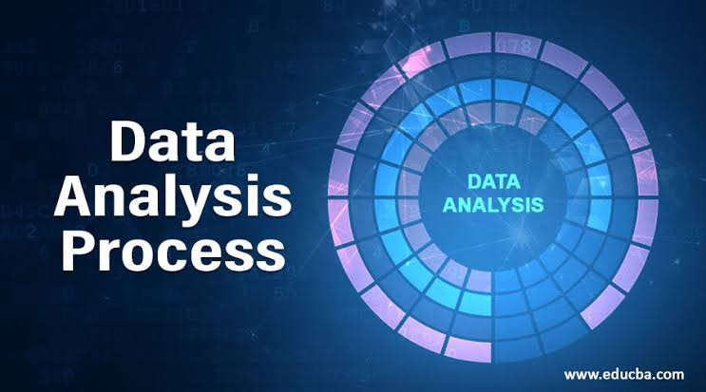

### Gather Information :

Execute your selected tools and techniques to gather information about the target. This may include:

❖ IP Addresses And Domain Information : Identify the target's IP addresses and associated services and Gather information about the target's domain registration and DNS records.

Example :

1. mxToolBox.com

##### Nslookup.io :

❖ Open Ports : Identify open ports and services running on them.

|  |
| --- |
| Analyze and Interpret Data: |
| Analyzing and interpreting data gathered from reconnaissance or scanning activities, such as those conducted using Nmap, is a critical step in understanding the security posture of a network and identifying potential vulnerabilities. Here's how to approach the analysis and interpretation of Nmap scan results.  Start by reviewing the output of the Nmap scan carefully. Depending on the options used during the scan, the output may include information about discovered hosts, open ports, running services, service versions, and potentially  detected operating systems. |
|  |
| Determine which hosts are active on the network based on the  scan results. Active hosts are those that responded to Nmap probes and are likely reachable and accessible for further analysis. |
|  |

|  |
| --- |
| If Nmap attempted operating system detection during the scan, analyze the results to determine the likely operating systems running on the target hosts. This information helps tailor further analysis and prioritize vulnerabilities based on the target's OS.  Based on the identified open ports, services, and operating systems, assess the potential vulnerabilities present on the network. Look for known vulnerabilities associated with specific services or configurations and prioritize them based on severity and potential impact.  By following these steps, cybersecurity professionals and network administrators can effectively analyze and interpret Nmap scan results to identify potential vulnerabilities and take proactive |

# Extraction of Meta Data and Exif Data from Files and

Documents :

|  |
| --- |
| Extracting metadata and Exif (Exchangeable Image File Format) data from files and documents can provide valuable insights into their origin, creation, and history. Here's how you can extract metadata and Exif data from various types of files: |

#### Let Us discuss how meta data can reveal information about this creation ,modification and authorship ,providing insights into potential threat actors and their activities

|  |  |
| --- | --- |
|  | |
|  | * ExifToolGUI is a graphical frontend for ExifTool that provides a user-friendly interface for viewing and editing metadata. It allows you to browse files, select specific   metadata fields, and extract metadata from multiple files at once. |
|  | |
|  | |

|  |  |
| --- | --- |
|  | * MetadataExtractor is a Java library and command-line tool specifically designed for extracting Exif data from image files. It supports a wide   range of image formats and provides detailed metadata information. |
|  | |
|  | |
|  | |
|  | * This online tool allows you to upload an image file and view its Exif metadata in a user-friendly format. It provides information such as camera settings, GPS coordinates, timestamps, and more. * Phil Harvey, the creator of ExifTool, offers a web service that allows you to upload files and extract metadata using ExifTool's capabilities. This can be   useful if you don't want to install ExifTool locally. |
| ExifRead is a Python library for reading Exif metadata from image files. It provides a simple API for extracting metadata fields such as camera make and model, GPS coordinates, and timestamps. | |
|  | * PyPDF2 is a Python library for working with PDF files. While it doesn't directly extract metadata, you can use it to parse PDF documents and   extract metadata stored in the document properties. |
|  | |
|  | |
|  | * Many document editing applications, such as Microsoft Office, Adobe Acrobat, and LibreOffice, allow you to view and edit document properties, including metadata such as author,title, and creation date. You can access these properties through the application's   user interface. |
|  | |

|  |  |
| --- | --- |
| Metadata can indeed provide valuable insights into the creation, modification, and authorship of files and documents, which can help in identifying potential threat actors and their activities. Here's how metadata can reveal such information: | |
|  | |
|  | * Some file formats, such as Microsoft Office documents and PDF files, include metadata   fields that store information about the document's author or creator. This information may include usernames, email addresses, or other identifying information. |
|  | |

Methods of Extraction :

|  |
| --- |
| There are various methods for extracting metadata from files and documents, depending on the file type, the tools available, and the user's preferences. Here are some common methods of extraction: |

|  |  |
| --- | --- |
|  | |
|  | |
|  | |
|  | * ExifTool is a versatile command-line tool that supports extracting metadata from a wide range of file types, including images, documents, audio files, and more. It can be used with specific command-line options to extract metadata fields of interest from files. * PDFtk (PDF Toolkit) is a command-line tool for working with PDF files. It can extract metadata from PDF documents, including document properties such as author, title, subject, and keywords.  * ​ |
|  | |
|  | |
|  | * ExifToolGUI is a graphical frontend for ExifTool that provides a user-friendly interface for viewing and extracting metadata from files. It allows users to browse files, select specific metadata fields, and extract metadata from multiple files at once.  * There are several GUI-based PDF metadata   editors available that allow users to view and edit metadata in PDF documents. Some of these tools also include options for extracting metadata from PDF files. |
|  | |

|  |
| --- |
|  |
| 1. ANALYSIS AND PROCESSING OF GATHERED   INFORMATION  The analysis and processing of gathered information are critical steps in the threat intelligence lifecycle, enabling cybersecurity professional to extract actionable insights from raw data and make informed decisions to protect their organizations against cyber threats. Furthermore, processing gathered information involves transformation raw data into actionable intelligence by enriching it with additional context, such as threat actor attribution, attack methodologies, and potential impact on the organization    PROCESSING AND ANALYZING COLLECTED DATA  Data analysis starts with identifying problem that can be  solved with data. Once you have identified this problem,  you can collect, clean, process, and analyze data. The process of analyzing this data is to identify trends, patterns, and meaning full insights, with the unlimited goal of solving the original problem. The term “data analysis” can be a bit misleading, as it can seemingly imply  that data analysis is a single step that’s only conducted once. In actuality, data analysis is an iterative process. And while this is obvious to any experienced data analyst, it’s important for aspiring data analysts, and those  who are interested in a career in data analysis, to understand this too. Want to learn more about the data analysis process and how it’s used? Then you’re in the right place. Below, we’ll tell you all about the data analysis  process, the different steps of the process, how data analysis is used, and how to do it the right way.  There is indeed a specific process for data analysis. Suppose you are looking to create the best recipe for pizza dough. You could frame your problem as a lack of knowledge—not having a sufficient pizza dough recipe. What data could help you solve this problem? One way would be to comb through the plethora of online recipes available. You could then sort  this data, filtering out recipes with low reviews or comments noting flaws in the recipe. Then, once you’ve collated the best recipes, you can begin to analyze them. What are the commonalities that emerge? Maybe you find that the best recipe depends on the style of pizza you want to make and that it’s best to group certain recipes together. The data analysis process won’t create the perfect pizza dough recipe for you, but it can get you headed in the right direction.This is arguably the most critical step, as it can set you up for success. The purpose is often defined as a business question or problem statement related to your organization’s goals. Examples include:  • Would customers respond positively to the launch of X product?  • What are some ways to reduce employee attrition?  • Will incorporating AI tools reduce production costs?  DATA COLLECTION :-  • Once you’ve defined the problem, then you can start collecting data.  Broadly speaking, there are three different categories of data, and the ones you use will depend on the nature of your problem. Most data  analysis problems require a combination of the three.  • First-party data is data that your own organization generates. Oftentimes, this is data about previous customer interactions that can be used to make accurate predictions about your customers’ behavior in the future.  • You could also use second-party data—data that’s generated by external sources, but is about your company specifically. This can include what customers are saying on social media platforms or review websites.  • Third-party data comes from groups like think tanks and government sources and is more concerned with the nature of your customer base, rather than a specific interaction that a customer has had with your company    .DATA CLEANING: -  Not all the data you collect will be useful or accurate, and you’ll need to discard the data points that are irrelevant, duplicated, inconsistent, or outdated.This is called data cleaning. When combining multiple sources of  data, you’ll likely wind up with duplicates and outliers. And when you’re dealing with millions of data points, as is often the case with data analysis, you can’t comb through each piece of data on your own to find the duplicates or outliers. Data analysts estimate that the time spent cleaning  data consumes about 70-90% of the data analysis process.  At this stage, you can also do an exploratory analysis, which is an initial and cursory data analysis. Exploratory data analysis will also assist with identifying other data points you may need.  DATA PROCESSING: -  Once you have all the relevant data, you can begin to process it. This entails organizing the data, sorting the data into relevant categories, and labeling them for easy organization. Now the data is prepped  for analysis.  DATA ANALYSIS: -  Data analysis can be done in numerous ways. One way is to use algorithms and mathematical models to manipulate data variables, which helps extract relevant information and valuable insights that tie into the problem defined in the first step.  ***Types of Data Analysis: -***  ➢ DESCRIPTIVE ANALYSIS  ➢ DIAGNOSTIC ANALYSIS  ➢ PREDICTIVE ANALYSIS  ➢ PRESERIPTIVE ANALYSIS  ➢ INFERENTIAL ANALYSIS    **DESCRIPTIVE ANALYSIS: -**  As the name suggests, descriptive analysis describes or summarizes the data and its characteristics. It doesn’t go beyond explaining what has happened. You use this type of data analysis to deliver a narrative of what has occurred. Descriptive statistics and analysis present scattered data into digestible pointers. You can also do a part of this at  the stage of exploratory data analysis.  **DIAGNOSTIC ANALYSIS: -**  With diagnostic analysis, you begin to focus on the “why,” and diagnose why something is occurring. At this stage, you are not looking for solutions or predictions. The goal is to understand the factors that are contributing to the problem. You use this technique when you want to go into issue identification mode.  **PREDICTIVE ANALYSIS**: -  Here’s where you start generating forecasts based on your data. Data analysts perform predictive analysis when they want to establish a situation in the future. This prediction helps stakeholders gauge business performance.  **PRESERIPTIVE ANALYSIS: -**  This kind of analysis brings together all of these data analysis techniques to offer recommendations. These form the basis of datadriven decisions..  **INFERENTIAL ANALYSIS:**  With diagnostic analysis, you begin to focus on the “why,” and diagnose why something is occurring. At this stage, you are not looking for solutions or predictions. The goal is to understand the factors that are contributing to the problem. You use this technique when you want to go into issue identification mode.  **PREDICTIVE ANALYSIS**: -  Here’s where you start generating forecasts based on your data. Data analysts perform predictive analysis when they want to establish a situation in the future. This prediction helps stakeholders gauge business performance.  **PRESERIPTIVE ANALYSIS: -**  This kind of analysis brings together all of these data analysis techniques to offer recommendations. These form the basis of datadriven decisions..  **INFERENTIAL ANALYSIS:**  With this technique, you derive conclusions based on the data you have collected and analyzed, such as, “lack of employee training is a cause of employee attrition” or “employee attrition affects customer satisfaction.    CORELATING INFORMATION FOR CONTEXTUAL  INSIGHTS  If you work with data regularly, you know context matters. As American writer Dan Simmons said, “Context is to data what water is to adolphin.” Essentially, data can’t survive without it. Context can be defined as the facts or circumstances that surround an event or situation. In the case ofdata, context represents the added details and setting that can help explain an observation or finding in the data. At each stage in the analytics process, you can see how context plays an instrumental role in shaping and enhancing data. For example, having  proper context is important in the data collection phase because you want to ensure you’re capturing the right data that aligns with your organization’sbusiness strategy. Without adequate context into how the data is going to be used, the data preparation phase will lack purpose and focus. During the analysis phase, if you don’t have adequate background information (domain  knowledge), it will be difficult to interpret and make sense of the numbers. When it comes to data storytelling, context is equally crucial.During the communication phase, putting your numbers in context will help them resonate more deeply with decision-makers. Tableau’s President/CEO Mark Nelson said, "Not everyone can speak the language of data, so you need to make data speak the language of everyone else. Putting data in context is the key to making it accessible." Unfortunately, for many people, ‘putting data in context’ simply means adding annotations to their data visualizations. While annotating your data charts can be helpful and make your information more accessible, context is  much more than just descriptive commentary. As American  novelist Michael Ventura said, “Without context, a piece of information is  just a dot. It floats in your brain with a lot of other dots and doesn't mean a damn thing. Knowledge is information-in-context -- connecting the dots.”if you use context properly, it can help your audience see the big picture and gain a richer appreciation of why your insight matters.Whenever you fail to properly contextualize your insights, you put them at risk of being misunderstood, overlooked, and ignored. While it’s generally accepted that it’s important to contextualize insights, I couldn’t find any defined tactics or strategies for doing so. In response to this need, I’ve  identified six ways in which you can add meaningful context to your insights and inspire audiences to act on each insight is unique and willrequire a slightly different form of context to enhance its meaning and significance. In some cases, you may discover that an insight may benefit from more than one approach. In addition, your intended audience may influence how much context is needed and which approach to use. I recommend exploring each of the following six context tactics in this guide and then prioritizing the approaches that are most appropriate for your  insight and audience. When it comes to data storytelling, context is equally crucial. During the communication phase, putting your numbers in context will help them resonate more deeply with decision-makers. Tableau’s President/CEO Mark Nelson said, "Not everyone can speak the language of data, so you need to make data speak the language of everyone else. Putting data in  context is the key to making it accessible.    "**1. COMPARATIVE: -**  Direct:  To add more perspective, it’s very common to share an item with other similar items. For example, you could compare the monthly sales of one product to those of other related products. With thisform of context, you can either emphasize how similar or dissimilar the item’s results are in comparison to those of the other items. In addition, you may compare the result to a goal/target or benchmark.  Indirect:  In some cases, you may want to compare items of different sizes. While  you can’t rely on a direct comparison of the absolute values, you can utilize an indirect comparison with a rate or ratio. For example, you could compare the win rate of a single salesperson with the average win rate for an entire sales team. Providing a benchmark can reveal meaningful parallels or discrepancies.  Relative:  It may be beneficial to show what portion a figure represents of a total or a whole amount. For example, you could clarify what percentage of total worldwide new hires occurred in a specific country. In this case, the relative context can highlight how significant or insignificant the portion is in relation to the whole.  **2. HISTORICAL: -**  Another crucial form of context is to show how something has performed over time. For example, in the case of product sales, there may be a variety of factors that contribute to differences between products (e.g., diverse  target markets, product life cycles, marketing activities, etc.).Rather than using an unfair comparison between two dissimilar products, it may be better to compare a product with its own past performance. With a historical perspective, you can stress how things have improved or degraded over time.  When you compare time periods, you’ll want to be mindful of potential seasonal effects or other cyclical behaviors that can skew the results for a particular time period. For example, it would be better to compare September’s results with those of the same month from the previous year. In addition, you want to avoid comparing partial time periods with  complete ones (e.g., month-to-date vs. past month).  3. SCALED (UP/DOWN): -  When you look at a value in terms of a single time period, it may not seem that meaningful in isolation. However, when you extrapolate out the combined effect over a longer timeframe, people gain a deeper appreciation of the item’s total positive or negative impact. For example, if you identified a way your company could save $50K in IT costs each month, it may not sound that significant. However, if you  aggregated the savings for a reasonable time horizon such as the next 12  months, the benefit becomes more significant ($600K).  In reverse, if you already have a large figure for a longer time duration, you may consider breaking its impact down for a shorter time period. Instead of only emphasizing the annual benefit of a new program, it may be helpful to isolate what the monthly or weekly gains could be. Smaller amounts for shorter timeframes may be more relatable for your audience.  **4. INFORMATIONAL: -**  Another major source of context comes from the situational information surrounding a pattern, trend, or anomaly. A variety of events may have coincided or potentially contributed to your finding. The audience can gain a richer perspective by understanding the circumstantial details.This background information could include *internal factors* that overlapped  with the result. For example, a spike in product sales may have coincided with a promotional discount, the increased availability of inventory, or thelaunch of a new product. In addition, *external factors* could also be flagged as being potentially influential. For example, the same sales increase could be tied to a competitor’s product recall announcement, a favorable review by a major influencer, or new government regulations.  With informational context, you must be careful to not assume or imply correlation means causation as there may or may not be a causal  relationship between the two events.  **5. EQUIVALENT: -**  A result may be hard to comprehend for audiences because it’s unfamiliar or unrelatable. For example, the metric in question may be less common, or the size of the number may be beyond the typical levels that people are accustomed to seeing. To help them understand the data, you may need to bridge the information gap with an equivalent example that’s more recognizable or approachable.  When Apple launched the iPod in 2001, its marketing campaign didn’t focus on the device’s enhanced storage capacity (5 GB). Instead, Apple’s CEO Steve Jobs positioned the device as “1,000 songs in your pocket”, which is a more consumer-friendly approach.  In the case of very large or small figures, it can be hard for people to fathom the magnitude or smallness of the numbers. For example,  Mariana Trench is the deepest point in the ocean at 36,201 feet (11,034 meters). By simply converting the unit of measurement from feet to miles (or kilometers), you make the depth more relatable (6.8 miles or 11 km). However, if you happened to be sharing this information with an audience in New York, you could highlight the Mariana Trench’s depth is the same distance as that between the Empire State Building and YankeeStadium.  **6. CONFIRMATIVE: -**  In some cases, you may anticipate a figure will be hard to believe or accept because it is a significant anomaly or outlier. Rather than letting your audience question or dismiss the finding, you may need to provide confirmative context so the audience can better understand why it is reliable and accurate. Several factors can influence the perception of how credible a finding is. An audience’s trust in a statistic can be enhanced or eroded by its source, data collection methodology, freshness, and other factors. If you anticipate questions or concerns about a number (“that sounds too good to be true”), you may need to highlight how it was verified or validated to ensure it is viewed as being credible    IDENTIFYING PATTERNS AND TRENDS IN TREAT DATA  echnical analysis is a method of analyzing marking data to identify trends, patterns, signals, that can help make informed designs. TA uses various tools and technology and to interpret prize and movements, volume, the indicators and char patterns   1. **TREND ANALYSIS: -**A trend is the general direction of the market or a specific asset over a period of time. Trend analysis is the process of identifying and following he trend using various methods, such as trend lines, moving averages, and trend indicators. Trend lines are straight lines drawn on a chart to connect the highs or lows of the price. Moving averages are smoothed lines that show the average price over a certain number of periods. Trend indicators are mathematical formulas that measure the strength, direction, and duration of the trend. Some examples of trend indicators are the average directional index (ADX), the moving average convergence divergence (MACD), and the relative strength index (RSI).   **2.PATTERN RECOGNITION: -**A pattern is a recognizable shape or formation on a chart that indicates a potential future price movement. Pattern recognition is the process of identifying and analyzing these patterns using various methods, such as support and resistance levels, candlestick patterns, and chart patterns. Support and resistance levels are horizontal or diagonal lines that indicate where the price tends to bounce or break. Candlestick patterns are combinations of one or more candlesticks that show the sentiment and behavior of the market participants. Chart patterns are geometric shapes hat form on a chart and signal a continuation or reversal of the trend. Some examples of chart patterns are triangles, wedges, flags, and head and shoulders.  **3. SIGNAL GENERATION: -**A signal is a specific event or condition on a chart that triggers a trading action, such as entering or exiting a position. Signal generation is the rocess of finding and executing these signals using various methods, such as trend following, breakout, and crossover strategies. Trend following strategies are based on following the direction of the trend and using ndicators or patterns to confirm the trend. Breakout strategies are based on identifying and trading the breakouts of support and resistance levels or chart patterns. Crossover strategies are based on using two or more indicators or moving averages and trading the crossovers of these lines. ome examples of crossover strategies are the golden cross, the death cross, and the MACD crossover.   1. **TA BEST PRACTICES: -**o identify trends, patterns, and signals in market data using TA, you need follow some best practices, such as choosing the right time frame, using multiple tools and techniques, and applying risk management. Choosing the ght time frame means selecting the chart interval that matches your ading style and objectives. Using multiple tools and techniques means ombining different methods of TA to confirm and enhance your analysis. pplying risk management means setting your entry, exit, and stop-loss oints, as well as managing your position size and portfolio diversification.A is a powerful and flexible method of analyzing market data to identify ends, patterns, and signals. By following these best ways and practices, ou can improve your trading performance and confidence.   **TRENDS: -**n technical analysis, trends are identified by trendlines or price action that highlight when the price is making higher swing highs and higher swing lows for an uptrend, or lower swing lows and lower swing highs for a downtrend. The three basic types of trends are up, down, and sideways.An uptrend is marked by an overall increase in price. Nothing moves straight up for long, so there will always be oscillations, but the overall direction needs to be higher.A downtrend occurs when the price of an asset moves lower over a period of time. While the price may move intermittently higher or lower, downtrends are characterized by lower peaks and lower troughs over time.Trends may be discovered in the short, medium, and long term. Generally, investors take positions in assets that will be profitable as long as the urrent trend continues. Taking positions that profit only if a trend reverses is riskier. Analysts use trendlines and channels, which are essentially boundaries for price fluctuations, in an attempt to spot and define trends. Upward trends are characterized by an asset price hitting a series of higher highs and higher lows, while downward trends are marked by lower highs and lower lows. Most traders trade in the direction of the trend. Traders who go opposite the trend are called contrarian investors.  **PATTERNS: -**A pattern is a series of data that repeats in a recognizable way. It can be identified in the history of the asset being evaluated or other assets with similar characteristics. Patterns often include the study of sale volume, as well as price. Patterns can occur within a downward or upward trend, or they can mark the beginning of a new trend.atterns are the distinctive formations created by the movements of securityprices on a chart. A pattern is identified by a line that connects common price points, such as closing prices or highs or lows, during a specific eriod of time. Chartists seek to identify patterns as a way to anticipate the future direction of a security’s price.here are bottoming, topping, and continuation patterns. A "follow-through day" pattern is an example of a pattern used by some analysts to identify market bottoms. The "head-and-shoulders" topping pattern is popular mong day and swing traders, while continuation patterns include the "cupand-handle," "flat base," and "three weeks tight."The trend is your friend" is a common catchphrase among technical analysts. A trend can often be found by establishing a line chart. A trendline is the line formed between a high and a low. If that line is going up, the trend is up. If the trendline is sloping downward, the trend is down. Trendlines are the foundation for most chart patterns.Investopedia does not provide tax, investment, or financial services and advice. The information is presented without consideration of the investment objectives, risk tolerance, or financial circumstances of any specific investor and might not be suitable for all investors. Investing involves risk, including the possible loss of principal.  **UNDERSTANDING TREND ANALYSIS: -**Trend analysis tries to predict a trend, such as a bull market run, and ride hat trend until data suggests a trend reversal, such as a bull-to-bear market. rend analysis is helpful because moving with trends, and not against them, will lead to profit for an investor. It is based on the idea that what has appened in the past gives traders an idea of what will happen in the future. There are three main types of trends: short-, intermediate- and long-term.A trend is a general direction the market is taking during a specified period of time. Trends can be both upward and downward, relating to bullish and bearish markets, respectively. While there is no specified minimum mount of time required for a direction to be considered a trend, the longer the direction is maintained, the more notable the trend.Trend analysis is the process of looking at current trends in order to predict future ones and is considered a form of comparative analysis. This can include attempting to determine whether a current market trend, such as gains in a particular market sector, is likely to continue, as well as whether trend in one market area could result in a trend in another.    Though a trend analysis may involve a large amount of data, there is no guarantee that the results will be correct.The "World Export & Import Dataset (1989 - 2023)" is a comprehensive collection of data related to international trade and trade policies. This dataset is designed to provide insights and analysis for researchers, policymakers, and analysts interested in understanding global trade dynamics. It covers various aspects of trade, including trade values, tariff rates, and trade policy indicators for numerous countries over multiple years  EVALUATING THE CREDIBILITY AND RELIABILITY  OF SOURCES  **1. ETHICAL PRINCIPLES FOR CRITICAL THINKING:**  **-**  Critical thinking is not only about logic and evidence, but also about ethics and values. As a critical thinker, you should be aware of your own biases, assumptions, and motivations, and how they might affect your judgment and actions. You should also respect the diversity of perspectives and opinions of others, and be open to constructive feedback and criticis.Moreover, you should strive to be honest, fair, and responsible in your use  and communication of information, and acknowledge thesources and limitations of your knowledge. Some ethical principles to hold to when thinking through a complex situation with no easy answers: - Just because something is possible doesn't mean it's permissible. - Take your instincts into account but don't depend solely on them - Not only is it important to evaluate the  ethical substance of an action, but it is also important to evaluate the public perception of action and how that can trigger  unwanted/undesirable reactions of an unethical nature. - Be careful to not let your own depth of knowledge lead you to arrogance and dismissal of others' thoughts and thought processes. Be gracious and patient even when you're actually right and others may not see it right away.  **2. STRATEGIES FOR EVALUATING SOURCES: -**  When you come across a source of information, be it a book, article, website, or person, it is important to ask yourself some questions to assess its credibility and reliability. Who is the author or publisher? What are their credentials, qualifications, and affiliations? Are there any conflicts of interest or hidden agendas? What is the purpose and audience of the source? Is it meant to inform, persuade, entertain, or sell something? Is it  directed at a general or specific audience? Is it objective or biased? When was the source published or updated? Is it current or outdated? Does it reflect the latest research and developments in the field? How is the source supported by evidence and references? Are there facts, data, statistics, examples, and citations? Are the sources of the evidence credible and  reliable? Are there any gaps, errors, or inconsistencies in the information? How is the source relevant and useful for your topic and purpose? Does it address your research question or problem? Does it provide new insights, perspectives, or solutions? Does it agree or disagree with other sources?  Asking these questions can help you determine the trustworthiness of the source.  A hypothetical case to illustrate the consequences of not acting as suggested: market researcher Sarah encountered a report from an unknown consultancy firm while analysing technology industry trends. Failing to critically evaluate the source had significant consequences. It led to unreliable data in her analysis, undermining her critical thinking process. She didn't check the report's publication date, resulting in an outdated analysis that lacked relevance to current developments. It compromised the quality of her research and its usefulness in informing her client's decisions. This case demonstrates the importance of rigorous source evaluation to ensure credibility,  impartiality, and relevance in critical thinking endeavours.  **3. STRATEGIES FOR EVALUATING INFORMATION: -**  In order to evaluate the information provided by credible and reliable sources, it is important to think critically and logically. You should not accept everything you read or hear as true or valid, but rather analyze, interpret, and synthesize the information. To do this, consider the main point or argument of the information, its organization and structure, the evidence and reasoning used to support it, how it is evaluated and challenged by other sources and viewpoints, and how it is applied and communicated to your situation and audienceAsk yourself questions such as: does it have a thesis statement, a premise, and a conclusion? Does it follow a logical sequence and a clear progression of ideas? Does it use relevant, reliable, and sufficient evidence to back up its claims? Does it  acknowledge and address counterarguments, objections, and alternative explanations? Does it answer your research question or solve your problem? Does it use clear, concise, and accurate language and style? By critically evaluating the information, you can ensure that it is valid and reliable. Other questions to consider when evaluating information: 1- When was the information last updated and how often is it updated? 2- What  data quality assurance steps are taken to ensure validity? 3- Can the source be compared with other sources that provide similar  information? 4- Does the information align with actual  observation(s)? 5- Are the data limitations stated in a straightforward manner? 6- Is there transparency regarding methodologies for determining the information? At times, when compilinginformation, different sources may be better for various data elements. With projections, it can help to have a few projections to consider based on different (e.g., business, environmental, consumer-driven) scenarios that could occur.  **4. BENEFITS OF CRITICAL EVALUATION: -**  Evaluating the credibility and reliability of sources and information is not only a skill, but also a habit and an attitude that can be highly beneficial. It can help to sharpen critical thinking skills, such as analysis, synthesis, evaluation, and communication, as well as improve academic performance  and success, like writing better essays, reports, and presentations, and achieving higher grades and feedback. Additionally, it can be used to develop personal and professional growth and development, like learning new knowledge, skills, and competencies, and advancing one's career and goals. Finally, it can be used to contribute to social and civic engagement and responsibility, like being an informed and active citizen, and making ethical and rational decisions and actions.  5. **CHALLENGES AND LIMITATIONS OF CRITICAL**  **EVALUATION**: -  Navigating the credibility and reliability of sources and information is not a simple task. There are a few difficulties and restrictions that you may come across and need to address. For instance, there is a plethora of information  available, but not all of it is trustworthy and dependable. You must be judicious, discerning, and cautious when selecting and utilizing the data you need and want. There is no single or definite standard or criterion for assessing sources and information. You must be pliable, adjustable, and  cognizant in utilizing and adjusting the approaches and queries you use.  There is no assurance or conviction that the sources and information you evaluate are accurate or valid. You must be modest, inquisitive, and dubious in questioning and confirming the information you experience and use. We are constantly surrounded by information, and it is not always easy to  know which sources to trust. Being able to evaluate the credibility of information is an important skill used in school, work, and day-to-day life. With so much advertising, controversy, and blogging going on, how do you  sift through the chaff and cut to the chase? Diversity of information sources as indicator of research quality In  academic discourse, one way to check the quality for researchwork is to look into the diversity of sources consulted in the research. It is believed that the principal of sources diversity is tied to quality because diverse ideas fuel democracy. Bias can occur when researchers tend to cite particular sources over other source types.3 The diversity of sources is helpful in avoiding the unconscious biases of researchers.4 To ensure diversity and credibility, a researcher must use information from diverse set of sources to ensure representativeness.5 Moreover, the greater the number of sources used by a researcher in report will more likely present the issue accurately. In addition, it is assumed that the balance of official and unofficial sourcesrepresents better representation of reality.6 Furthermore, the inclusion of expert sources is also taken as an indicator of credibility The bibliometric is the statistical analysis of sets of scientific publications that allows the identification of research quality for new knowledge as well as results in production indicators    VALIDATING AND VERIFYING INFORMATION  ACCURACY  Data valuation ensures data meets citifying for accuracy while data verification conform its reliability while comparing with other sources. Data profiling collects information about data distribution, outliers, and missing values, while data cleaning removes errors and inconsistencies.  **1. DEFINE YOUR DATA REQUIREMENTS: -**  Before you collect, process, or analyse any data, you need to have a clearunderstanding of what you want to achieve, what kind of data you need, and how you will use it. This will help you set the criteria and standards for data accuracy, such as the level of detail, precision, consistency, and completeness. You also need to identify the sources and methods of data  collection, and evaluate their reliability and validity. For example, you might want to check the credentials of the data provider, the sampling technique, the survey design, or the measurement tools. Data validation ensures data meets predefined criteria for accuracy, while data verification confirms its reliability by comparing it with other sources. Data profiling collects information about data distribution, outliers, and missing values, while data cleaning removes errors and inconsistencies. Data monitoring continuously checks data  for accuracy and completeness, using automated tools or manual  review. To ensure data accuracy, start with a clear understanding of data quality requirements, use a variety of methods, involve multiple people, keep records of the verification process, and continuously monitor data for accuracy. By combining these methods, organizations can ensure their data is accurate and trustworthy  .**2. PERFORM DATA VALIDATION: -**  Data validation is the process of checking whether the data meets the predefined criteria and standards for data accuracy. There are different types of data validation, such as format, range, consistency, completeness, and uniqueness. For example, you might want to check if the data is in the correct format, such as date, time, or currency; if the data falls within the expected range, such as age, weight, or temperature; if the data is consistent  across different sources or records; if the data is complete and has no missing values; or if the data is unique and has no duplicates. You can use various tools and techniques to perform data validation, such as formulas, functions, rules, filters, or queries. Data type checks ensure data is correct, range checks fall within a predefined range, format checks follow a specific format, consistency checks ensure data is logically consistent, uniqueness checks ensure uniqueness, and logic checks ensure data makes sense. Consistency checks ensure data is logically consistent, while uniqueness checks ensure uniqueness. Logical checks ensure data makes sense, such as a user's age and date of birth.  **3. CONDUCT DATA VERIFICATION: -**  Data verification is the process of confirming whether the data is accurate and trustworthy by comparing it with other sources of information. There are different types of data verification, such as cross-checking, triangulation, auditing, or testing. For example, you might want to crosscheck the data with other datasets or databases; triangulate the data with  different methods or perspectives; audit the data by reviewing the data collection and processing procedures; or test the data by applying logic, common sense, or domain knowledge. You can use various tools and techniques to conduct data verification, such as charts, graphs, tables, statistics, or reports.  **4.IMPLEMENT DATA QUALITY CONTROL: -**  Data quality control is the process of monitoring and maintaining the data accuracy throughout the data lifecycle. It involves establishing and following data quality policies, procedures, and standards; implementing data quality checks and corrections; documenting and reporting data quality  issues and actions; and reviewing and improving data quality practices. For example, you might want to assign roles and responsibilities for data quality management; implement data quality checks and corrections at different stages of data collection, processing, and analysis; document and report data quality issues and actions using logs, dashboards, or alerts; and  review and improve data quality practices using feedback, evaluation, or benchmarking.  **5. APPLY DATA QUALITY ASSURANCE: -**  Data quality assurance is the process of ensuring that the data quality control measures are effective and sufficient. It involves verifying and validating the data quality policies, procedures, and standards; evaluating and measuring the data quality performance and outcomes; and providing and receiving data quality feedback and recommendations.  **6.LEARN FROM DATA QUALITY ERRORS: -**  Data quality errors are inevitable and can occur at any stage of the data lifecycle. They can be caused by various factors, such as human error, system error, or environmental error. However, data quality errors can also be valuable sources of learning and improvement. They can help you identify and address the root causes of data inaccuracy, prevent or reduce the recurrence of data quality issues, and enhance your data quality skills  and knowledge. For example, you might want to analyze and classify the data quality errors using root cause analysis, Pareto analysis, or fishbone diagram; prevent or reduce the recurrence of data quality issues using corrective and preventive actions, contingency plans, or best practices; and enhance your data quality skills and knowledge using training, coaching or monitoring    5.THREAT INTELLIGENCE FUSION AND Enrichment  **integrating multiple sources of threat intelligence:**  **Introduction**  🔰Threat intelligence is crucial for organizations to understand and mitigate cybersecurity risks effectively. It involves gathering, analyzing, and applying information about potential threats to an organization's assets, infrastructure, and personnel. However, relying on a single source of threat intelligence may not provide comprehensive coverage. Integrating multiple sources of threat intelligence enhances the overall security posture by offering a more holistic view of potential threats.  **🔰Benefits of Integrating Multiple Sources**  1. Enhanced Coverage: Different threat intelligence sources focus on various aspects of cybersecurity threats, such as malware analysis, vulnerability research, or threat actor behavior. Integrating these sources provides a broader and more detailed view of potential threats.  2. Increased Accuracy: Cross-referencing information from multiple sources helps validate the accuracy of threat intelligence. It reduces the risk of false positives or misinterpretations that could lead to ineffective security measures.  3. Early Threat Detection: Combining diverse sources allows for early detection of emerging threats or attack patterns. Timely awareness enables proactive security measures, reducing the impact of potential incidents.  4. Contextual Understanding: Each threat intelligence source may provide unique context or insights into threats. Integrating these sources helps create a comprehensive understanding of the threat landscape, including motives, tactics, and potential targets.    **🔰Key Considerations for Integration**  1. Data Quality: Ensure that the threat intelligence data from each source is accurate, relevant, and up-to-date. Establish criteria for evaluating the quality of information to avoid relying on unreliable sources.  2. Interoperability: Choose threat intelligence sources that support interoperability and integration with existing security tools and platforms. APIs, standardized data formats (e.g., STIX/TAXII), and automation play a crucial role in seamless integration.  3. Aggregation and Correlation: Implement tools or platforms that can aggregate and correlate threat intelligence data from multiple sources. This consolidation simplifies analysis and enables the identification of patterns or trends across different feeds.  4. Contextual Analysis: Develop processes or frameworks for analyzing integrated threat intelligence in context. Consider factors such as the organization's industry vertical, geographic location, and specific threat landscape to prioritize and act on intelligence effectively.    **🔰Best Practices for Integration**  1. Diverse Source Selection: Choose a mix of commercial threat intelligence providers, open-source feeds, industry-specific sources, and internal intelligence generated from security monitoring tools or incident reports.  2. Continuous Monitoring: Implement continuous monitoring of threat intelligence sources to capture real-time updates and changes in threat actor tactics. Automated alerts and notifications can facilitate timely response to evolving threats.  3. Collaboration and Sharing: Foster collaboration and information sharing within the organization and with trusted partners or industry peers. Participate in threat intelligence sharing communities or Information Sharing and Analysis Centers (ISACs) for collective defense against threats.  4. Feedback Loop: Establish a feedback loop to provide intelligence findings back to the sources. Contributing insights or indicators of compromise (IOCs) benefits the broader cybersecurity community and improves the quality of shared threat intelligence.    **Conclusion**  Integrating multiple sources of threat intelligence is a strategic approach to bolstering cybersecurity defenses. By leveraging diverse and validated information, organizations can enhance threat detection, response capabilities, and overall resilience against evolving cyber threats. Continuous evaluation, collaboration, and contextual analysis are key to maximizing the benefits of integrated threat intelligence.  **Enriching Data with Contextual**  **Information**  **🔰Introduction**  Data enrichment is the process of enhancing raw data with additional contextual information to provide deeper insights and improve decision-making. Contextual information adds relevance, accuracy, and completeness to data, enabling organizations to extract maximum value from their data assets.  **🔰Benefits of Data Enrichment with Contextual Information**  1. Enhanced Understanding: Contextual information provides a deeper understanding of data by adding relevant details such as time, location, relationships, and historical trends. This enables more accurate analysis and interpretation of data.  2. Improved Decision-making: Enriched data facilitates better decision-making by providing contextually relevant insights. Decision-makers can leverage enriched data to identify patterns, trends, and correlations that drive informed and strategic actions.  3. Personalization: Contextual data enrichment enables personalized experiences for users and customers. By understanding individual preferences, behaviors, and demographics, organizations can tailor products, services, and communications to meet specific needs effectively.  4. Risk Mitigation: Enriching data with contextual information enhances risk management capabilities. By considering contextual factors such as regulatory requirements, market conditions, and historical performance, organizations can assess and mitigate risks more effectively.    **🔰Key Components of Data Enrichment with Contextual Information**  1. Metadata Enhancement: Adding metadata tags to data elements provides descriptive context, including data source, creation date, format, and ownership. This metadata enhances data discoverability, usability, and governance.  2. Geospatial Context: Incorporating geospatial information such as geographic coordinates, addresses, maps, and spatial relationships enriches data with location-based context. Geospatial data enables analyses related to demographics, market segmentation, logistics, and asset tracking.  3. Temporal Context: Including temporal information such as timestamps, event dates, and historical trends adds time-based context to data. Temporal context enables trend analysis, forecasting, anomaly detection, and understanding data changes over time.  4. Relationship Mapping: Mapping relationships between data entities, such as customers, products, transactions, and interactions, enriches data with relational context. Relationship mapping facilitates network analysis, customer journey mapping, and fraud detection.    **🔰Methods of Data Enrichment with Contextual Information**  1. Manual Enrichment: Human analysts or data stewards manually add contextual information to data records based on domain knowledge, research, or external sources. Manual enrichment ensures accuracy but can be time-consuming and resource-intensive.  2. Automated Enrichment: Utilize automated tools, algorithms, or APIs to enrich data with contextual information. Automated enrichment processes leverage machine learning, natural language processing (NLP), and data integration techniques for efficient and scalable enrichment.  3. Third-Party Data Enrichment Services: Partner with third-party providers offering data enrichment services that specialize in adding contextual information to diverse datasets. These services often include data cleansing, validation, and enrichment based on predefined rules or models.  4. Crowdsourced Enrichment: Engage internal teams, customers, or external communities in crowdsourcing efforts to enrich data with contextual information. Crowdsourcing leverages collective intelligence and diverse perspectives for comprehensive data enrichment.  **🔰Best Practices for Data Enrichment with Contextual Information**  1. Define Enrichment Goals: Clearly define objectives and desired outcomes for data enrichment with contextual information. Identify key data elements, contextual attributes, and enrichment methods aligned with business objectives.  2. Data Quality Assurance: Implement data quality measures to ensure the accuracy, consistency, and relevance of enriched data. Conduct data validation, cleansing, and profiling to maintain high-quality enriched datasets.  3. Privacy and Compliance: Adhere to data privacy regulations and industry standards when enriching data with contextual information. Ensure compliance with data protection laws, secure handling of sensitive information, and obtain necessary consent for data enrichment activities.  4. Continuous Improvement: Establish processes for continuous monitoring, evaluation, and improvement of data enrichment practices. Solicit feedback from stakeholders, track enrichment performance metrics, and iterate on enrichment strategies to enhance data value over time.  **🔰Conclusion**  Enriching data with contextual information is essential for unlocking actionable insights, improving decision-making, and driving business value. By leveraging metadata, geospatial context, temporal information, and relationship mapping, organizations can transform raw data into meaningful intelligence. Adopting best practices, utilizing automation, and ensuring data quality and compliance are key to successful data enrichment with contextual information.  **Performing Threat Actor Attribution**  **🔰Introduction**  Threat actor attribution is the process of identifying and attributing cyberattacks, intrusion attempts, or malicious activities to specific individuals, groups, or organizations. Attribution is a complex and challenging task that requires extensive technical analysis, intelligence gathering, and collaboration between cybersecurity professionals, law enforcement agencies, and intelligence communities.  **🔰Key Steps in Threat Actor Attribution**  1.Incident Detection and Analysis:  - Identify and investigate cybersecurity incidents, such as data breaches, malware infections, or network intrusions.  - Gather evidence, including logs, network traffic data, forensic artifacts, and malware samples associated with the incident.  2. Threat Intelligence Collection:  - Collect threat intelligence from multiple sources, including open-source intelligence (OSINT), commercial threat feeds, government agencies, cybersecurity vendors, and industry alliances.  - Gather information on known threat actor tactics, techniques, procedures (TTPs), infrastructure, tools, motivations, and historical activities.  3. Technical Analysis:  - Conduct technical analysis of the attack vectors, malware characteristics, command and control (C2) infrastructure, and other indicators of compromise (IOCs).  - Use reverse engineering, malware analysis, network forensics, and log analysis techniques to extract actionable intelligence.  4. Attribution Indicators:  - Identify attribution indicators, such as code similarities, infrastructure overlaps, operational patterns, digital signatures, language analysis, and geopolitical context.  - Look for unique identifiers or patterns associated with specific threat actors, such as known aliases, tactics, targeting preferences, or political motivations.  5. Collaboration and Information Sharing:  - Collaborate with industry peers, cybersecurity researchers, law enforcement agencies, and government organizations to share threat intelligence and attribution findings.  - Participate in threat intelligence sharing communities, Information Sharing and Analysis Centers (ISACs), and public-private partnerships to enhance attribution capabilities.  6. Geopolitical and Contextual Analysis:  - Consider geopolitical factors, regional tensions, historical events, and strategic interests when attributing cyberattacks to nation-state actors or state-sponsored groups.  - Analyze the broader context, including political motives, economic espionage, ideological agendas, or military objectives, to understand the rationale behind cyber threats.  7. Evidence Corroboration:  - Corroborate attribution findings with multiple sources of evidence, including technical data, intelligence reports, eyewitness accounts, victim statements, and legal documentation.  - Ensure that attribution conclusions are based on verified information and adhere to legal standards, especially in cases involving law enforcement or international incidents.    **🔰Challenges and Considerations**  False Flags: Threat actors often use deception techniques, false flags, and obfuscation tactics to mislead investigators and deflect attribution efforts.  Anonymity and Pseudonymity: Attribution of cyber threats to anonymous or pseudonymous actors, such as hacktivist groups or underground forums, can be challenging without concrete identifiers.  Legal and Political Implications: Attribution findings may have legal, diplomatic, or geopolitical implications, requiring careful assessment and coordination with relevant authorities.  Ethical Considerations: Maintain ethical standards and avoid unfounded accusations or premature attribution conclusions that could harm innocent parties or escalate tensions.    **🔰Conclusion**  Threat actor attribution is a complex and multifaceted process that requires a combination of technical expertise, intelligence analysis, collaboration, and contextual understanding. While attribution challenges exist, diligent investigation, evidence-based analysis, and responsible information sharing contribute to accurate and actionable attribution conclusions, enhancing cybersecurity resilience and threat response capabilities.  **Combining Technical and Human Intelligence for Enhanced Threat Analysis**  **🔰Introduction**  Effective threat analysis requires a combination of technical expertise and human intelligence to identify, assess, and mitigate cybersecurity risks. While technical tools and automated systems provide valuable data insights, human intelligence adds context, interpretation, and strategic decision-making capabilities. Combining these two forms of intelligence enhances threat detection, response effectiveness, and overall cybersecurity resilience.  **🔰Benefits of Combining Technical and Human Intelligence**   1. Comprehensive Data Insights: Technical intelligence tools, such as security information and event management (SIEM) systems, endpoint detection and response (EDR) solutions, and threat intelligence platforms, generate vast amounts of data. Human intelligence complements these tools by providing contextual understanding, analysis of complex threats, and identifying patterns or anomalies that automated systems may overlook. 2. Contextual Analysis: Human intelligence adds context to technical data by considering factors such as threat actor motives, tactics, techniques, and procedures (TTPs), geopolitical context, industry-specific risks, and organizational vulnerabilities. This contextual analysis enables more accurate threat prioritization and tailored response strategies. 3. Behavioral Analysis: Human intelligence excels in behavioral analysis, including psychological profiling of threat actors, understanding insider threats, and detecting subtle indicators of malicious intent. Combining technical telemetry with human behavioral analysis enhances anomaly detection and early threat warning capabilities. 4. Adaptive Response: Human intelligence enables adaptive and nuanced response strategies based on real-time insights, situational awareness, and risk assessment. Human analysts can adjust security controls, incident response plans, and mitigation tactics dynamically to address evolving threats effectively.     **🔰Integration of Technical and Human Intelligence**  1. Data Fusion and Correlation:  - Integrate technical data sources, such as log files, network traffic, system logs, and security events, into centralized analytics platforms.  - Use threat intelligence feeds, indicators of compromise (IOCs), and machine-readable threat data to enrich technical data with external context.  - Leverage machine learning and AI algorithms to automate data correlation, anomaly detection, and pattern recognition, augmenting human analysts’ capabilities.  2. Human Expertise and Analysis:  - Employ skilled cybersecurity analysts, threat hunters, and incident responders to perform in-depth analysis, threat hunting, and forensic investigations.  - Encourage collaboration between technical teams and human analysts to share insights, validate findings, and leverage collective expertise in threat analysis.  3. Contextual Understanding:  - Provide training and resources to human analysts on contextual analysis, threat modeling, and risk assessment frameworks.  - Foster a culture of knowledge sharing, continuous learning, and cross-functional collaboration to enhance the integration of technical and human intelligence.  4. Decision Support Systems:  - Develop decision support systems that combine technical data visualization, automated alerts, and human-generated intelligence reports.  - Enable human analysts to make informed decisions based on data-driven insights, threat intelligence, situational awareness, and organizational risk tolerance.    **🔰Best Practices for Combining Technical and Human Intelligence**   1. Interdisciplinary Teams: Build multidisciplinary teams comprising technical experts, threat intelligence analysts, data scientists, and behavioral psychologists to leverage diverse skill sets in threat analysis. 2. Continuous Training: Provide ongoing training, workshops, and simulations to enhance technical skills, analytical capabilities, critical thinking, and incident response readiness.   3.Collaborative Tools: Implement collaborative platforms, communication channels, and incident response frameworks that facilitate seamless interaction between technical and human intelligence teams.   1. Feedback Loop: Establish a feedback loop to capture lessons learned, improve threat detection capabilities, refine analysis processes, and adapt response strategies based on post-incident reviews.     **🔰Conclusion**  Combining technical and human intelligence is essential for robust threat analysis, proactive defense strategies, and effective cybersecurity risk management. By integrating automated data analytics, machine learning algorithms, and human expertise, organizations can achieve a holistic approach to threat detection, response, and resilience building. Continuous improvement, collaboration, and contextual understanding are key to maximizing the benefits of this integrated intelligence approach.    **Creating an Actionable Intelligence Reports**  **🔰Introduction**  An actionable intelligence report serves as a critical tool for cybersecurity professionals, executives, and decision-makers to understand threats, assess risks, and prioritize response efforts. This guide outlines the key components and structure of an actionable intelligence report.  1. Executive Summary  - Provide a concise overview of the report’s key findings, including significant threats, vulnerabilities, and impact assessments.  - Summarize actionable recommendations and priority areas for risk mitigation and incident response.  2. Threat Landscape Analysis  - Describe the current threat landscape, including emerging threats, threat actor tactics, techniques, and procedures (TTPs), and relevant industry trends.  - Highlight specific threat actors, attack vectors, and potential targets based on threat intelligence analysis.  3. Vulnerability Assessment  - Identify and assess vulnerabilities in the organization’s systems, applications, infrastructure, and third-party dependencies.  - Prioritize vulnerabilities based on severity, exploitability, and potential impact on business operations.  4. Incident and Event Analysis  - Summarize recent cybersecurity incidents, data breaches, or suspicious activities detected within the organization’s environment.  - Analyze incident response metrics, including detection time, containment efforts, and remediation actions taken.  5. Threat Intelligence Insights  - Present actionable threat intelligence insights derived from technical analysis, threat feeds, open-source intelligence (OSINT), and human intelligence sources.  - Highlight indicators of compromise (IOCs), malware signatures, command and control (C2) infrastructure, and attribution findings.  6. Impact Assessment  - Evaluate the potential impact of cyber threats and vulnerabilities on the organization’s assets, reputation, regulatory compliance, and financial stability.  - Quantify risk exposure, potential losses, and business continuity implications.  7. Mitigation Recommendations  - Provide actionable recommendations for mitigating identified threats, addressing vulnerabilities, and improving overall cybersecurity posture.  - Include prioritized remediation actions, security controls, incident response procedures, and risk management strategies.  8. Executive Insights and Key Takeaways  Summarize key insights, strategic recommendations, and actionable steps tailored for executive decision-makers.  - Highlight the importance of cybersecurity investments, resource allocation, and organizational readiness for cyber threats.  9. Appendices  - Include supplementary information, technical details, supporting data, threat intelligence sources, and methodology used in the analysis.  - Appendices may also contain additional charts, graphs, diagrams, or threat actor profiles for reference.    🔰Conclusion  An actionable intelligence report provides stakeholders with the information they need to make informed decisions, allocate resources effectively, and respond to cybersecurity threats proactively. By following a structured format, including comprehensive analysis, and offering actionable recommendations, organizations can enhance their cybersecurity resilience and mitigate risks effectively.  **STAGE=2**  6. **OPERATIOANALIZING THREAT INTELLIGENCE**  Integrating threat intelligence into security operations can significantly enhance an organization's ability to detect, respond to, and mitigate cyber threats effectively. Here's a project outline for integrating threat intelligence into security operations:  **Project Objectives:**   1. **Define Intelligence Requirements:** Identify the organization's intelligence needs and objectives, considering factors such as the threat landscape, critical assets, and security challenges. 2. **Select Threat Intelligence Sources:** Identify and evaluate relevant threat intelligence sources, including commercial feeds, open-source intelligence (OSINT), threat sharing communities, and internal logs. 3. **Implement Data Collection:** Develop processes and tools to collect and aggregate threat intelligence data from selected sources. This may involve leveraging APIs, web scraping, log analysis, and other data collection techniques. 4. **Data Processing and Enrichment:** Process and enrich collected threat intelligence data to refine and organize it into a usable format. This may involve categorizing data, enriching it with additional context, and normalizing it for consistency. 5. **Analysis and Correlation:** Analyze and correlate threat intelligence data to identify patterns, trends, and insights. This may involve using analytics tools, machine learning algorithms, and manual analysis techniques to derive actionable intelligence. 6. **Integration with Security Tools:** Integrate threat intelligence feeds and indicators of compromise (IOCs) with existing security tools and systems, such as SIEM (Security Information and Event Management) platforms, intrusion detection systems (IDS), and endpoint security solutions. 7. **Automated Threat Detection:** Develop automated processes and scripts to detect and alert on security events and anomalies based on threat intelligence indicators. This may involve setting up real-time monitoring and alerting systems to notify security teams of potential threats. 8. **Incident Response Orchestration:** Develop playbooks and workflows for incident response based on threat intelligence insights. This may involve automating response actions, such as blocking malicious IP addresses, isolating compromised systems, and updating firewall rules. 9. **Reporting and Visualization:** Develop reports and dashboards to communicate threat intelligence findings, insights, and recommendations to stakeholders. This may involve using visualization tools to present data in a clear and actionable manner. 10. **Continuous Improvement:** Establish processes for continuous monitoring, evaluation, and improvement of the threat intelligence integration framework. This may involve gathering feedback from stakeholders, assessing the effectiveness of threat intelligence operations, and refining strategies and processes accordin         To enhance threat intelligence capabilities, consider integrating Threat Intelligence Platforms (TIPs) with security tools like SIEM (Security Information and Event Management) systems, intrusion detection/prevention systems (IDS/IPS), endpoint detection and response (EDR) solutions, and firewalls .22 Jan, 2024      **Expected Deliverables:**   1. Threat intelligence integration framework documentation, including requirements, architecture, and implementation details. 2. Automated scripts and tools for threat intelligence data collection, processing, and analysis. 3. Integration with existing security tools and systems, including SIEM platforms and intrusion detection systems. 4. Incident response playbooks and workflows based on threat intelligence insights. 5. Reports and dashboards for communicating threat intelligence findings and recommendations to stakeholders. 6. Documentation for monitoring, evaluation, and continuous improvement processes.   **Implementing**  **threat intelligence into security operations**  **Abstract:**  The project aims to integrate threat intelligence into security operations to enhance the organization's ability to detect, respond to, and mitigate cyber threats effectively. By leveraging threat intelligence feeds and indicators of compromise (IOCs), the project will develop automated processes, workflows, and tools to improve incident detection, response, and remediation capabilities. The implementation will involve data collection, processing, analysis, and integration with existing security tools and systems to provide actionable intelligence insights to security teams.  **Objectives:**  **Select Threat Intelligence Sources:** Evaluate and select relevant threat intelligence sources, including commercial feeds, open-source intelligence (OSINT), and internal logs.  **Implement Data Collection**: Develop processes and tools to collect and aggregate threat intelligence data from selected sources.  **Data Processing and Enrichment**: Process and enrich collected threat intelligence data to refine and organize it into a usable format.  **Analysis and Correlation**: Analyze and correlate threat intelligence data to identify patterns, trends, and insights.  Integration with Security Tools: Integrate threat intelligence feeds and IOCs with existing security tools and systems, such as SIEM platforms and intrusion detection systems (IDS).  **Automated Threat Detection**: Develop automated processes and scripts to detect and alert on security events and anomalies based on threat intelligence indicators.  **Incident Response Orchestration**: Develop playbooks and workflows for incident response based on threat intelligence insights.  **Reporting and Visualization:** Develop reports and dashboards to communicate threat intelligence findings and recommendations to stakeholders.  **Continuous Improvement:** Establish processes for continuous monitoring, evaluation, and improvement of the threat intelligence integration framework.  A team of IT security professionals that safeguard enterprises by continuously monitoring, detecting, analyzing, and investigating cyber threats is called a security operations center, or SOC. Networks, servers, computers, endpoint devices, operating systems, applications, and databases are continuously examined for signs of a cyber security incident. The SOC team analyzes feeds, establishes rules, identifies exceptions, enhances responses, and keeps a lookout for new vulnerabilities.    **Expected Deliverables:**   1. **Threat intelligence integration framework documentation.** 2. **Automated scripts and tools for threat intelligence data collection, processing, and analysis.** 3. **Integration with existing security tools and systems.** 4. **Incident response playbooks and workflows based on threat intelligence insights.** 5. **Reports and dashboards for communicating threat intelligence findings.** 6. **Documentation for monitoring, evaluation, and continuous improvement processes.**   **AUTOMATING THREAT INTELLIGENCE FEED CONSUMPION**  **Automating threat intelligence feed consumption in OSINT (Open Source Intelligence) involves setting up a system to automatically gather, process, and analyze threat intelligence data from various sources. Here's a general guide on how to do it:**  **Identify Relevant Sources: Determine which OSINT sources are relevant to your organization or area of interest. These could include security blogs, social media platforms, forums, dark web marketplaces, and specialized threat intelligence feeds.**  **Select Automation Tools: Choose automation tools or platforms that can help gather and process data from these sources. Common tools used for OSINT automation include web scrapers, data collection APIs, and specialized threat intelligence platforms.**  **Data Collection: Set up automated processes to collect data from the selected sources. This may involve writing scripts to scrape websites, using APIs to access data from social media platforms, or subscribing to threat intelligence feeds.**  **Data Normalization: Normalize the collected data into a standardized format to make it easier to analyze and compare. This may involve converting data into a common schema, cleaning up inconsistencies, and removing duplicate entries.**  **Data Enrichment: Enhance the collected data with additional context and metadata to provide more valuable insights. This could include adding geolocation information, categorizing data by threat actor or malware family, and correlating data with internal security logs.**  **Automated Analysis: Implement automated analysis techniques to identify patterns, trends, and potential threats within the collected data. This could involve using machine learning algorithms to detect anomalies, clustering similar events together, and prioritizing alerts based on risk.**  **Alerting and Reporting: Set up automated alerting mechanisms to notify security teams of relevant threats in real-time. This could include email alerts, Slack notifications, or integration with a Security Information and Event Management (SIEM) system. Additionally, generate regular reports summarizing key findings and trends.**  **Continuous Monitoring and Updates: Regularly update your automation workflows to adapt to changes in the threat landscape and incorporate new sources of threat intelligence. This ensures that your organization stays ahead of emerging threats and vulnerabilities.**  **Compliance and Privacy Considerations: Ensure that your automated threat intelligence processes comply with relevant regulations and privacy requirements, especially when dealing with sensitive or personally identifiable information.**  **Testing and Optimization: Test your automation workflows regularly to ensure they are functioning correctly and producing accurate results. Optimize your processes based on feedback and performance metrics to improve efficiency and effectiveness over time.**  **Now go to the OSINT framework web site select as in given below and get the information**    **Now select any website on get information**        **You can search about any thing in blogs for eg: is given below see the information**        [#**India** DALnet](https://netsplit.de/channels/details.php?room=%23India&net=DALnet)  Chat Room - 151 users - 71 minutes ago - current topic: Welcome To ð ð®ð³ #**InDiA** ð®ð³ ð ðª·Life is beauty, admire it. Life is a dream ð­, realize it. Life is a challenge, meet it. ðª·ð¿ðª» For Help, Join #**India**Help category: [India](https://netsplit.de/channels/?chat=india) - network: [DALnet](https://netsplit.de/servers/?net=DALnet)  -  irc2go: [#India](https://irc2go.com/webchat/?net=DALnet&room=India)  [#fedora-**india** Libera.Chat](https://netsplit.de/channels/details.php?room=%23fedora-india&net=Libera.Chat)  Chat Room - 6 users - 71 minutes ago - current topic: Channel for Fedora users/contributors from **India** | Current release: F34 | Common bugs: https://fedoraproject.org/wiki/Common_F34_bugs | Join us for the open meeting every second Friday: https://calendar.fedoraproject.org/meeting/9959/ category: [Fedora India](https://netsplit.de/channels/?chat=fedora+india) - network: [Libera.Chat](https://netsplit.de/servers/?net=Libera.Chat)  -  irc2go: [#fedora-india](https://irc2go.com/webchat/?net=Libera.Chat&room=fedora-india)  [#**india** IRC.je](https://netsplit.de/channels/details.php?room=%23india&net=IRC.je)  Chat Room - 3 users - current topic: Reddit **India** | No racism, trolling, or being a tit | Remember: 55% of **India** don't speak Hindi | 100% of **India** speak Java tho category: [India](https://netsplit.de/channels/?chat=india) - network: [IRC.je](https://netsplit.de/servers/?net=IRC.je)  -  irc2go: [#india](https://irc2go.com/webchat/?net=IRC.je&room=india)  [#**india** Snoonet](https://netsplit.de/channels/details.php?room=%23india&net=Snoonet)  Chat Room - 2 users - 49 minutes ago - current topic: Reddit **India** | No racism, trolling, or being a tit | Remember: 55% of **India** don't speak Hindi | 100% of **India** speak Java tho category: [India](https://netsplit.de/channels/?chat=india) - network: [Snoonet](https://netsplit.de/servers/?net=Snoonet)  -  irc2go: [#india](https://irc2go.com/webchat/?net=Snoonet&room=india)  [#**india** SkyChatz](https://netsplit.de/channels/details.php?room=%23india&net=SkyChatz)  Chat Room - 9 users - 49 minutes ago - current topic:  ::: Vanakkam & Welcome To SkyChatz #**India** - Have A Great Time - Tune To Our Stream At www.SakthiMedia.com - Visit #help for Any Assistance ::: category: [India](https://netsplit.de/channels/?chat=india) - network: [SkyChatz](https://netsplit.de/servers/?net=SkyChatz)  -  irc2go: [#india](https://irc2go.com/webchat/?net=SkyChatz&room=india)  [##**india** Libera.Chat](https://netsplit.de/channels/details.php?room=%23%23india&net=Libera.Chat)  Chat Room - 18 users - 71 minutes ago - current topic: Welcome to ##**India** | Feel free to talk about anything appropriate | Be respectful | #**India** redirects here but it's not the same channel. category: [India](https://netsplit.de/channels/?chat=india) - network: [Libera.Chat](https://netsplit.de/servers/?net=Libera.Chat)  -  irc2go: [##india](https://irc2go.com/webchat/?net=Libera.Chat&room=%23india)  [#**india** EFnet](https://netsplit.de/channels/details.php?room=%23india&net=EFnet)  Chat Room - 37 users - 71 minutes ago - current topic: **India**: whose feet are washed by the ocean, who wears the Himalayas as her crown, and is adorned with the gems of rishis and kings category: [India](https://netsplit.de/channels/?chat=india) - network: [EFnet](https://netsplit.de/servers/?net=EFnet)  -  irc2go: [#india](https://irc2go.com/webchat/?net=EFnet&room=india)  [#**India** HybridIRC](https://netsplit.de/channels/details.php?room=%23India&net=HybridIRC)  Chat Room - 15 users - current topic: Welcome to #**India**. Chat, make friends and be who you are. Don't hate, spam or troll. Be nice to fellow chatters. Enjoy your time :) category: [India](https://netsplit.de/channels/?chat=india) - network: [HybridIRC](https://netsplit.de/servers/?net=HybridIRC)  -  irc2go: [#India](https://irc2go.com/webchat/?net=HybridIRC&room=India)  [#**india** freenode](https://netsplit.de/channels/details.php?room=%23india&net=freenode)  Chat Room - 5 users - 71 minutes ago - current topic: Welcome to #**india** IRC Channel @ freeNODE Network. Need Help join #OPerator Channel. category: [India](https://netsplit.de/channels/?chat=india) - network: [freenode](https://netsplit.de/servers/?net=freenode)  -  irc2go: [#india](https://irc2go.com/webchat/?net=freenode&room=india)  [#**india** Mibbit](https://netsplit.de/channels/details.php?room=%23india&net=Mibbit)  Chat Room - 2 users - 54 minutes ago - current topic: Welcome To #**india** .. Proud To Be An **India**n .. Enjoy Chat category: [India](https://netsplit.de/channels/?chat=india) - network: [Mibbit](https://netsplit.de/servers/?net=Mibbit)  -  irc2go: [#india](https://irc2go.com/webchat/?net=Mibbit&room=india)  Now open the dark web in OSINT framework    Now open any website on that dark web            These is all about **Automating threat intelligence feed consumption.**  **DEVELOPING INCIDENT RESPONSE PLAYBOOKS BASED ON THREAT INTELLIGENCE**  **Developing incident response playbooks based on threat intelligence in open-source intelligence (OSINT) involves several key steps to effectively integrate external threat data into your organization's incident response processes.**  **Understand Your Environment: Before diving into creating incident response playbooks, it's crucial to have a deep understanding of your organization's digital environment. This includes knowing your network architecture, critical assets, common vulnerabilities, and existing security measures.**  **Collecting Threat Intelligence: Start by gathering relevant threat intelligence from open sources. This can include information on known vulnerabilities, emerging threats, hacker forums, data breaches, malware reports, and more. Utilize OSINT tools and platforms such as Shodan, VirusTotal, and Threat Intelligence Platforms (TIPs) to collect and aggregate this data.**  **Analysis and Prioritization: Once you have collected a significant amount of threat intelligence data, analyze it to identify potential threats that could affect your organization. Prioritize these threats based on their relevance, likelihood of occurrence, and potential impact on your environment. This step helps in focusing your incident response efforts on the most critical issues.**  **Mapping Threats to Incident Scenarios: Map the identified threats to specific incident scenarios relevant to your organization. For example, if there's a known vulnerability in a widely-used software that your organization relies on, create an incident scenario for a potential exploitation of that vulnerability.**  **Developing Playbooks: Based on the mapped threat scenarios, start developing incident response playbooks. These playbooks should outline step-by-step procedures to detect, analyze, contain, eradicate, and recover from security incidents related to the identified threats. Each playbook should include detailed instructions, escalation paths, and response actions tailored to the specific threat scenario.**  **Integration with Existing Processes: Ensure that the developed incident response playbooks seamlessly integrate with your organization's existing security processes and tools. This includes integrating with security information and event management (SIEM) systems, endpoint detection and response (EDR) solutions, and other security technologies.**  **Testing and Refinement: Test the effectiveness of the incident response playbooks through tabletop exercises, simulated security incidents, or red teaming exercises. Identify any gaps or areas for improvement and refine the playbooks accordingly. Regularly update the playbooks to incorporate new threat intelligence and evolving attack techniques.**  **Training and Awareness: Train your incident response team and relevant stakeholders on the content and procedures outlined in the playbooks. Ensure that everyone involved in incident response is aware of their roles and responsibilities during a security incident.**  **Now we take the any website IP address like prgc.edu.in for to know the IP address using NSLOOKUP.IO website .**    **And IP address is 45.79.16.72** now to use **SHODAN website to find the vulnerability**    **REPORT**  **Vulnerability**  **CVE-2023-45802 When a HTTP/2 stream was reset (RST frame) by a client, there was a time window were the request's memory resources were not reclaimed immediately. Instead, de-allocation was deferred to connection close. A client could send new requests and resets, keeping the connection busy and open and causing the memory footprint to keep on growing. On connection close, all resources were reclaimed, but the process might run out of memory before that. This was found by the reporter during testing of CVE-2023-44487 (HTTP/2 Rapid Reset Exploit) with their own test client. During "normal" HTTP/2 use, the probability to hit this bug is very low. The kept memory would not become noticeable before the connection closes or times out. Users are recommended to upgrade to version 2.4.58, which fixes the issue.**  **CVE-2023-31122 Out-of-bounds Read vulnerability in mod_macro of Apache HTTP Server.This issue affects Apache HTTP Server: through 2.4.57.**  **CVE-2023-25690 Some mod_proxy configurations on Apache HTTP Server versions 2.4.0 through 2.4.55 allow a HTTP Request Smuggling attack. Configurations are affected when mod_proxy is enabled along with some form of RewriteRule or ProxyPassMatch in which a non-specific pattern matches some portion of the user-supplied request-target (URL) data and is then re-inserted into the proxied request-target using variable substitution. For example, something like: RewriteEngine on RewriteRule "^/here/(.*)" "http://example.com:8080/elsewhere?$1"; [P] ProxyPassReverse /here/ http://example.com:8080/ Request splitting/smuggling could result in bypass of access controls in the proxy server, proxying unintended URLs to existing origin servers, and cache poisoning. Users are recommended to update to at least version 2.4.56 of Apache HTTP Server.**  **CVE-2022-37436 Prior to Apache HTTP Server 2.4.55, a malicious backend can cause the response headers to be truncated early, resulting in some headers being incorporated into the response body. If the later headers have any security purpose, they will not be interpreted by the client.**  **CVE-2022-36760 Inconsistent Interpretation of HTTP Requests ('HTTP Request Smuggling') vulnerability in mod_proxy_ajp of Apache HTTP Server allows an attacker to smuggle requests to the AJP server it forwards requests to. This issue affects Apache HTTP Server Apache HTTP Server 2.4 version 2.4.54 and prior versions.**  **CVE-2022-31813 7.5Apache HTTP Server 2.4.53 and earlier may not send the X-Forwarded-* headers to the origin server based on client side Connection header hop-by-hop mechanism. This may be used to bypass IP based authentication on the origin server/application.**  **CVE-2022-30556 5.0Apache HTTP Server 2.4.53 and earlier may return lengths to applications calling r:wsread() that point past the end of the storage allocated for the buffer.**  **CVE-2022-29404 5.0In Apache HTTP Server 2.4.53 and earlier, a malicious request to a lua script that calls r:parsebody(0) may cause a denial of service due to no default limit on possible input size.**  **CVE-2022-28615 6.4Apache HTTP Server 2.4.53 and earlier may crash or disclose information due to a read beyond bounds in ap_strcmp_match() when provided with an extremely large input buffer. While no code distributed with the server can be coerced into such a call, third-party modules or lua scripts that use ap_strcmp_match() may hypothetically be affected.**  **CVE-2022-28614 5.0The ap_rwrite() function in Apache HTTP Server 2.4.53 and earlier may read unintended memory if an attacker can cause the server to reflect very large input using ap_rwrite() or ap_rputs(), such as with mod_luas r:puts() function. Modules compiled and distributed separately from Apache HTTP Server that use the 'ap_rputs' function and may pass it a very large (INT_MAX or larger) string must be compiled against current headers to resolve the issue.**  **CVE-2022-28330 5.0Apache HTTP Server 2.4.53 and earlier on Windows may read beyond bounds when configured to process requests with the mod_isapi module.**      **These all about of Developing incident response playbooks based on threat intelligence.**  **ESTABLISHING A CONTINUOUS IMPROVEMENT CYCLE FOR THREAT**  **INTELLIGENCE PROCESSES**  **Establishing a continuous improvement cycle for threat intelligence processes involves creating a structured approach to gather, analyze, and utilize information about potential threats to an organization's security. Here's a breakdown of how to establish such a cycle:**  **Assessment and Planning: Begin by assessing your current threat intelligence processes. Identify strengths, weaknesses, and areas for improvement. Determine your organization's specific threat landscape and prioritize the types of threats that are most relevant.**  **Data Collection: Gather data from various sources such as security tools, threat feeds, open-source intelligence, and internal reports. Ensure that the data collected is relevant to your organization's industry, assets, and potential adversaries.**  **Analysis and Prioritization: Analyze the collected data to identify patterns, trends, and potential threats. Prioritize threats based on their likelihood and potential impact on your organization. This step may involve the use of threat intelligence platforms, data analytics, and human expertise.**  **Actionable Intelligence: Convert analyzed data into actionable intelligence by providing context and recommendations for response. This may include creating threat advisories, updating security controls, or implementing mitigation strategies.**  **Implementation: Execute the recommended actions based on the actionable intelligence. This could involve deploying patches, updating security policies, or enhancing monitoring capabilities.**  **Monitoring and Feedback: Continuously monitor the effectiveness of the implemented actions and gather feedback from various stakeholders. This feedback loop helps in identifying any gaps or shortcomings in the response and allows for adjustments to be made accordingly.**  **Review and Improvement: Regularly review the entire threat intelligence process to identify areas for improvement. This could include refining data collection methods, enhancing analysis techniques, or updating response procedures based on lessons learned from past incidents.**  **Training and Awareness: Ensure that relevant personnel are trained in threat intelligence concepts and procedures. Promote a culture of security awareness throughout the organization to encourage proactive threat detection and response.**  **Integration and Automation: Explore opportunities to integrate threat intelligence processes with existing security systems and automate repetitive tasks wherever possible. This helps in streamlining operations and improving the efficiency of threat detection and response.**    **To open OSINT website then click on the threat intelligence and click on the TTPs then search any website and get information**              **These is all about of Establishing a continuous improvement cycle for threat intelligence processes.**  **REFERENCES**   1. We are used website <https://osintframework.com> for information gathering tools 2. After we used the tools like domain name ,social networks, geolocation tools, forums , blogs , IRC, dark web, OSINT automations, malware analysis tool, threat intelligences etc.. 3. Visted website for information gathering are <https://www.facebook.com/search/top/?q=email%40gmail.com> <https://github.com/Datalux/Osintgram> <https://twitter.com/i/flow/login?redirect_after_login=%2Fsearch-advanced> , [https://redditmetis.com/#](https://redditmetis.com/) , <http://suncalc.net/#/13.8658,79.0561,5/2024.04.27/11:50> , <https://boardreader.com> , <http://www.blogsearchengine.org> , <https://search.mibbit.com> , <https://www.reddit.com/r/deepweb> , <https://iaca-darkweb-tools.com> , <https://malwareanalysis.tools> , <https://github.com/datasploit/datasploit> , <https://www.phishtank.com> , <https://github.com/armbues/ioc_parser> , <https://attack.mitre.org/techniques/enterprise/> . 4. We find the vulnerability’s in these websites are [Shodan Se arch Engine](https://beta.shodan.io/) 5. To know the IP address by using the website [DNS Lookup](https://www.nslookup.io/) 6. We are used the website for IP address is [PITHAPUR RAJA'S GOVT. COLLEGE (prgc.edu.in)](https://prgc.edu.in/) |